OLIVIA DEAN

SHARES NEW VIDEO FOR ‘LADIES ROOM’

ADDS TWO MORE EVENTIM APOLLO SHOWS
TO SOLD OUT SPRING 2024 UK TOUR

BBC RADIO 1 SOUND OF 2024 LONGLISTED ARTIST

NAMED BBC INTRODUCING ARTIST OF THE YEAR 2023

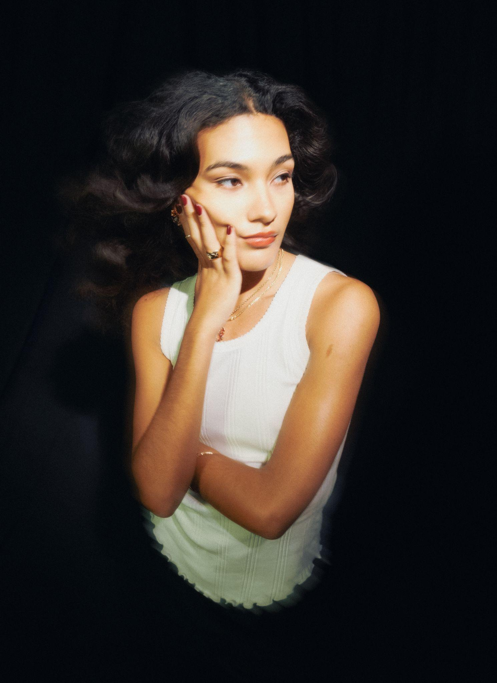
Hi-res assets here // Photo credit: Alexander Fjodorov

Olivia Dean today shares a new live video for her standout single ‘Ladies Room’, lifted from her acclaimed debut album Messy. Shot by Sirius Gahan, the video captures the joyous magic of the performance at one of Olivia’s three recent sold out headline shows in New York City.

Watch the video for ‘Ladies Room’

She also announces two more headline shows at London’s Eventim Apollo, added to her already sold out spring 2024 tour which will see her headline the biggest venues of her career across the UK and Europe. The newly announced show will take place on Saturday 4th May, following an already sold out first night at the Eventim Apollo on Thursday 2nd May, seeing her perform to 10,000 fans across two nights in her hometown. Support for the UK and Ireland tour comes from fast-rising Irish artist Aby Coulibaly, with Prima Queen joining for the first London date.

Presale tickets for the second Eventim Apollo show opens at 10am on Wednesday 6th December, with general sale beginning Friday 8th December. Tickets and more information available via https://www.oliviadeano.com.

The news rounds out a huge 2023 for Olivia Dean, which saw the release of her acclaimed debut album Messy, which debuted at #4 in the UK Official Album Charts and was nominated for the prestigious Mercury Prize. She recently completed her first headline tour of the US and Canada, which included three nights in New York, two nights in LA and concluded at Corona Capital in Mexico.

The Messy tour sees Olivia sell over 30,000 tickets across the UK and Europe next spring, and is due to play major festival spots all over the world in 2024.

Today it was announced that Olivia is a longlisted artist on BBC Radio 1’s Sound of 2024 poll, and in recent weeks Dean has been named BBC Introducing Artist of The Year, following the likes of Nia Archives, Self Esteem, Arlo Parks, Celeste and more. Dean was also recently nominated for The Breakthrough Award at the first Rolling Stone UK awards.

This summer saw Olivia play to packed audiences across the UK and beyond, at festivals including Glastonbury, All Points East, Montreux Jazz festival and many more, as well as a sold out outdoor show at Somerset House, which was the fastest selling of the whole series. Along with playing Glastonbury (with headliner Elton John singing her praises: "I think she’s a big star … she’s a fabulous singer, she’s beautiful, she’s got that personality that really shines through"), Olivia has fulfilled two more of her childhood dreams this year; playing on Jools Holland and being nominated for the Mercury Prize.

Listen to Messy

Olivia Dean live dates

2024
Thursday 25th April - SWG3 Galvanizers - Glasgow, UK - SOLD OUT
Friday 26th April - Stylus - Leeds, UK - SOLD OUT
Saturday 27th April - Albert Hall - Manchester, UK - SOLD OUT
Monday 29th April - O2 Institute - Birmingham, UK - SOLD OUT
Tuesday 30th April - O2 Academy - Bristol, UK - SOLD OUT
Thursday 2nd May - Eventim Apollo - London, UK - SOLD OUT
Saturday 4th May - Eventim Apollo - London, UK
Sunday 5th May - Eventim Apollo - London, UK
Saturday 11th May - Ancienne Belgique - Brussels, BE
Monday 13th May - Paradiso - Amsterdam, NL - SOLD OUT
Tuesday 14th May - Paradiso - Amsterdam, NL - SOLD OUT
Thursday 16th May - Stadthalle - Cologne, DE
Friday 17th May - Tempodrom - Berlin, DE
Saturday 18th May - Docks - Hamburg, DE

About Olivia Dean

Olivia Dean is one of the UK’s brightest rising stars and of 2023’s standout musicians, beloved for her diverse musicality, endearing down-to-earth lyrics and magnetic, feel-good live performances. This summer Dean released her long-awaited debut album Messy, which was shortlisted as a Mercury Prize Album of the Year and charted at #4 in the UK’s Official Album Chart.

Messy cements Olivia Dean as one of the most original and versatile voices in UK pop. Crafting classic yet conversational hooks with genre-fluid tinges, she’s honed a way of exploring universal themes of love, loss and everything in between with razor-sharp but open-hearted storytelling.

Since 2019 Olivia has been gathering fans apace across the release of her three acclaimed EPs Ok Love You Bye, What Am I Gonna Do On Sundays? and Growth and in 2021 achieved her first top 20 single with her cover of ‘The Christmas Song’, recorded for Amazon Originals.

Now with over 5 million monthly listeners globally and over 460 million global streams to date, Olivia has sold out shows internationally at venues including The Roundhouse and Somerset House in her hometown of London and festivals worldwide such as Glastonbury, Montreux Jazz festival and many more. Olivia will play her biggest run of shows to date in Spring 2024 for her Messy tour.

She has supporters across BBC Radio 1, Beats 1, The New York Times, The Guardian, Sunday Times Style, Dazed, The Face, NME, Rolling Stone UK, Hypebae, ELLE and more tipping her for greatness. Olivia has become a regular feature at fashion weeks, and is an ambassador for Chanel.

Praise for Olivia Dean:
““Messy” makes clear Dean’s pop-soul expertise” - New York Times

"a distinct vision of off-kilter pop" - The Guardian

"Her 12-track record navigates falling out of love and back into it, with comforting, conversational lyrics all articulated in the warm, glowy tones of her full-bodied voice." - The Independent

“the capital’s most exciting new star” - Evening Standard

“smoky, self-assured London grooves” - Financial Times

"the soul sensation steps up with the perfect summer soundtrack" - Daily Star

“an album that ultimately underscores Dean's long-term potential” - Rolling Stone UK

"a record that sees Dean explore family ties, healthy love and “not getting too hung up on being the best version of yourself”. It’s authentically Olivia Dean from start to finish, mess and all." - NME

“delivered by her silken vocals draped over tender, soul-filled production in a way that could both break and mend hearts.” - Dazed

"One of our most exciting new pop voices, Olivia Dean's legacy is just beginning" - Dork

"every inch a pop star about to break" - Music Week

"Dean has become renowned for her feel-good ballads, amassing an impressive amount of fans in the process" - The Face

“Her relatable internetisms, compelling storytelling and powerhouse pop vocals come with just the right amount of tongue-in-cheek humour.” - ELLE

Follow Olivia Dean on Instagram / Facebook / Twitter

For all media enquiries please contact Warren@chuffmedia.com on 07762 130510

