ANNOUNCES 20 DATE UK AND EUROPEAN TOUR FOR SPRING 2023
HEADLINES EVENTIM APOLLO ON 13 MARCH 2024
GENERAL ON SALE 6 OCTOBER 10AM BST
LINK HERE

HOTTEST RECORD “INTO YOUR ROOM” OUT NOW

LIFTED FROM THE HIGHLY ANTICIPATED DEBUT ALBUM
“PAINT MY BEDROOM BLACK”
PRE- ORDER HERE
TO BE RELEASED ON 13 OCTOBER 2023

AMAZON CURVE SESSION “INTO YOUR ROOM”OUT NOW
WATCH HERE

Download press pics and album artwork here

Today, the BRIT winning and Ivor Novello nominated singer songwriter Holly Humberstone announces her biggest UK and European tour to date, headlining 20 venues in Spring 2024, including The Albert Hall in Manchester on 8 March and London’s Eventim Apollo on 13 March 2024. From selling out her LA headline show at The Fonda Theatre to storming the stages at Lollapalooza in Chicago to Summersonic in Japan and debuting on the mainstage at Reading & Leeds in the UK, Holly's consistent live experiences capture the heart of her raw songwriting. Next week the 23-year-old artist will play a run of intimate live shows in partnership with independent record stores across the UK. In celebration of the release of her debut album, Paint my Bedroom Black on 13 October, the dates will be the only chance to catch Holly live in the UK before her headline tour next year. The run of sold-out in-stores include a special hometown date at Nottingham’s Rough Trade, a short distance from Grantham where Holly grew up, as well as two sold-out Rough Trade East’s. Tickets for Holly’s headline Spring tour are on pre-sale now, and go on general sale on 6 October at 10am BST.
PRE-SALE
Holly Humberstone has become one of the most important British female artists of her generation. Getting ready to release her immaculate debut album Paint My Bedroom Black on 13 October 2023 (Friday 13th!), the record was written with longtime collaborator Rob Milton during pockets of time touring the globe last year. Holly’s time on the road was lonely as well as liberating, with most days watching friends and family through her phone, while living a “Truman Show-like” existence. “I took ages to write it because I wanted to love them all,” says Holly. Last week, the 23-year-old revealed Hottest Record “Into Your Room”, the fourth single to be lifted from Paint My Bedroom Black, already being playlisted at BBC Radio 1 and Tune Of The Week. The song was written in California, when Rob Milton flew over and the two of them hit up Ethan Gruska (producer for Phoebe Bridgers and Fiona Apple). From Ethan’s small studio outside of LA, they experimented with pawn shop-bought instruments and synths, and wrote “Into Your Room” in one day. It captures Holly’s guilt from not being present in her new relationship, a track that is dappled in dream alt-pop, and reflects the album’s expansive sonic moments that sound like hurtling down a West Coast Highway: “You’re the centre of this universe/my sorry ass revolves around you”.
LISTEN TO “INTO YOUR ROOM”
WATCH AMAZON CURVE SESSION
The production of Paint My Bedroom Black unfolds into new sonic architecture – the teenage bedroom door opens into swathes of LA and London night buses, with high-octane pop pressure points, neon electronica, and 80s rock runs. The album writhes in the lyrical and sonic duality of an artist propelled into new experiences and shifting identities, and represents her coming of age, growing from an unknown singer at her parent’s piano to one of the most exciting alternative pop stars. The dark and otherworldly space Holly has built and invited fans into, both sonically and visually, has been lucid and visceral, with the camera always on her shoulder, a lens into her chaotic thoughts and deep feelings. Already nominated for two Ivor Novello’s, winning the BRIT Rising Star in 2022 and coming runner up in BBC Sound Of 2021, Humberstone’s bear-all storytelling is the heart of her craft. The rising star dropped “Antichrist” and “Room Service” in June, the double A-Side singles that reflect her introspection and extraversion, two opposing artistic multitudes that inform Holly’s lyricism and sound. “I feel like two different people half the time. My biggest challenge is always to make something I feel I haven't done before, that reflects new parts of me.” The new parts of Holly appear on “Antichrist”, an exposing image of her last break-up, a heartbreak ballad of self-loathing, set against propulsive pop: “Am I the Antichrist? How do I sleep at night?”, juxtaposed against delicate “Room Service”, an ode to locking yourself away from the world. The introduction of these two starkly different tracks act as a revolving door into the visceral duality of Holly Humberstone.
PRE ORDER “PAINT MY BEDROOM BLACK”
WATCH “ANTICHRIST” HERE
WATCH “ROOM SERVICE” HERE

Last month, Holly Humberstone released “Superbloodmoon” featuring d4vd, the third song taken from Paint My Bedroom Black. A Super blood moon is when the Earth's moon is in a total lunar eclipse and the sky becomes red, and Holly loved the idea of how rare it was. She met billion streaming American singer and songwriter d4vd in London at longtime collaborator Rob Milton’s studio, and they both wrote the song in a few hours, imagining two people staring at the rare lunar eclipse from opposite sides of the world. Always inspired by her environment and how that affects her sense of self and identity, from her parent’s Haunted House to flatshares in London with The Walls Are Way To Thin, “Superbloodmoon” reflects the landscape surrounding Holly, travelling the world, taking a flight last year on tour and trying to find an anchoring and missing loved ones.
WATCH “SUPERBLOODMOON”
LISTEN TO “SUPERBLOODMOON”

With a talent for capturing and characterising moments that are both uncomfortably intimate and brutally revealing in her songwriting and creative – most of Holly’s 2022 was spent in hotel rooms, stuck between places, watching life from afar rather than being totally present in it. Lacking real connections and missing loved ones, the stirring official video for “Antichrist”, directed by Jean-Charles Chavarin, tells the story of the self-flagellation that comes with hurting someone you love, as you run away from yourself, trying to escape from room to room, until your reflection turns away from you. Last week, Holly dropped the “Room Service” video, shot in room 627 on a webcam, the same room that Holly invited 80 fans to hear songs for the first time from Paint My Bedroom Black. Inspired by early zoom calls where Holly’s world felt blurry and faraway, the video captures a day in the life of Holly on tour, trying to find normality and home in the mundane, locked away from the world in a hotel room.

Finishing 2022 on a huge high, ending her biggest UK headline tour with 5000 fans singing back favourites “Scarlett” and “Overkill” at O2 Academy Brixton, the physical manifestation of her 242.6M global streams, Holly Humberstone started 2023 with her journal in hand and creative, walled off time, as she locked herself away in Rob Milton’s studio in London, to piece together the pieces of herself she felt like she left on the road, in rooms across the world. Holly has become renowned for painting a picture of a place so viscerally, being rooted in the walls and also people that makes a city liveable, where you can “get drunk with your mates and just forget about work”. From her family home in “Haunted House” to feeling lost and isolated in her London shared flat with The Walls Are Way To Thin, Paint My Bedroom Black is Holly’s fragmented and dark love letter to friends and lovers, a hideaway from the world when her fans need one.
PAINT MY BEDROOM BLACK TRACKLISTING
- Paint My Bedroom Black
- Into Your Room
- Cocoon
- Kissing In Swimming Pools
- Ghost Me
- Superbloodmoon (featuring d4vd)
- Antichrist
- Lauren
- Baby Blues
- Flatlining
- Elvis Impersonators
- Girl
- Room Service
Instore tour
1 Oct Liverpool Jacaranda SOLD OUT
2 Oct Leeds Crash SOLD OUT
3 Oct Nottingham Rough Trade
5 Oct London Banquet SOLD OUT
6 Oct Southampton The Brook, Vinilo SOLD OUT
8 Oct Newcastle Newcastle University w. Reflex Records
9 Oct London Rough Trade East TWO SOLD OUT SHOW

Headline Tour

13 Feb Café de la Danse Paris
14 Feb Melkweg MAX Amsterdam
16 Feb DR Studie 2 Copenhagen
17 Feb Fryshuset (Klubben) Stockholm
19 Feb Knust Hamburg
20 Feb Hole44 Berlin
21 Feb MeetFactory Prague
23 Feb Simmcity Vienna
24 Feb Strom Munich
25 Feb Mascotte Zurich
27 Feb Rockhal Luxembourg
28 Feb Gebäude 9 Cologne
29 Feb Trix Hall Antwerp
8 March Queen’s Hall Edinburgh
9 March Albert Hall Manchester
10 March The Engine Shed Lincoln
12 March O2 Academy Leicester
13 March Eventim Apollo London
15 March Beacon Bristol
16 March Academy Dublin

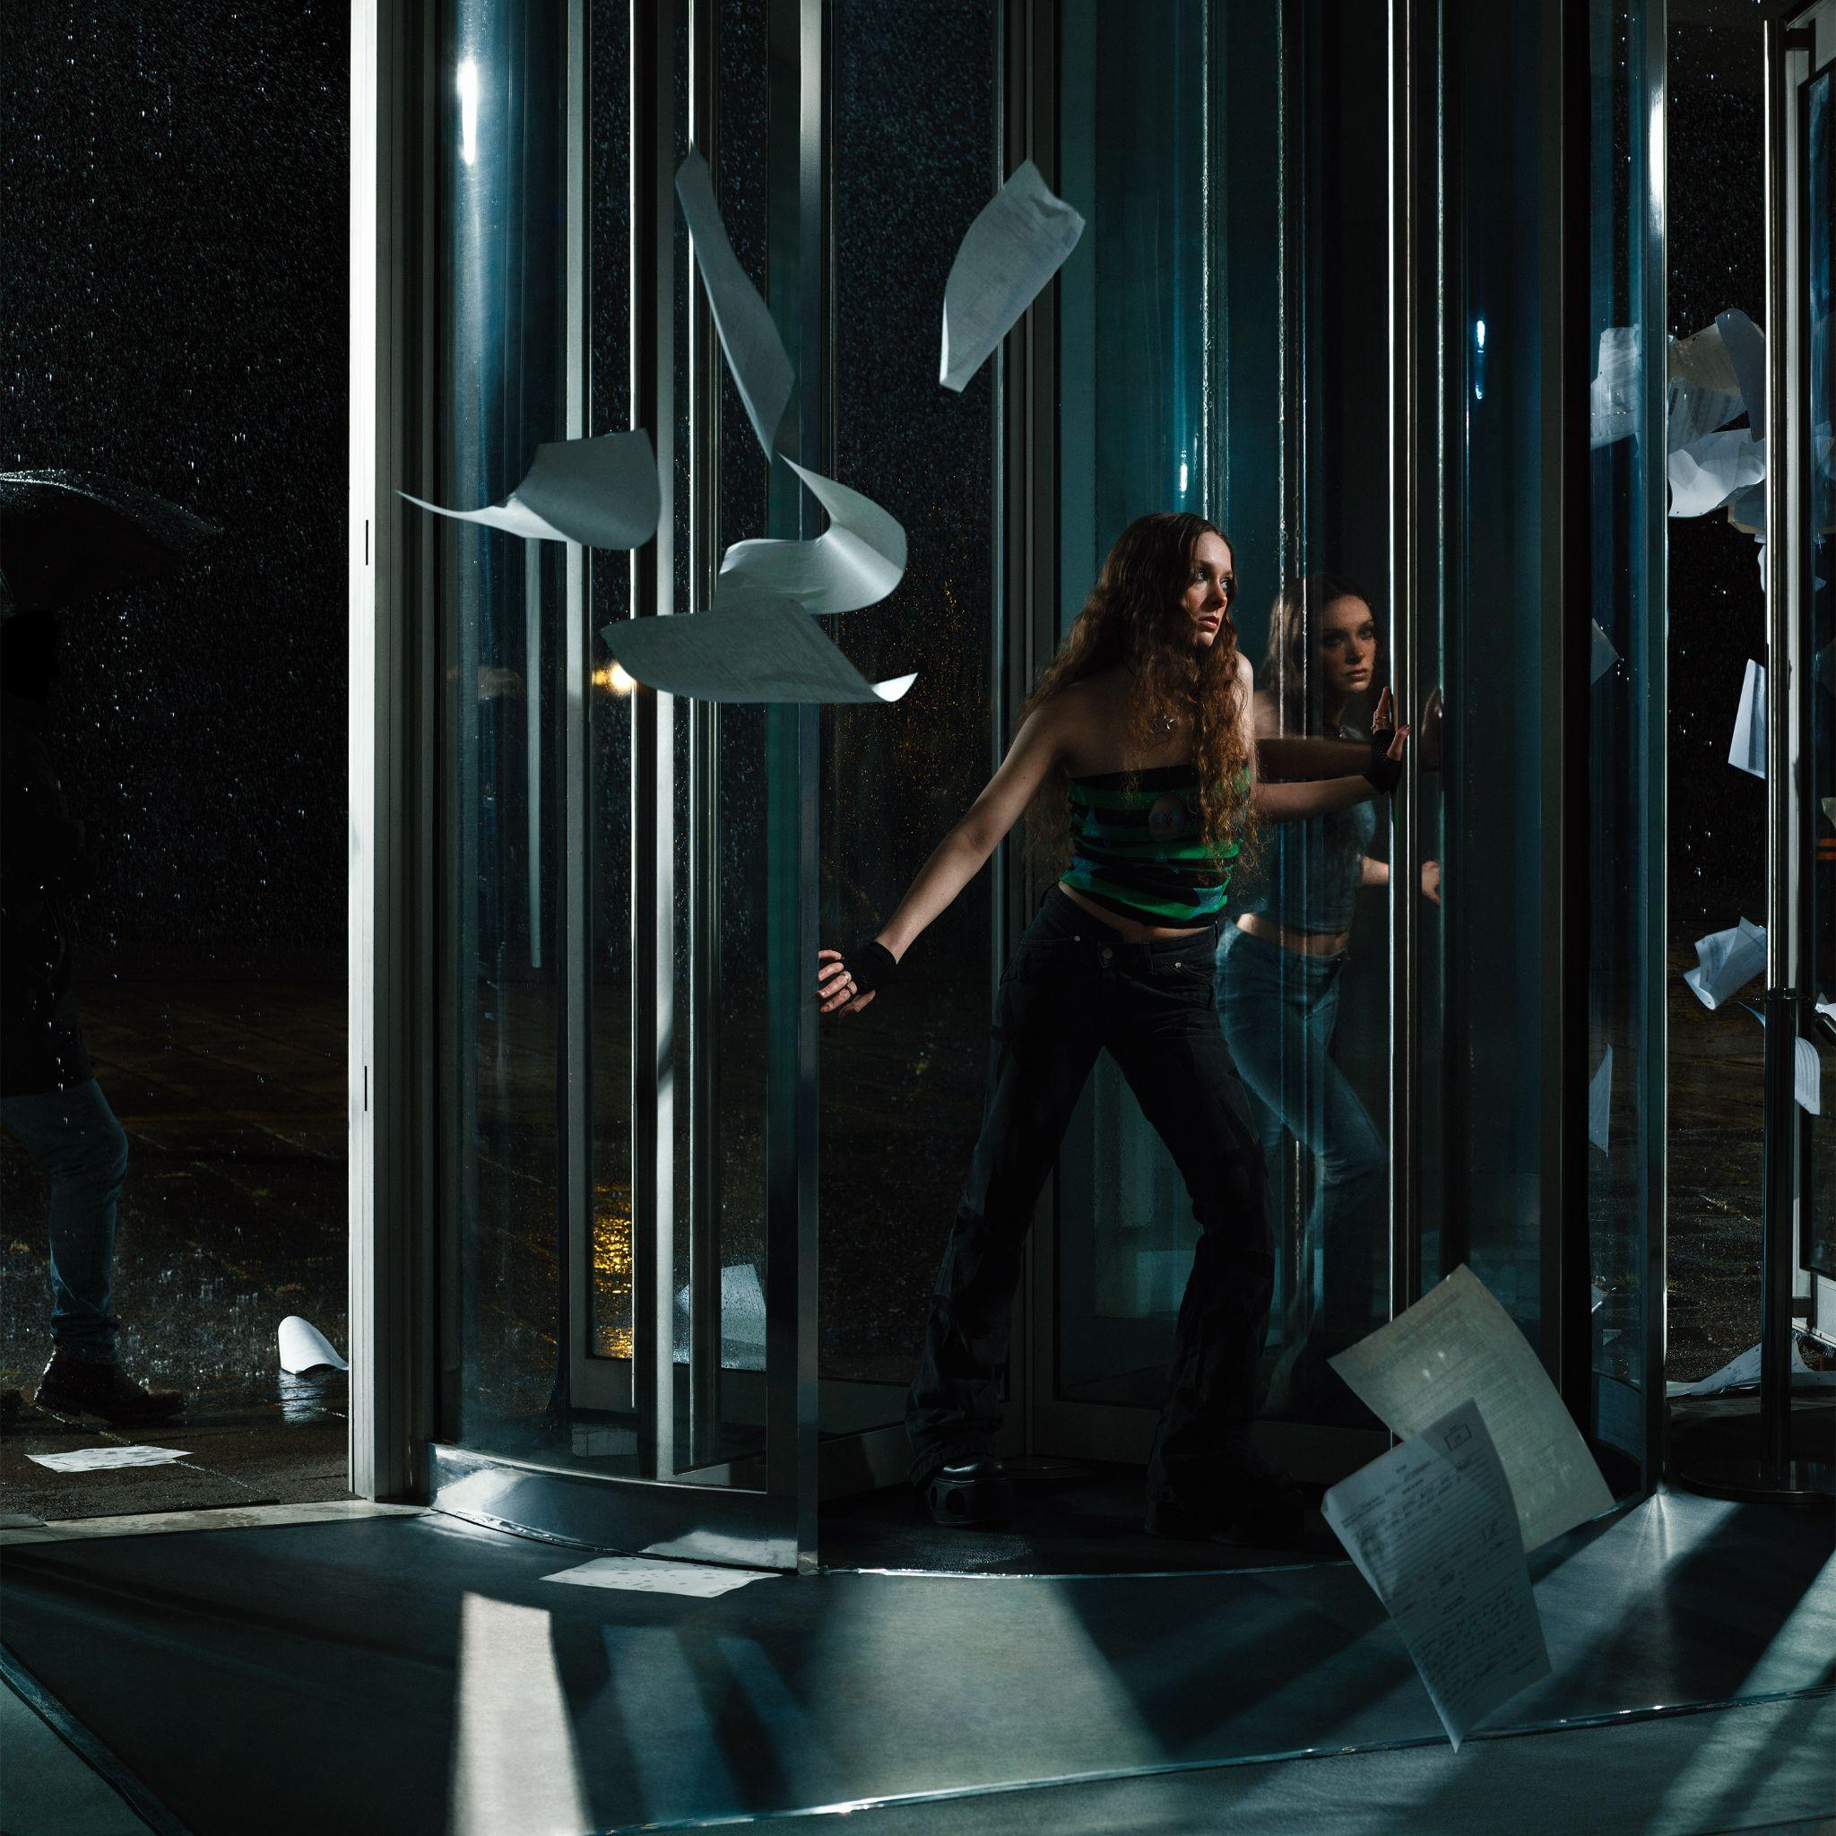

Follow Holly Humberstone:
YouTube/ Instagram / Twitter / Facebook / Spotify /
Apple / TikTok

For more information and press enquiries please contact

Jenny Entwistle
Jenny@chuffmedia.com

