BREAKOUT BRITISH STAR CAITY BASER ANNOUNCES 14-TRACK MIXTAPE ‘STILL LEARNING’ - OUT MARCH 12
ALSO ANNOUNCED TODAY: CAITY’S BIGGEST EVER UK TOUR INCLUDING SHOW AT LONDON’S HAMMERSMITH APOLLO
TICKETS AVAILABLE AT CAPPED PRICES AS PER CAITY’S PLEDGE TO KEEP HER SHOWS AFFORDABLE FOR HER FANS
NEW SINGLE ‘I LOVE MAKING BAD BOYS CRY’ OUT NOW VIA EMI RECORDS / CHOSEN MUSIC

Caity Baser press shot. All press assets available here.

Caity Baser has today announced that her brand new mixtape ‘Still Learning’ will be released on 12th March 2024 via EMI Records / Chosen Music.
The ‘Still Learning’ mixtape will feature 14 tracks all performed and co-written by Caity including new single ‘I Love Making Bad Boys Cry’ - which is out now.
It will be available digitally to stream and download, and physically via vinyl as well as a limited run of CDs - which Caity is putting on sale for only £5 as part of a thank you to her fans. Those lucky enough to claim one of these limited edition CDs will also gain early access to buy capped-price tickets to her forthcoming UK tour.
Only 12 months ago Caity was playing in front of 100 people a night and now the highly-acclaimed rising star has announced her biggest tour to date: the ‘Still Learning’ tour, where Baser will perform eleven shows across the UK including a show at London’s historic venue, Hammersmith Apollo. Beginning in March 2024 in Leeds, the tour will conclude with a homecoming show in Southampton where Caity grew up. Combined, the tour will see Caity perform to over 40,000 people - such is the draw of her unique live performances.
Of the Still Learning tour, Caity says:
"Being on stage is my absolute favourite place to be, ever. My shows have been crazy - within a year I’ve gone from playing my first show to 150 people, to huge sold out shows ,massive festival main stages, everyone shouting back all the lyrics to me...which is still crazy to think about! But it’s only made me want to go bigger and better for this tour. So expect a totally new show with some surprises and also the usual chaos ofc. CAN’T WAIT TO SEE U ALL THERE!!"
Maintaining her pledge to her fans during the cost of living crisis, Caity has ensured tickets for the forthcoming Still Learning tour have also been made available at a capped, reduced price. This is a matter which is very important to her, motivated by her memories of often not being able to afford tickets to gigs when she was growing up.
Of her capped tour ticket prices and mixtape, Caity says:
“As I hope people know by now, I like to make everything I do as accessible as possible to everyone, and I wouldn't want someone to not come to one of my shows because of money or whatever - especially with everything that's going on in the world at the moment. We’re all in this together and without all of my fans none of this would be happening. You got me here, so you should be there at my shows!
So.. I asked my team to keep the ticket and mixtape prices as low as possible for my fans (they call themselves the Slaysers). And I’ve also put the mixtape at a fiver for my Slaysers - they’re super limited and i hope u love them as much as i do! See u all on tour next year!!”
Caity Baser’s Still Learning UK tour dates are as follows:
Tuesday 26th March - O2 Academy, Leeds
Wednesday 27th March - Academy, Manchester
Thursday 28th March - Rock City, Nottingham
Saturday 30th March - O2 Academy, Liverpool
Monday 1st April - 3Olympia, Dublin
Wednesday 3rd April - O2 Academy, Glasgow
Thursday 4th April - O2 City Hall, Newcastle
Saturday 6th April - The Great Hall, Cardiff
Sunday 7th April - O2 Academy, Birmingham
Monday 8th April - O2 Academy, Bristol
Tuesday 9th April - O2 Guildhall, Southampton
Wednesday 17th April, University of East Anglia, Norwich
Friday 19th April - Hammersmith Apollo, London
The ‘Still Learning’ mixtape will be the largest release of material by Caity Baser, and along with brand new songs (some of which were previewed at Caity’s recent live shows) will feature her singles ‘X&Y’, ‘2468’ and ‘Pretty Boys’ - her first ever UK Top 30 single.
Of the mixtape, Caity says:
"This mixtape is a window into everything that i've experienced in the last year or two: all the fucking nonsense from boys, the amazing times with my best mates, my fans, the mistakes I’ve made and everything else. It's also me trying new things - there's some new sounds on there, stuff you've not heard from me before, but I love it all and it's honest and real to me and I hope you love it as much as I do!"
Full tracklist for ‘Still Learning’ mixtape is as follows:
- I’m A Problem
- The Plot
- Showgirl
- Pretty Boys
- I Love Making Bad Boys Cry
- Fuck Every Love Song
- 2468
- X&Y
- Everything Everywhere All At Once
- Bicker
- Grow Up
- Oh Well
- Choose Me
- I’ll Be Here For You
Caity Baser is one of the UK’s fastest-rising, unique and in-demand pop acts of today. She is an acclaimed singer, songwriter, and pop provocateur with an endearing, larger-than-life personality which has helped forge her huge legion of die-hard fans in such a short space of time.
Still only 21 years old, the Brighton-based, Southampton-born singer gained initial success during lockdown from an improvised song she posted online - which took her on a whirlwind journey of success where she has played live to thousands who scream back at her every lyric to every song. She has earned widespread critical attention and acclaim and regularly scores hit singles in the UK charts and national radio playlists for her honest, no-filter catchy Gen Z anthems.
These anthems include early successes ‘Friendly Sex’ and ‘X&Y - both included on the forthcoming ‘Still Learning’ mixtape’, which quickly gained the attention of record labels across the world. She signed a deal with EMI Records in late 2022, going on to release hit singles including the top 30 track ‘Pretty Boys’ (which was also playlisted at BBC Radio 1 as well as many other national radio stations), and dance-pop summer anthems ‘Feels This Good’ with Sigala, Mae Muller and Stefflon Don as well as ‘Dance Around It’ with chart-topping DJ/producer Joel Corry.
Baser has earned the interest of national media for her prowess of writing a catchy, instantly recognisable melody combined with lyrics uniquely specific to her life growing up in the UK. She released her 2023 EP ‘Thanks For Nothing, See You Never’ to much critical acclaim, with NME dubbing her “pop’s wittiest new songwriter” and Rolling Stone UK hailing her "Gen Z's new favourite pop star". Music tastemaker magazine Dork crowned the EP as “pop chaos in the best tradition”.
Having just come off her hugely successful debut tour of Australia and New Zealand, Caity has returned home to announce the biggest and most exciting phase of her music career to date: her Still Learning era.
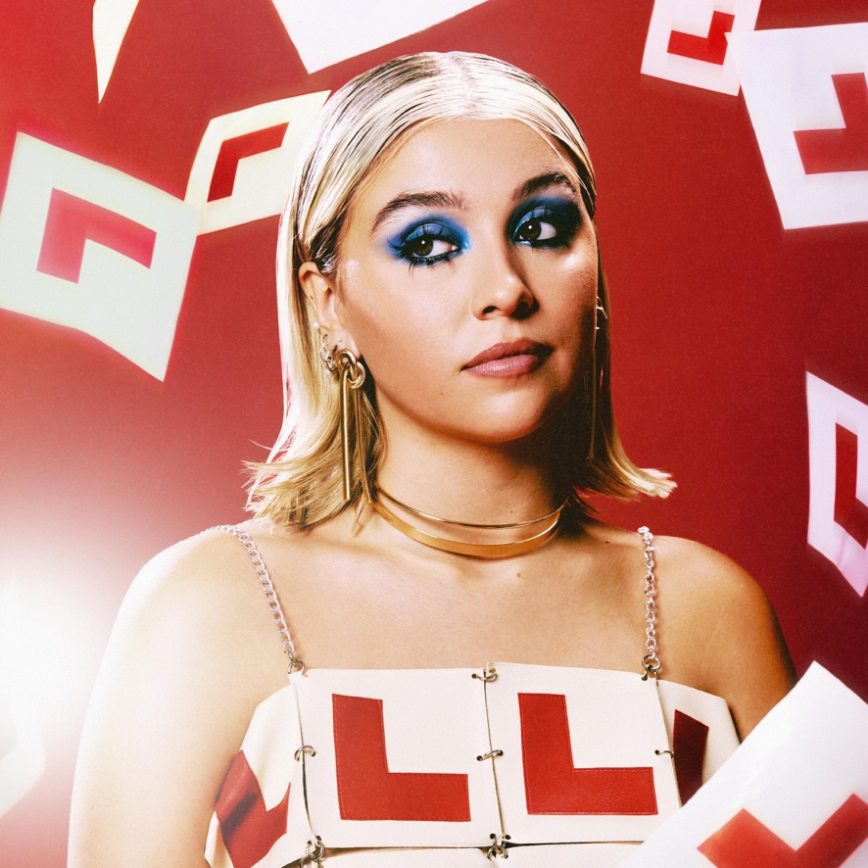
Cover art for ‘Still Learning’ by Caity Baser. All press assets available here.

For more on Caity Baser:
Instagram | Twitter | TikTok | Website | Facebook

For more info contact warren@chuffmedia.com

