SELF ESTEEM

ANNOUNCES 2023 ‘I TOUR THIS ALL THE TIME’ TOUR

INCLUDING HUGE LONDON HAMMERSMITH APOLLO SHOW

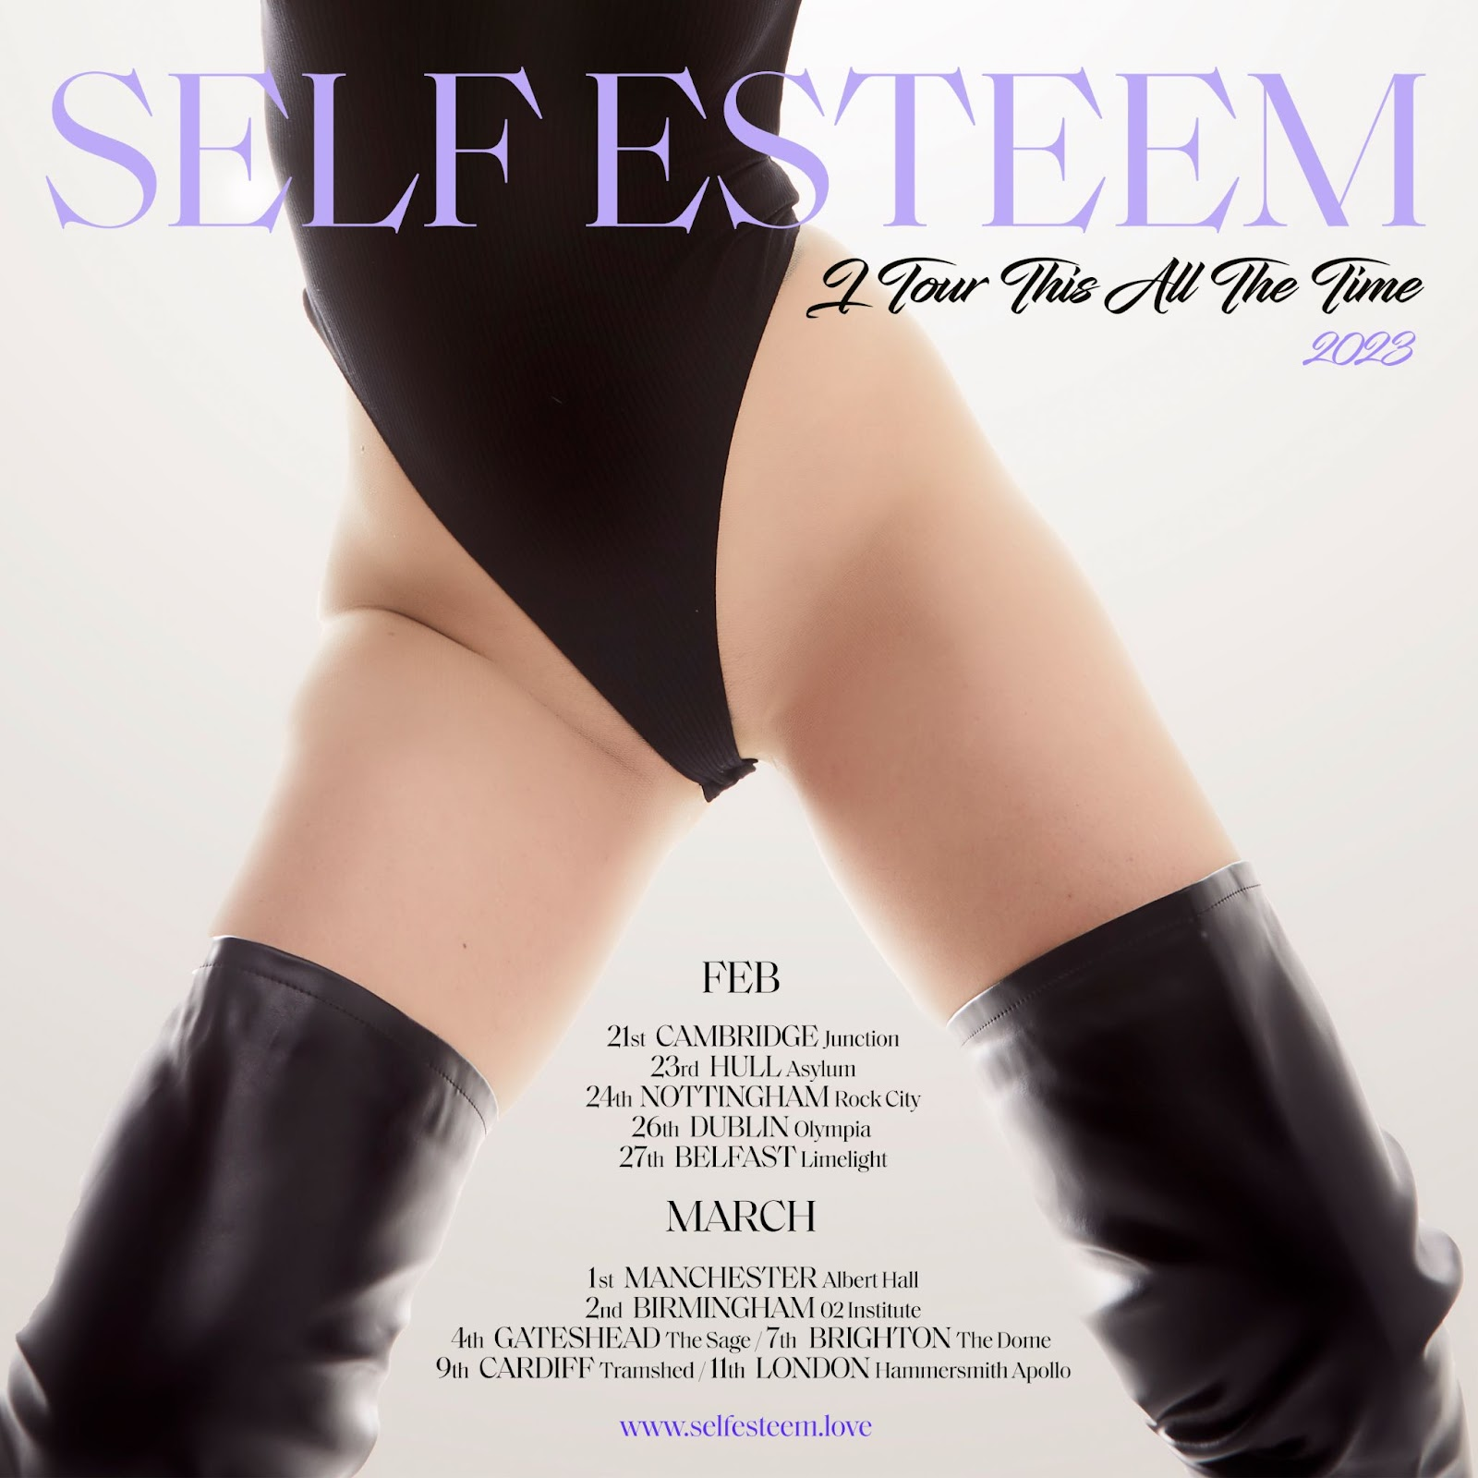

Hi-res assets here

“The sound of an artist coming into her own, Rebecca Taylor’s remarkable second album as Self Esteem mixes the intimate and conversational with the unabashedly dramatic” - The Guardian, 5*, Album of the year

"Musically smart songs that combine shiny appeal with real originality and spark, this is an off-kilter pleasure" - The Times, 5*, Album of the year

“Prioritise Pleasure finds its feet more firmly with songs that can only be described as huge… songs are soaked in strings, choral gang vocals and grown-up pop-radio beats, while Taylor’s lyrics are so open and relatable, they recall Amy Winehouse” - iPaper, Album of the year

"Musically smart songs that combine shiny appeal with real originality and spark, this is an off-kilter pleasure" - 5*, The Times

“With huge choruses and head-flicking 90s dance moves, Rebecca Lucy Taylor’s performance is a maximalist pop triumph” - 5*, Observer New Review, Pop Artist of the Week

Self Esteem today announces her biggest ever run of headline live dates, the ‘I Tour This All The Time’ tour, due to take place across February and March 2023. The 11 date run kicks off at Cambridge’s Junction and culminates with a massive show at London’s Hammersmith Apollo. Presale tickets are available from 10am tomorrow to those signed up to the Self Esteem mailing list, with general tickets onsale from 10am on Thursday 31st March via https://www.selfesteem.love/.

Described as “a maximalist pop triumph” (The Observer, 5*), “Full of unabashed, unapologetic female rage” (The Telegraph, 5*) and “nothing short of revolutionary” (Evening Standard, 5*), a Self Esteem live show is not to be missed. A space for unbridled joy, dancing and emotional catharsis, there are plenty of opportunities to join the party across festivals including Glastonbury, TRNSMT, All Points East and many more this summer.

Buy tickets to see Self Esteem live

Sign up to the Self Esteem mailing list for presale access

Featuring the acclaimed singles ‘I Do This All The Time,’ ‘Prioritise Pleasure’, ‘How Can I Help You’ and ‘Moody’, Prioritise Pleasure is a remarkable step up from Rebecca Taylor’s 2019 debut Compliments Please and sheds light on important issues around female autonomy, comparison culture, self-doubt, heartbreak, sexual assault, comparison culture and self-accepatance, comforted and counter-balanced with an array of rhythmic flourishes that speak to the eclecticism of her experience and influence. Self Esteem was nominated for the Best New Artist award at this year’s BRIT Awards and is currently composing the soundtrack for the UK premiere of Suzie Miller’s award-winning play Prima Facie, starring Jodie Comer.

Listen to Prioritise Pleasure

SELF ESTEEM 2022 TOUR DATES

3rd April - BBC Radio 6 Music Festival, Cardiff, UK
16th April - Stockton Calling Festival, Stockton-On-Tees, UK
24th April - DIY Alive Festival, Oval Space, London, UK (In conversation)
1st May - Sound City Festival, Liverpool, UK
6th May - Focus Wales Festival, Wrexham, UK
4th June - Mighty Hoopla Festival, London, UK
11th June - Kite Festival, Oxfordshire, UK
12th June - Syd for Solen Festival, Frederiksberg, Denmark
19th June - Bigfoot Festival, Middle Claydon, UK
24th June - Glastonbury Festival, Shepton Mallet,, UK
3rd July - Down The Rabbit Hole Festival, Ewijk, Netherlands
9th July - TRNSMT Festival, Glasgow, UK
13th July- Slottsfjell, Tonsberg, Norway
22nd July - Latitude Festival, Suffolk, UK
23rd July - Tramlines Festival, Sheffield, UK
24th July - Standon Calling Festival, Royston, UK
30th July - Deer Shed Festival, Thirsk, UK
12th August - Boardmasters Festival, Cornwall, UK
14th August - Summer Well Festival, Buftea, Romania
19th August - All Points East Festival, London, UK
20th August - Pukkelpop, Hasselt, Belgium
21st August - Camp Bestival, Shropshire, UK
26th August - Victorious Festival, Portsmouth, UK
28th August - Connect Festival, Edinburgh, UK
04th September - Forwards Festival, Bristol, UK

SELF ESTEEM 2023 TOUR DATES

21st February - Junction, Cambridge, UK
23rd February - Asylum, Hull, UK
24th February - Rock City, Nottingham, UK
26th February - Olympia, Dublin, UK
27th February - Limelight, Belfast, UK
1st March - Albert Hall, Manchester, UK
2nd March - O2 Institute, Birmingham, UK
4th March - The Sage, Gateshead, UK
7th March - The Dome, Brighton, UK
9th March - Tramshed, Cardiff, UK
11th March - Hammersmith Apollo, London, UK

More praise for Prioritise Pleasure

“Subversive, clever, of the moment and utterly joyous, this is a record that reminds you how life-affirming pop music can be.” - Record Collector, 5*

“Commanding, assertive, and powerful, Prioritise Pleasure is everything pop music should be. Wholly unafraid to tackle difficult subjects with ease, in Rebecca Taylor we also have the makings of a serious pop behemoth.” - The Line of Best Fit, 10/10

“Through her own personal stories - and those of others - Prioritise Pleasure manages to challenge accepted norms and helps to exorcise long-buried demons; it’s powerful to the last drop.” - DIY, 5*

"one of those special records that's importance and legacy will be felt for years to come... a staggering step up." - Dork, 5*

“Prioritise Pleasure may well be the album of the year. It represents Rebecca Taylor reaching her well-deserved pinnacle, as a modern popstar with the whole package: voice, humour, choreography, honesty, looks and the uncanny ability to pen a banger.” - Gigwise, 10/10

“‘Prioritise Pleasure’ is an ambitious and vibrant testament to women but more importantly, a testament to herself. It’s nothing less than pop perfection.” - The Forty Five, 5*

“Assured and unapologetic, it’s charged with a dark, smirking wit that’s impossible to turn away from” - NME, 4*

“A fierce, feminist, pop prism that is dancable, joyous and above all else - fun” - Rolling Stone UK

"modern, maximalist pop songs with top notes of of R&B, trap and Afrobeat, plus experimental detailing... There are no misfires" - Uncut, 8/10

“Rather than using pop polish to mask uncomfortable truths, Prioritise Pleasure hits so powerfully specifically because it uses the language of a pop record to state them frankly. It’s masterful.” - Loud & Quiet, 8/10

“‘Prioritise Pleasure’ is a strong offering with inspiring, soul-searching songs... Taylor shows that she can do it all with this second album” - Clash, 8/10

“What is radical is this: Taylor uses chaos, rage and despair as tools to prop up her stadium-sized ambitions… These songs tell us not to stand still anymore. They tell us to start showing off. They tell us to sing again, for ourselves, for each other, all together, gnarly, messy, loud and free.” - The Quietus

“Rebecca Lucy Taylor’s second solo album teaches us that to be rooted in one’s emotions is a method of survival.” - The New Statesman

Website / Instagram / Facebook / Twitter / TikTok

For all media enquiries please contact Warren@chuffmedia.com on 07762 130510

