Kurupt FM unleash their ‘Kuruption’ in 6-date UK tour for 2022,
hitting iconic London venue Printworks
*NEW DATE ADDED*
Friday 18th February 2022 at London Printworks

Due to popular demand, Manchester show changed to Manchester Academy venue

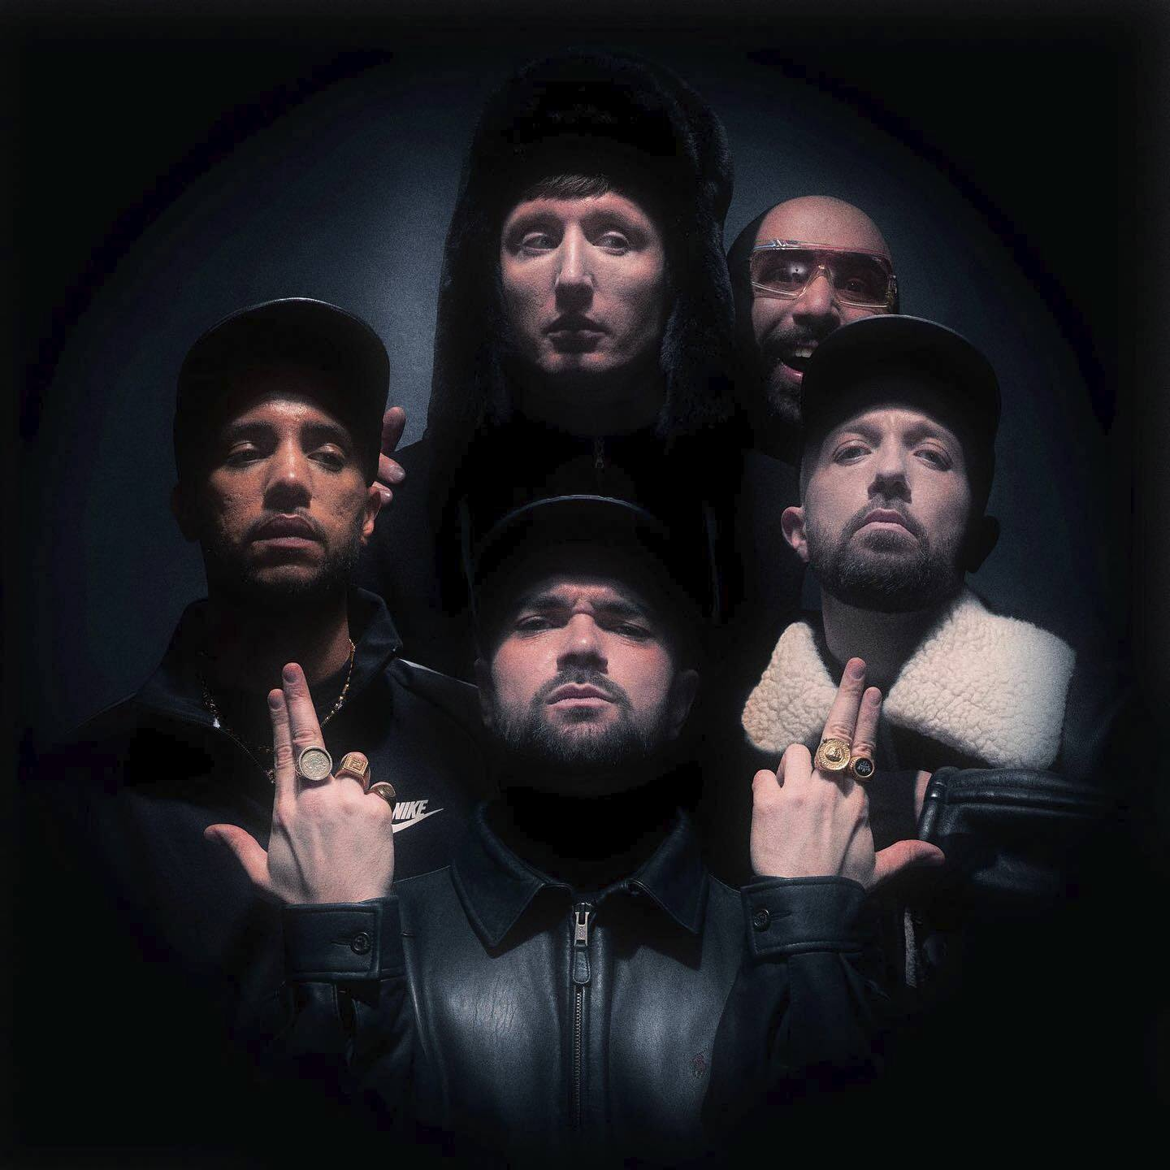

“YOU ARE NOW IN TUNE TO THE WORLD’S GREATEST: KURUPT FM

YOU THOUGHT WE WERE DEAD, YOU THOUGHT WE WAS GONE

BUT GUESS WHAT? WE’RE BACK!

RISING FROM OUR OWN ASHES, FISTS IN THE AIR

PRESENTING TO YOU… THE GREATEST HITS”

- MC GRINDAH
(THE BEST MC IN THE GALAXY)

Dust off your Avirex jacket and dig out your Nike Clima-Fit cap: Kurupt FM are bringing pure kuruption LIVE, having just announced 5 UK show dates for 2022, including London’s iconic Printworks available to buy via www.gigsandtours.com, on sale 24th September.

Deemed the best (and only) pirate radio station in the whole of Brentford, Kurupt FM step forward confidently with an all-new collection of future smashes. The tour follows the release of their album: 21 tracks of the best music that the country has ever produced, with guest appearances from the cream of the crop of the UK industry, and the feature-film adaptation of their BAFTA-Award winning series. People Just Do Nothing: Big In Japan follows Grindah, Beats, Chabuddy G, Steves and Decoy as they begin their journey to international stardom, after hearing the news that one of their songs has been used on a popular Japanese game show.

Those looking for some familiarity will no doubt recognise their recent garage anthems ‘Summertime’ with Craig David, and ‘Dreaming’ feat. JayKae and MIST, while long-time fans will rejoice at the all-star remix of their legendary ‘Heart Monitor Riddim’ featuring grime veterans Blacks, P Money and Footsie - all of which demanded a spot on the track.

One of the last true representatives of MC culture: The Greatest Hits (Part 1) sees MC Grindah puts his versatility on display, never breaking a sweat whether he’s spitting on garage, grime, baseline, drum n bass, jungle or even ragga (just don’t expect to hear him wasting his talents on house music). Never far away is DJ Beats, who despite being banned from making music by his partner Roche, retains his status as music’s most loyal hype man.

While you’d never want to mistake the crew for soft, alongside The Greatest Hits (Part 1)’s lyrical casualties there are also some tender moments that showcase Kurupt FM as urgent voices of our generation: DJ Beats dismantles toxic masculinity on the platonic love note ‘Letter To Grindah’, while ‘Your Mum Loves Garage’ celebrates motherhood.

“You know me, I can sell anything mate,” says Kurupt FM manager Chabuddy G, of the experience. “Ice to an Eskimo, halal meat to a racist vegan… selling garage music to Japan is water off a duck’s beak mate.”

Tickets available now at www.gigsandtours.com.

Tour dates:

03 Feb 2022 - Manchester Academy *New Venue*
04 Feb 2022 - Bristol Marble Factory
05 Feb 2022 - Oxford O2 Academy
08 Feb 2022 - Birmingham O2 Institute
11 Feb 2022 - London Printworks
18 Feb 2022 - London Printworks *New Date Added*

For more information please contact warren@chuffmedia.com

