Sam Fender Adds Extra London + Newcastle Dates to Spring 2022 Tour
Tour Now Stops For Two Nights At Wembley Arena + Newcastle’s Utilita Arena As First Nights Sell Out Instantly
“One of the year’s best” **** - NME
“Urgent, incisive and brave” ***** - The Guardian
“Stunning” **** - Rolling Stone UK
“Profoundly sad and also a euphoric singalong. It’s a triumph” ***** - Evening Standard
“Fender has become one of Britain’s most compelling songwriters. It’s thrilling to witness” – The Sunday Times
***** - DORK
***** - The I
***** - Sunday Mirror
***** - Sunday Express
**** - The Telegraph
**** - The Times
**** - Daily Star
Sam Fender is very pleased to announce two additional arena shows to his Spring 2022 tour, as tens of thousands of tickets sell out within the first minutes of going on sale. The arena tour, Sam’s biggest to date, kicks off on 20th March in Nottingham, now stops for two nights at both Wembley Arena (1st + 2nd April) and Newcastle’s Utilita Arena (5th and 6thApril).
Tickets for all shows are on general sale now through https://www.samfender.com/live/
Later today, Sam learns whether Seventeen Going Under will follow 2019’s Hypersonic Missiles by debuting at number one in the UK album chart. The album arrived last week to a slew of critical acclaim.
Watch the video for new single “Spit of You” featuring Stephen Graham here
Sam Fender Live:
2021:
25th October – Barrowlands, Glasgow SOLD OUT
26th October – Barrowlands, Glasgow SOLD OUT
18th November – Newcastle Arena SOLD OUT
20th November – Alexandra Palace, London SOLD OUT
21st November – Alexandra Palace, London SOLD OUT
24th November – Leeds Arena SOLD OUT
25th November – Cardiff Arena SOLD OUT
2022:
20th March – Motorpoint Arena, Nottingham
21st March – M&S Bank Arena, Liverpool
24th March - 3Arena, Dublin
26th March – SSE Hydro Arena, Glasgow
27th March – Utilita Arena, Birmingham
30th March - Brighton Centre
1st April – SSE Arena Wembley, London SOLD OUT
2nd April - SSE Arena Wembley, London *NEW DATE*
5th April – Utilita Arena, Newcastle SOLD OUT
6th April - Utilita Arena, Newcastle *NEW DATE*
6th July – Castlefield Bowl, Manchester
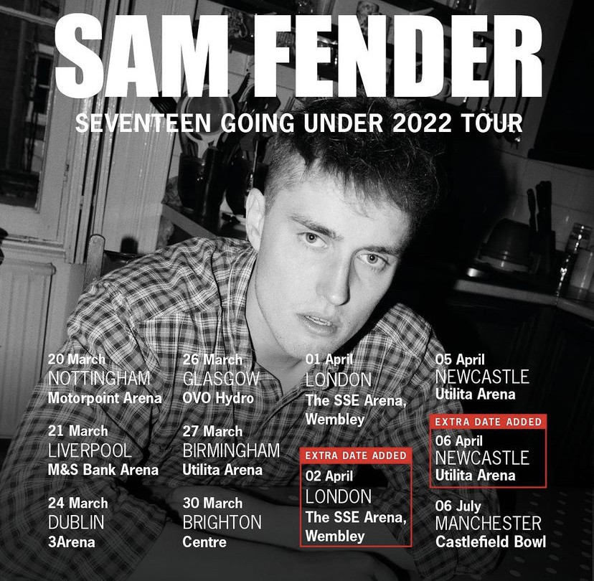

For more information & enquiries please contact jenny@chuffmedia.com

