**TOM A. SMITH SIGNS TO FICTION RECORDS**

**NEW SINGLE “FASHION”, OUT 25 JULY**

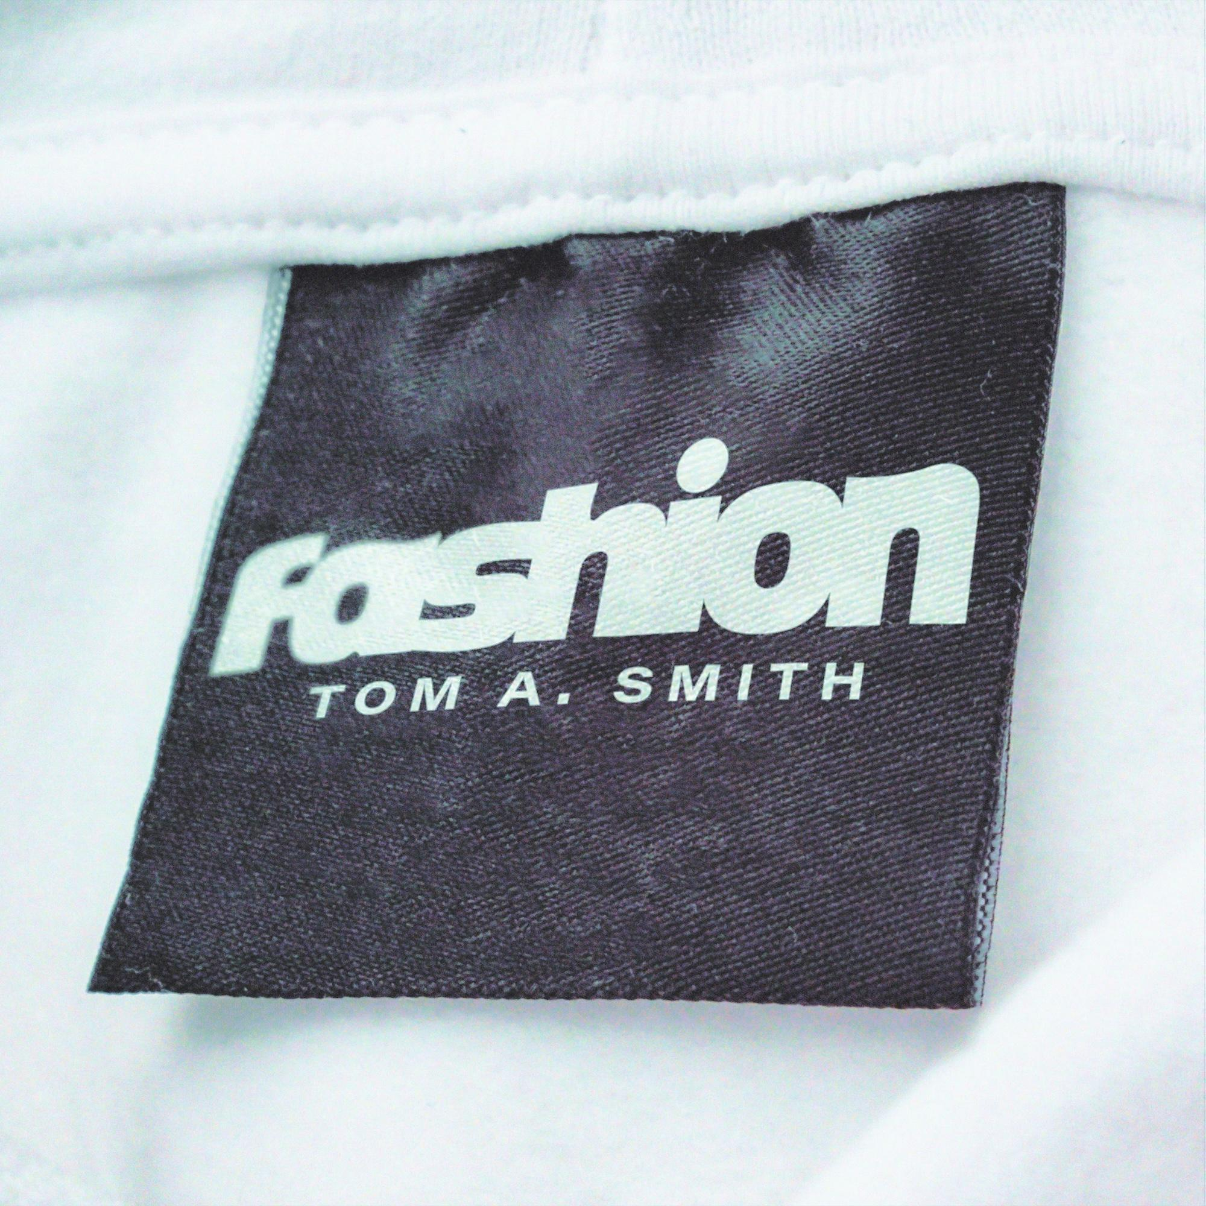

**LISTEN TO “FASHION” HERE (SMARTLINK NEEDED)  
PREVIEW HERE (LINK NEEDED)**

*Label home of The Cure, The Maccabees, The Mysterines, Kae Tempest, The Horrors & Tame Impala*

Fiction Records, now part of the Virgin Music Group, is thrilled to welcome Tom A. Smith to its storied roster. The Sunderland-born, alt-rock firebrand marks the beginning of this new era with the release of “Fashion” on 25 July via Fiction.

Jim Chancellor (Fiction Records): *“So, so happy to have Tom sign to the new-look Fiction. He’s been grafting his whole life at his craft. Having kept a close eye on him, the time is now for sir Tom. Fiction is honoured to be part of his next chapter.”*

Tom A. Smith: *“Signing to Fiction is incredible. So many of my influences came through this label and I feel that connection already. It’s a real honour, and ‘Fashion’ feels like the perfect way to kick off this new era.”*

Co-written and produced with Barry Hyde and mixed by Ali Chant, “Fashion” bursts with urgent guitars, razor-sharp hooks and Smith’s unmistakable vocal grit. *“I’m really excited for everyone to hear what we’ve created,”* Tom says. *“It’s become a staple of the live set and points the way to our new sound.”*

To celebrate the release, Tom A. Smith will also embark on a string of live performances later this year. See below for the full list of confirmed appearances.

**Tom A. Smith UK Tour Dates:**

* 19 Jul – What’s Happenin’ Digbeth?
* 20 Jul – Splendour Festival
* 15 Aug – The Fire Station, Sunderland
* 22 Aug – Come Together Festival
* 23 Aug – Darlington Arena (w/ Razorlight)
* 28 Aug – 110 Above Festival
* 29 Aug – This Feeling By The Sea

Still only twenty-one, Tom A. Smith has already dazzled at Glastonbury (twice), BBC Radio 1’s Big Weekend, BST Hyde Park (invited by Elton John), and opened Leeds Festival to 6,000 fans. He’s toured or shared stages with Catfish & The Bottlemen, The Lathums, The Mysterines, Courteeners, Miles Kane, DMA’s, and more. Viral cover performances have drawn praise from Iman Bowie, Morrissey, Nile Rodgers, Tim Booth and Blossoms, underscoring a talent whose reach already spans generations.

Armed with a relentless work ethic, electrifying live show and now the backing of Fiction Records, Tom A. Smith steps confidently into his next phase, one that begins with the swaggering anthem “Fashion” and promises much more to come.

**DISCOVER TOM A. SMITH**

[Website](https://www.tomasmithmusic.com/) | [Facebook](https://www.facebook.com/TomASmithMusic/?locale=en_GB) | [Instagram](https://www.instagram.com/tomasmithmusic/?hl=en) | [YouTube](https://www.youtube.com/channel/UCsSIZ1VDZjJjwS5qGlIutnw) | [Spotify](https://open.spotify.com/artist/6haZIHZVYI79wKvp6FCFML)

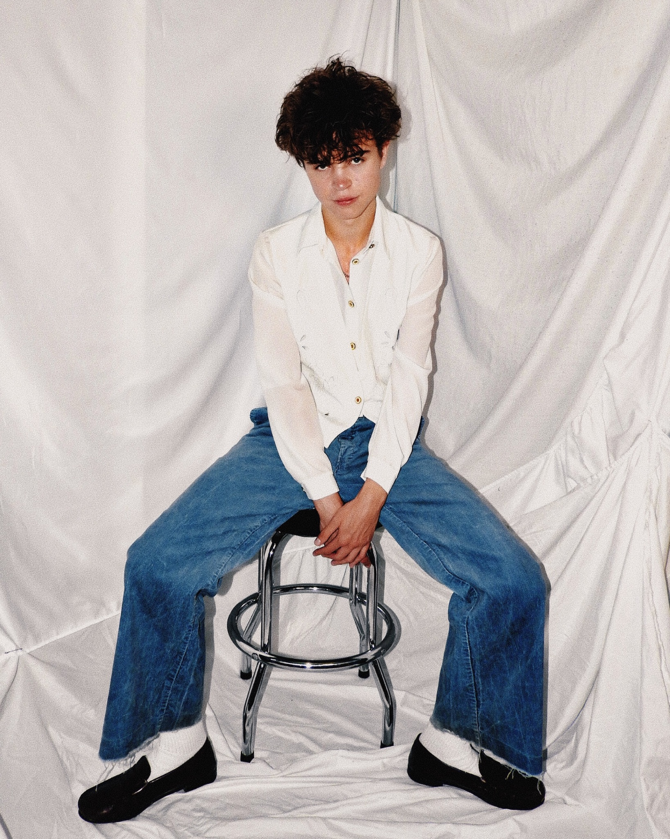

Photo Credit: Katie Anderson