ROCK’S HOTTEST RISING BAND THE WARNING SHINE
ON NEW SINGLE “AUTOMATIC SUN”

LISTEN HERE
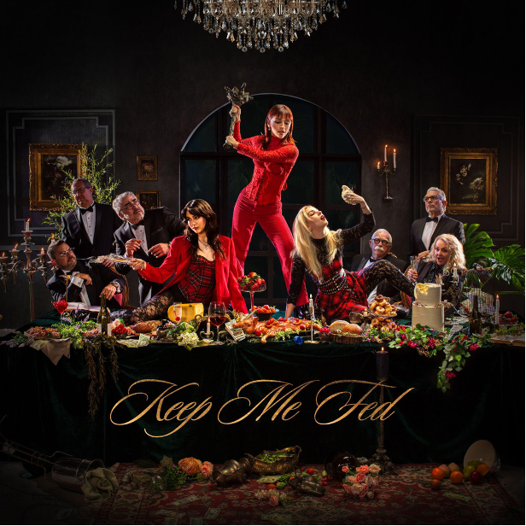
WATCH LYRIC VIDEO HERE

MUCH-ANTICIPATED NEW ALBUM KEEP ME FED ARRIVES JUNE 28TH

PRE-ORDER/PRE-SAVE & LISTEN HERE

On the fast track towards a major breakthrough, the alternative sister-trio from Monterrey, Mexico, The Warning, unveil a new single entitled “Automatic Sun” today. Listen HERE. Watch the lyric video HERE. The track was produced by Anton Delost and Dan Lancaster. It only increases anticipation for their anxiously awaited new full-length album, Keep Me Fed [LAVA/Republic Records], out June 28, 2024. Physical products will be available at RepublicRecords.com, featuring newly launched band member exclusive signed CDs as well as vinyl, t-shirts, and fan packs [CD/t-shirt or vinyl/t-shirt]. Pre-order/Pre-save HERE.

“Automatic Sun'' showcases yet another side of the enigmatic band. A head-nodding beat sets the tempo as a thick bassline thumps through slick claps. The groove turns on a dime, and a stomping riff takes hold. At the song’s core, the chantable hook resounds with a lament, “Look what you’re doing to me.” With this new music, The Warning continues to shine brighter than ever.

Regarding the song, Dany shares, “It’s about missing someone and the energy this person gives you. You’re drawn into their gravitational pull and brightness—like an automatic sun.”

To announce Keep Me Fed, the band shared not one, but two singles—“Hell You Call A Dream” and the Spanish-language “Qué Más Quieres.” Beyond generating over 1 million total streams worldwide, the songs landed plugs from Rolling Stone Mexico, Rock Sound and more.

In talking about the story behind the decision to name the album Keep Me Fed, “throughout the whole process, the work was consuming us,” says Pau. “By impacting everything we did, the album kept us fed both creatively and personally. We’re inviting other people to participate and consume it too.”

Keep Me Fed also features “MORE”, which the band performed at the 2023 MTV VMAs, and the recently released fan favorite “S!CK” that is climbing the Active Rock charts. Revolver raved, “Like the Mexican sister-trio’s previous output, it's undeniably infectious,” and Classic Rock hailed it as a “shot-in-the-arm of propulsive, fire-spitting hard rock.” Rolling Stone pegged it as one of “All The Songs You Need To Know This Week.”
Thus far in 2024, The Warning performed at ShipRocked in the Caribbean, Mexico’s prestigious Pa’l Norte and Vive Latino Festivals, and kicked off their month-long full-scale European tour. The tour marks the band’s return to Europe after their own 2023 run of beyond sold out headline EU & UK dates in addition to their monumental run supporting MUSE & Royal Blood on their stadium tours. They also sold out shows across Mexico, South America including their largest show to date in Mexico City at the infamous Pepsi Center. Upcoming, the band just announced their first ever tour dates in Japan that includes a show with Band-Maid.

Check out the full confirmed itinerary below. Fans can purchase tickets here: www.thewarningband.com/tour
The Warning are as hungry as ever on Keep Me Fed, and they’re about to sink their teeth into 2024.

The Warning Tour Dates
4/4 Madrid, ESP Sala La Riviera
4/5 Lisbon, POR LAV Lisboa Ao Vivo
4/6 Santiago De Compostela, ESP Sala Capitol
4/8 Barcelona, ESP Sala Razzmatazz
4/9 Bilbao, ESP Kafe Antzokia
4/11 Milan, IT Magazzini
4/12 Zurich, CHE Dynamo
4/13 Munich, GER Backstage Werk
4/14 Prague, CZ REP Meetfactory
4/16 Berlin, GER Metropol
4/17 Cologne, GER Live Music Hall
4/18 Paris, FR Alhambra
4/19 Haarlem, NL Patronaat
4/21 Birmingham, UK O2 Institute 2
4/22 Leeds, UK Stylus
4/23 Glasgow, UK The Garage
4/25 Manchester, UK Academy 2
4/26 Cardiff, UK Y Plas
4/27 London, UK O2 Forum Kentish Town
5/12 Tokyo, JPN Ex Theater (w/ Band-Maid)
5/13 Tokyo, JPN Space Odd
5/14 Osaka, JPN Soma
7/5 Arras, FR Main Square Festival
7/7 Barcelona, ES Barcelona Rock Festival
7/13 Madrid, Spain Mad Cool Festival
7/18 Bonona, IT Bonsai Garden Festival
7/20 Maidstone, UK Maidstone Festival
7/27 Abertillery, UK Steelhouse Festival
7/31 Wacken, GR Wacken Open Air Festival
8/1 Kostrzyn Nad Odra, PL Pol ‘and’ Rock Festival
8/3 Granichen, CH Open Air Granichen
8/5 Amsterdam, NL Melkweg Festival
9/21 Camden, NJ MMRBQ Radio Show
9/26 Louisville, KY Louder Than Life Festival
10/11 Sacramento, CA Aftershock Festival

THE WARNING
The Warning draw strength and power from a lifetime of sisterhood and music. The Mexico-born sister trio—Daniela “Dany” [guitar, lead vocals, piano], Paulina “Pau” [drums, vocals, piano], and Alejandra “Ale” Villarreal [bass, piano, backing vocals]—have logged thousands of miles on the road, generated hundreds of millions of streams, and left countless fans in awe. All of this tireless work and dedication has shaped and sharpened their sound with knifepoint precision, arming alternative anthems with universally catchy hooks and an uncompromising hard rock kick. The girls have devoted themselves to a shared dream since their childhood in Monterrey, Mexico. They initially made waves with a string of independent releases, paving the way for their acclaimed 2022 full-length offering ERROR. Between performing alongside Muse, Foo Fighters, Guns N’ Roses, Royal Blood, The Pretty Reckless, and Three Days Grace, the band ignited MTV’s Extended Play Stage at the 2023 MTV VMAs. Representative of their cultural impact, Pepsi even notably chose them as the face of Pepsi Black in Mexico. Moreover, they emerged as the rare force who could comfortably appear in features by Vanity Fair, People, Cosmopolitan, and Glamour as well as on Metallica’s star-studded Blacklist compilation—placing their cover of “Enter Sandman” [with Alessia Cara] shoulder-to-shoulder with contributions from Ghost, St. Vincent, Chris Stapleton, IDLES and Weezer. Now, The Warning embrace their destiny on their 2024 full-length album, Keep Me Fed [LAVA/Republic Records] out on June 28th. The album was introduced by “MORE,” “S!CK” “Hell You Call A Dream” and “Qué Más Quieres.”

See full tour dates at www.thewarningband.com/tour.

Listen to Keep Me Fed singles HERE.
Watch Keep Me Fed videos HERE.

••• Follow The Warning •••
www.thewarningband.com
Instagram // TikTok // YouTube // Facebook // Twitter

For more information and press enquiries please contact:
Jenny Entwistle
jenny@chuffmedia.com

