THE LAST DINNER PARTY ARRIVE WITH DEBUT SINGLE, NOTHING MATTERS

HOTLY TIPPED BAND SET FOR THE GREAT ESCAPE, LATITUDE, GREEN MAN AND READING + LEEDS

WATCH VIDEO FOR NOTHING MATTERS HERE

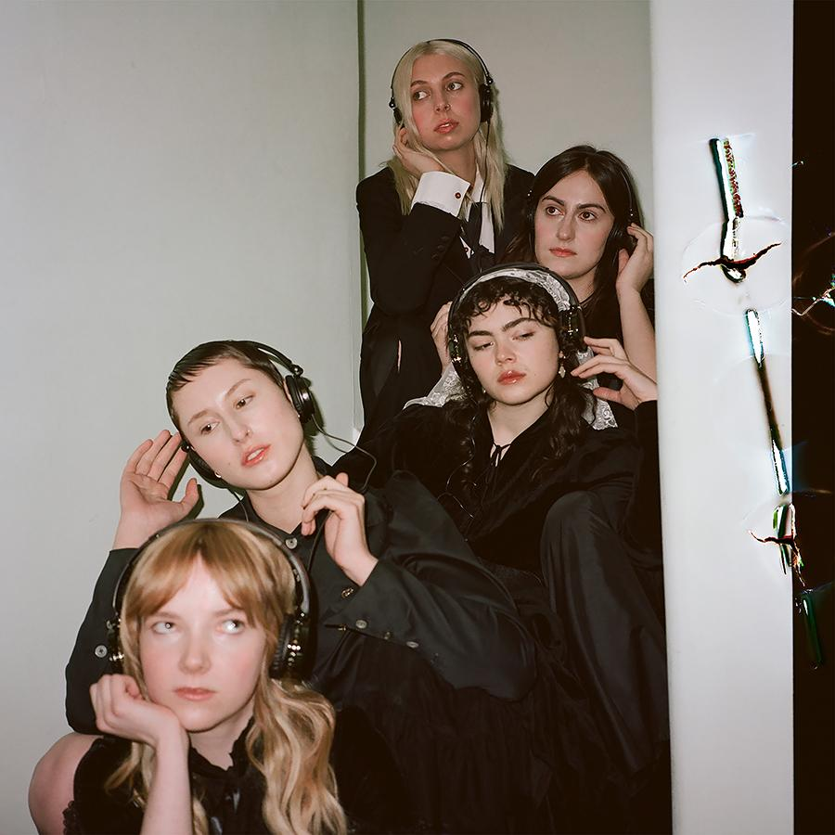

“London’s buzziest word-of-mouth new band” – DIY Magazine
“The buzziest unknown entity on the block” – Rolling Stone UK
“Your next favourite band” – DORK Magazine
“Something new and exciting and jubilant and celebratory” - BEAT
“Indie’s latest ‘if you know, you know’ breakout stars… Tune in now before the secret gets out” – NME

The Last Dinner Party are excited to unleash their debut single, Nothing Matters.

The track was produced by James Ford in London, and it follows months of excitement that stems from a series of much hyped live shows inside and outside of the capital. With record labels following them down the motorway, all baying for their signatures, and the band making a glorious mess of stages ahead of the likes of Nick Cave and The Rolling Stones, The Last Dinner Party have done it all without uploading a note of music online.
Until now. Nothing Matters is the sound of five young women making the music they wanted to hear and inspired by the live shows they hadn’t ever seen. It’s riveting, it’s charming, it’s exciting, and it’s really, really good.

Fronted by expressive, livewire vocalist Abigail Morris, The Last Dinner Party are a complete breath of fresh air. A band who mean every word they sing and every note they play, but really, they just want to have a lot of fun. And they want you to join them.

Nothing Matters is a brilliant introduction to a vital new band.

The Last Dinner Party are:
Abigail Morris (vocals), Georgia Davies (bass), Lizzie Mayland (guitar), Aurora Nishevci (keys), and Emily Roberts (lead guitar)

Live Dates:
Headline Shows
25th April – Camden Assembly, London SOLD OUT
12th May – The Bullingdon, Oxford
13th May – Find Joy, Bristol
27th May – Moles, Bath
20th July – Hare and Hounds, Birmingham
22nd July – Bodega, Nottingham
27th July – Headrow House, Leeds
28th July – Deaf Institute, Manchester
Festivals
11th May – The Great Escape, Brighton
26th-29th May – HowTheLightGetsIn, Hay-on-Wye
21st-23rd July – Latitude Festival, Southwold
21st-23rd July – Truck Festival, Oxfordshire
28th-30th July – Y Not Festival, Derbyshire
10th August – Boardmasters, Cornwall
17-20th August – Green Man Festival
25th August – Reading Festival
26th August – Leeds Festival

Supporting First Aid Kit

14th August – O2 Academy, Liverpool
15th August – O2 Academy, Liverpool
16th August – O2 Academy, Edinburgh

The Last Dinner Party: TWITTER / INSTAGRAM / YOUTUBE / WEBSITE

For more information please contact
Warren@chuffmedia.com on 07762 130 510

