Present

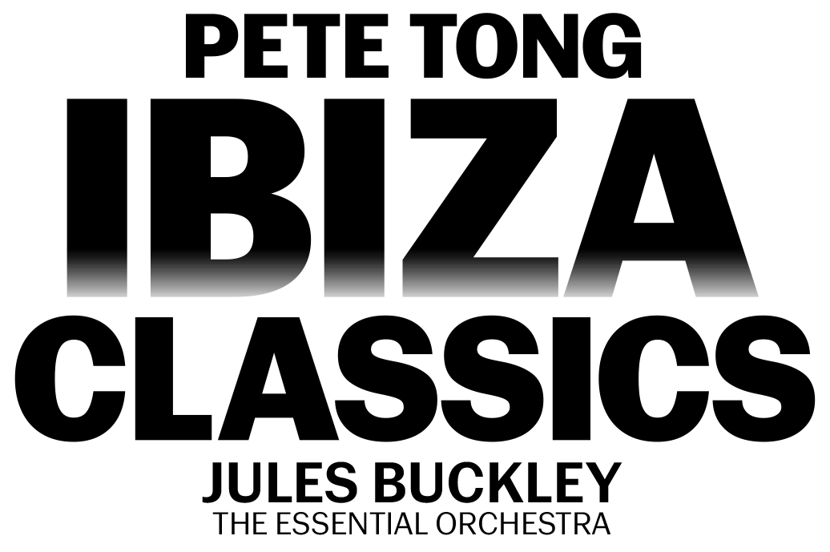

FRIDAY 26TH JULY 2024 – SANDOWN PARK RACECOURSE

Join in the conversation online #JCLive

Following a HUGE show in 2019, PETE TONG’S IBIZA CLASSICS will be returning to Sandown Park Racecourse with the Essential Orchestra and Jules Buckley on Friday 26th July.

A brand-new show for 2024, the evening will expertly collide the worlds of classical and club with stunningly reimagined versions of house tracks including “Rhythm Is A Dancer”, “Horny”, “Rhythm Of The Night” and “Feel The Love” alongside forever fan favourites in “Insomnia”, “Cafe Del Mar” and many, many more.

Expect a hedonistic night of fun and nostalgia - your favourite club tracks reimagined by the 65-piece Essential Orchestra conducted by Jules Buckley, coupled with incredible visual effects and the latest in music technology. An unrivalled highlight of the summer, get Friday 26th July in your diary for a night of unbarred joy.

As the voice of Radio 1’s prestigious dance programming, there are few individuals in the world of dance music who can claim the kind of influence Pete Tong has had over the last twenty years. With an unparalleled ear for new talent, Tong has become the leading tastemaker of the electronic generation. While he’s known publicly as Pete Tong the DJ, behind the scenes, he’s an industry icon.

Sarah Drabwell, General Manager, Sandown Park Racecourse, said
“We’re thrilled that Pete Tong Ibiza Classics will be returning to the racecourse in 2024. Their phenomenal show in 2019 was undoubtably a highlight, and we can’t wait to see what they have in store for us in July.”

Pete Tong said
“We’re delighted to be returning to Sandown Park Racecourse next year. We always have the best time on the green and can’t wait to share with you all what we’ve been working on for our 2024 summer show.”

The Jockey Club Live events are renowned for combining an electric evening at the races with a spectacular concert, in an informal and relaxed open-air setting. Returning for 2024, the concerts continue to welcome some of the nation’s biggest music talents to historic racecourses across the country, with recent headliners including Bastille, Anne-Marie, Olly Murs, Tom Jones and The Script. In addition to world-class live music, the events provide a selection of culinary delights for all, ranging from street food to the racecourses’ array of exceptional restaurants.

Tickets for PETE TONG’S IBIZA CLASSICS at Sandown Park Racecourse will be on sale at 10am on Friday 24th November via thejockeyclublive.co.uk, with a presale available to customers at 10am on Wednesday 22nd November.

Sign up to The Jockey Club Live’s mailing list to secure the best price by buying in advance during the presale window. Tickets are priced starting from £50.40 for presale, and from £56 general sale. There will be hospitality packages available to suit all budgets. Limited child tickets are available from £33.60.
The Jockey Club Live will be hosting live concerts after racing at racecourses across the country including Sandown Park, Market Rasen, Carlisle, Newmarket, Aintree and Haydock Park in 2024. Keep an eye out for future announcements…

FOR MORE INFORMATION AND ALL MEDIA ENQUIRIES FOR
THE JOCKEY CLUB LIVE PLEASE CONTACT

Jenny Entwistle at Chuff Media
jenny@chuffmedia.com

About The Jockey Club Live
The Jockey Club Live is an innovative event entertainment promoter specialising in combining live music and racing. Since its launch in 2014 the Jockey Club Live has promoted more than 120 concerts with a combined attendance of moe than 1 million and was revealed by Music Week as the UK’s 6th largest music promoter. The Jockey Club Live’s vision is to bring the biggest names in pop music to racing events across the country; giving consumers an exceptional experience of live music and racing.
thejockeyclublive.co.uk

About Sandown Park Racecourse
Founded in 1875, Sandown Park Racecourse has provided the backdrop to some of the greatest moments in horse racing history. A day at the races at Sandown Park has it all with top-level racing throughout the year including the bet365 Jump Finale, Coral-Eclipse Summer Festival and Betfair Tingle Creek Meeting, well as the popular Music Nights.

It is owned by The Jockey Club, the largest employer in British horseracing and one of the leading sports businesses operating in the UK today, with annual turnover in excess of £200 million. We run 15 of the UK’s racecourses – large and local – where we are charged with looking after some of the nation’s biggest events, including the Randox Grand National Festival at Aintree, The Cheltenham Festival, The Derby at Epsom Downs and the QIPCO Guineas Festival in Newmarket.

We welcome thousands of racehorses a year to our training centres in Newmarket, Lambourn and Epsom. We run The National Stud in Newmarket and our charity, Racing Welfare, makes help available to all of racing’s people. We are governed by Royal Charter to act for the long-term benefit of British Racing, which is Britain’s second-biggest spectator sport.

For more information, please visit thejockeyclub.co.uk.

