Present

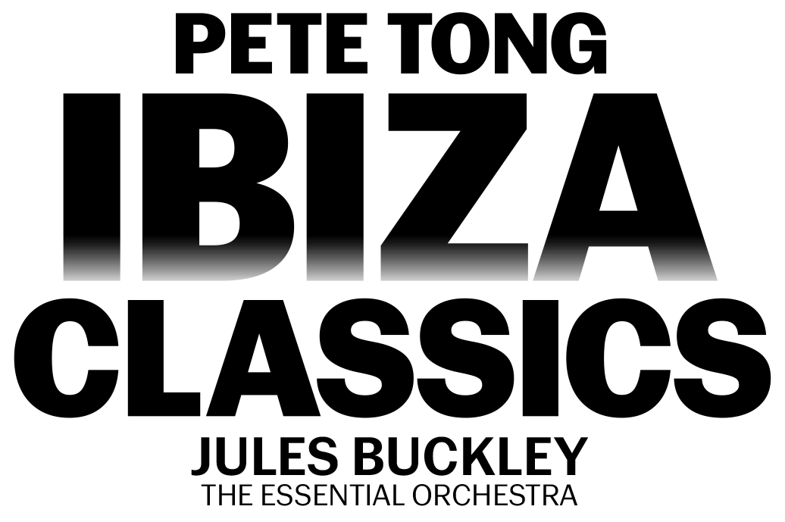

FRIDAY 21ST JUNE 2024 – NEWMARKET RACECOURSES

Join in the conversation online #JCLive

After a HUGE sold-out show in 2022, PETE TONG’S IBIZA CLASSICS will be returning to the July Course with the Essential Orchestra and Jules Buckley on Friday 21st June, opening the Newmarket Nights season.

A brand-new show for 2024, the evening will expertly collide the worlds of classical and club with stunningly reimagined versions of house tracks including “Rhythm Is A Dancer”, “Horny”, “Rhythm Of The Night” and “Feel The Love” alongside forever fan favourites in “Insomnia”, “Cafe Del Mar” and many, many more.

Expect a hedonistic night of fun and nostalgia - your favourite club tracks reimagined by the 65-piece Essential Orchestra conducted by Jules Buckley, coupled with incredible visual effects and the latest in music technology. An unrivalled highlight of the summer, get Friday 21st June in your diary for a night of unbarred joy.

As the voice of Radio 1’s prestigious dance programming, there are few individuals in the world of dance music who can claim the kind of influence Pete Tong has had over the last twenty years. With an unparalleled ear for new talent, Tong has become the leading tastemaker of the electronic generation. While he’s known publicly as Pete Tong the DJ, behind the scenes, he’s an industry icon.

Sophie Able, General Manager of Newmarket Racecourses, said
“Pete Tong’s Ibiza Classics has become a Newmarket favourite for a very good reason. The incomparable night combines the tracks we all know and love, reimagined by the incredible Essential Orchestra and Jules Buckley. Their show in 2022 was undoubtably a highlight for us, and we can’t wait to welcome them back in 2024 with a brand-new show.”

Pete Tong said
“We’re delighted to be returning to Newmarket Nights next year. We always have the best time on the green and can’t wait to share with you all what we’ve been working on for our 2024 summer show.”

Newmarket Nights continues to be the premier entertainment destination for the East. Renowned for combining an electric evening at the races with a spectacular evening concert in an informal and relaxed open-air setting, the award-winning series is set to return for 2024.

The concerts continue to bring some of the nation’s biggest music talents to the green, with recent headliners including Bastille, Anne-Marie, Olly Murs, Pete Tong and The Script. In addition to world-class live music, the events provide a selection of culinary delights for all, ranging from street food to Newmarket’s array of exceptional restaurants.

Tickets for PETE TONG’S IBIZA CLASSICS at Newmarket Racecourses will be on sale at 10am on Friday 24th November via thejockeyclublive.co.uk, with a presale available to customers at 10am on Wednesday 22nd November.

Sign up to The Jockey Club Live’s mailing list to secure the best price by buying in advance during the presale window. Tickets are priced starting from £33.60 for presale, and from £39.20 general sale. There will be hospitality packages available to suit all budgets. Tickets for JLS (Friday 28th June), BUSTED (Friday 19th July) and BECKY HILL (Friday 9th August) are on sale now.
The Jockey Club Live will be hosting live concerts after racing at racecourses across the country including Sandown Park, Carlisle, Market Rasen, Newmarket, Aintree and Haydock Park in 2024. Keep an eye out for future announcements…

FOR MORE INFORMATION AND ALL MEDIA ENQUIRIES FOR
THE JOCKEY CLUB LIVE PLEASE CONTACT

Jenny Entwistle at Chuff Media
jenny@chuffmedia.com

About The Jockey Club Live
The Jockey Club Live is an innovative event entertainment promoter specialising in combining live music and racing. Since its launch in 2014 the Jockey Club Live has promoted more than 120 concerts with a combined attendance of moe than 1 million and was revealed by Music Week as the UK’s 6th largest music promoter. The Jockey Club Live’s vision is to bring the biggest names in pop music to racing events across the country; giving consumers an exceptional experience of live music and racing.
thejockeyclublive.co.uk

About Newmarket Racecourses
Newmarket’s two magical racecourses, the Rowley Mile and the July Course, together form the greatest venue in the East of England. Hosting exhilarating world class Flat racing, pulsating music nights, great value family days, award-winning restaurants and exceptional conferences, in 2016 Newmarket Racecourses proudly celebrated 350 years of extraordinary royal patronage.

Newmarket Racecourses are part of The Jockey Club which stages thrilling sporting occasions including the Randox Grand National, The Cheltenham Festival and The Cazoo Derby. Millions of people every year enjoy the special experiences on offer through racing, music, food and entertainment. Governed by Royal Charter, every penny made goes back into British Racing to help the sport thrive. The Jockey Club was founded in 1750 and today is the largest commercial group in Britain’s second-biggest spectator sport (2018 turnover: £214.6 million), operating 15 racecourses nationwide, The National Stud, Jockey Club Estates, Jockey Club Catering, Jockey Club Live and the charity, Racing Welfare. For more information visit thejockeyclub.co.uk.

