Present

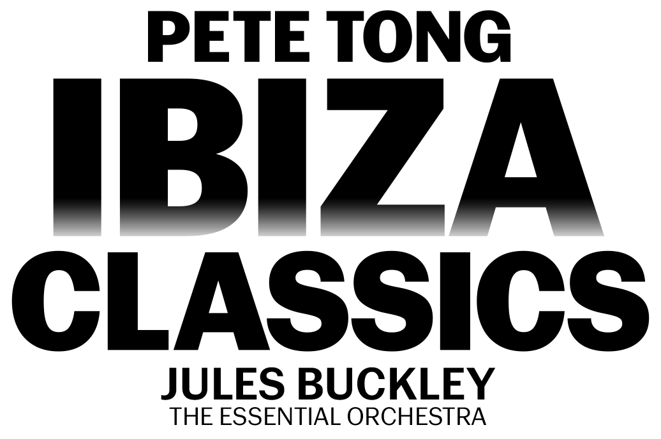

SATURDAY 22ND JUNE 2024 – HAYDOCK PARK RACECOURSE

Join in the conversation online #JCLive

Following the reveal that chart toppers BUSTED will be making their debut at the Merseyside course on Saturday 20th July, The Jockey Club Live and Haydock Park Racecourse is delighted to reveal another first-time headliner. The acclaimed live show from PETE TONG’S IBIZA CLASSICS will be opening the season on Saturday 22nd June.

A brand-new show for 2024, the evening will expertly collide the worlds of classical and club with stunningly reimagined versions of house tracks including “Rhythm Is A Dancer”, “Horny”, “Rhythm Of The Night” and “Feel The Love” alongside forever fan favourites in “Insomnia”, “Cafe Del Mar” and many, many more.

Expect a hedonistic night of fun and nostalgia - your favourite club tracks reimagined by the 65-piece Essential Orchestra conducted by Jules Buckley, coupled with incredible visual effects and the latest in music technology. An unrivalled highlight of the summer, get Saturday 22nd June in your diary for a night of unbarred joy.

As the voice of Radio 1’s prestigious dance programming, there are few individuals in the world of dance music who can claim the kind of influence Pete Tong has had over the last twenty years. With an unparalleled ear for new talent, Tong has become the leading tastemaker of the electronic generation. While he’s known publicly as Pete Tong the DJ, behind the scenes, he’s an industry icon.

Molly Dingwall, General Manager, Haydock Park Racecourse said
“We’re thrilled to be welcoming Pete Tong’s Ibiza Classics to the racecourse for the very first time. Following a sold-out show at Aintree Racecourse last year, we can’t wait to see their brand-new show for 2024 here at Haydock Park!”

Pete Tong said
“We’re delighted to be headlining Haydock Park Racecourse for the first-time next year. We always have the best time in Merseyside and can’t wait to share with you all what we’ve been working on for our 2024 summer show.”

The Jockey Club Live events are renowned for combining an electric evening at the races with a spectacular concert, in an informal and relaxed open-air setting. Returning for 2024, the concerts continue to welcome some of the nation’s biggest music talents to historic racecourses across the country, with recent headliners including Bastille, Anne-Marie, Olly Murs, Tom Jones and The Script. In addition to world-class live music, the events provide a selection of culinary delights for all, ranging from street food to the racecourses’ array of exceptional restaurants.

Tickets for PETE TONG’S IBIZA CLASSICS at Haydock Park Racecourse will be on sale at 10am on Friday 24th November via thejockeyclublive.co.uk, with a presale available to customers at 10am on Wednesday 22nd November.

Sign up to The Jockey Club Live’s mailing list to secure the best price by buying in advance during the presale window. Tickets are priced starting from £39.20 for presale, and from £44.80 general sale. There will be hospitality packages available to suit all budgets. Limited child tickets are available from £16.80. Tickets for BUSTED (Saturday 20th July) are on sale now.
The Jockey Club Live will be hosting live concerts after racing at racecourses across the country including Sandown Park, Market Rasen, Carlisle, Newmarket, Aintree and Haydock Park in 2024. Keep an eye out for future announcements…

FOR MORE INFORMATION AND ALL MEDIA ENQUIRIES FOR
THE JOCKEY CLUB LIVE PLEASE CONTACT

Jenny Entwistle at Chuff Media
jenny@chuffmedia.com

About The Jockey Club Live
The Jockey Club Live is an innovative event entertainment promoter specialising in combining live music and racing. Since its launch in 2014 the Jockey Club Live has promoted more than 120 concerts with a combined attendance of more than 1 million and was revealed by Music Week as the UK’s 6th largest music promoter. The Jockey Club Live’s vision is to bring the biggest names in pop music to racing events across the country; giving consumers an exceptional experience of live music and racing.
thejockeyclublive.co.uk

About Haydock Park Racecourses
Haydock Park is a dual-purpose racecourse, staging 32 racedays on the Flat and over Jumps in 2020, and a leading conference centre in the north west of England. More information is available at haydock.thejockeyclub.co.uk

Haydock Park is part of The Jockey Club which stages thrilling sporting occasions including The Randox Grand National, The Cheltenham Festival and The Cazoo Derby at Epsom Downs.

Millions of people every year enjoy the special experiences The Jockey Club offers through racing, music, food and entertainment. Governed by Royal Charter, every penny made goes back into British Racing to help the sport thrive.

The Jockey Club was founded in 1750 and today is the largest commercial group in Britain's second-biggest spectator sport, operating 15 racecourses nationwide, The National Stud, Jockey Club Estates, Jockey Club Catering, Jockey Club Live and the charity, Racing Welfare. For more information, visit thejockeyclub.co.uk

