Present

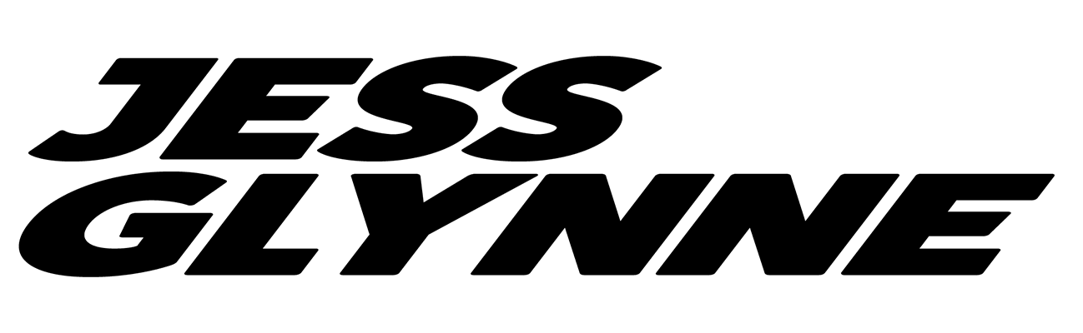

FRIDAY 6TH AUGUST 2021
NEWMARKET RACECOURSES

2021 NEWMARKET LINE UP COMPLETE
Join in the conversation online #JCLive21

The Jockey Club Live are delighted to reveal that Jess Glynne will be returning to Newmarket Nights on Friday 6th August. With the addition of Jess to the bill, the line-up for live open-air concerts after racing at Newmarket Racecourses this Summer is now complete.

Sophie Able, General Manager, Newmarket said:
“We have been working tirelessly behind-the-scenes since the announcement of the Government’s roadmap to secure a fantastic summer of live music. We can’t wait to welcome music fans back to Newmarket for incredible racing, plus the joy that live music brings - something we’ve all missed over the past year.

With the addition of Jess Glynne, our season features beloved household names to chart-topping talent, making sure there is an evening for all and continuing Newmarket Night’s legacy as an unmissable event in the summer calendar.”

When you look at the statistics that have marked Jess Glynne’s sky-rocketing career so far, there is probably a look of mild disbelief on your face…. Her debut album I Cry When I Laugh is one of the defining British pop records of its era. It debuted at number one, spawning 12 million worldwide singles sales, 39 weeks on the UK top 10, 2.5 billion Spotify streams, a sold out UK arena tour, Brit, MTV: EMA, Ivor Novello, MOBO, Q and Glamour award nominations. She is the only British female ever to achieve seven #1 UK singles, and is fast-becoming the ultimate modern British popstar – effortlessly brokering the hinterlands between pop, soul, R&B and house music.

Jess Glynne said:
“I had a wicked time headlining Newmarket Nights in 2017, looking forward to coming back. August will be all the more special after the last year we have all had!”

The Jockey Club Live are leading promoters on the UK live scene, delivering spectacular line-ups of some of the hottest chart talent and legendary household names to some of the world’s most famous racecourses. Summer Saturday Live and Newmarket Nights are a staple in the region’s social calendar and each year host tens of thousands of fans of live music. Past headliners have included Kylie, George Ezra and Little Mix.

The events are renowned for combining a fun filled evening at the races with a spectacular evening concert in the informal and relaxed open-air setting of the hallowed turf. Newmarket Nights won the ‘Best Event for Groups’ at the prestigious 2018 Group Leisure & Travel Awards.

The Jockey Club racecourses have world-class customer facilities, featuring an array of award-winning restaurants that cater for all tastes, from fine dining through to delicious bistro food. The Jockey Club’s racecourses welcome over 2million people a year for some of the UK’s biggest racing events so you can be sure a fantastic evening.

Tickets will be on sale at 10am on Friday 21st May via thejockeyclub.com/live, with a presale available to customers at 10am on Wednesday 19th May. Tickets start at £32.48 (inclusive of 12% booking fee). Book with confidence! The Jockey Club Live offer a money back guarantee if cancelled.

In addition to Newmarket, The Jockey Club Live will be hosting live concerts at Sandown Park and Haydock Park this summer, returning to Aintree, Market Rasen and Carlisle Racecourses in 2022.

2021
17th July - Olly Murs - Haydock Park Racecourse
23rd July - Tom Jones - Newmarket Racecourses
30th July - Olly Murs - Newmarket Racecourses
5th August - Craig David - Sandown Park Racecourse
6th August – Jess Glynne – Newmarket Racecourses
13th August - Rick Astley - Newmarket Racecourses
28th August - Tom Jones - Haydock Park Racecourse*
28th August - McFly - Newmarket Racecourses^

2022
10th June - Nile Rodgers & CHIC - Aintree Racecourse
15th July - The Script - Newmarket Racecourses
27th July - Nile Rodgers & CHIC - Sandown Park Racecourse
12th August - Pete Tong & The Heritage Orchestra - Newmarket Racecourses

* Tom Jones at Haydock Park is a standalone concert and does not feature racing prior.
^ McFly headline Summer Saturday Live at Newmarket Racecourses, a day time family event.

Tickets for all shows are available now at thejockeyclub.com/live

For all media information, including previews, interviews, reviews etc for
The Jockey Club Live, contact Warren or Jenny at Chuff Media – tel. 020 8281 0989 name@chuffmedia.com

About The Jockey Club Live
The Jockey Club Live is an innovative event entertainment promoter specialising in combining live music and racing. Since it’s launch in 2014 the Jockey Club Live has promoted over 120 concerts with a combined attendance of over 1 million and was revealed by Music Week as the UK’s 6th largest music promoter. The Jockey Club Live’s vision is to bring the biggest names in pop music to racing events across the country; giving consumers an exceptional experience of live music and racing.

About Newmarket Racecourses
Newmarket’s two magical racecourses, the Rowley Mile and the July Course, together form the greatest venue in the East of England. Hosting exhilarating world class Flat racing, pulsating music nights, great value family days, award-winning restaurants and exceptional conferences, in 2016 Newmarket Racecourses proudly celebrated 350 years of extraordinary royal patronage.

Newmarket Racecourses are part of The Jockey Club which stages thrilling sporting occasions including the Randox Health Grand National, The Cheltenham Festival and The Investec Derby. Millions of people every year enjoy the special experiences on offer through racing, music, food and entertainment. Governed by Royal Charter, every penny made goes back into British Racing to help the sport thrive. The Jockey Club was founded in 1750 and today is the largest commercial group in Britain’s second-biggest spectator sport (2018 turnover: £214.6 million), operating 15 racecourses nationwide, The National Stud, Jockey Club Estates, Jockey Club Catering, Jockey Club Live and the charity, Racing Welfare. For more information visit www.thejockeyclub.co.uk.

