EMBARGO
10AM FRIDAY 27TH OCTOBER
Present
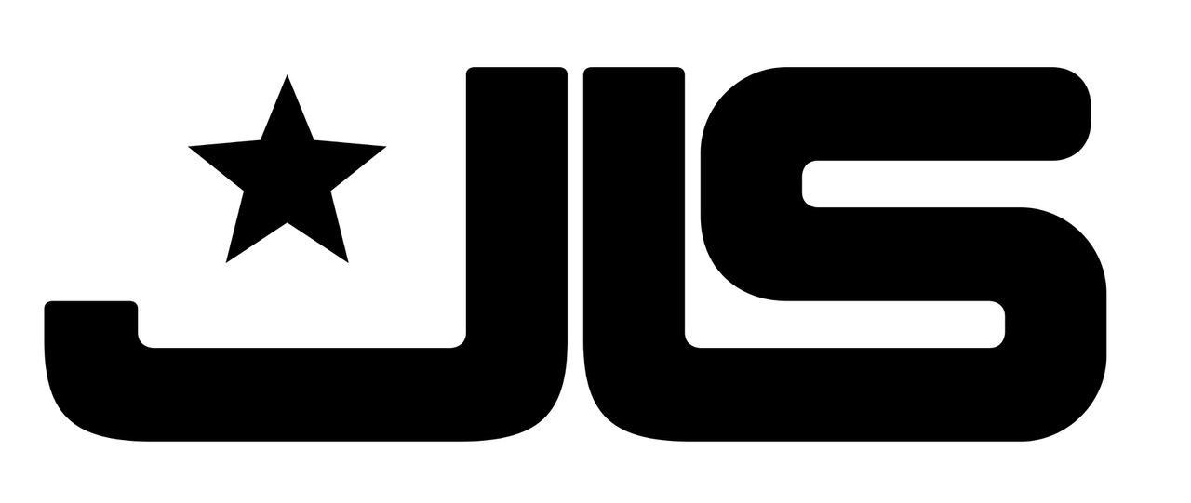

FRIDAY 28TH JUNE 2024 – NEWMARKET RACECOURSES

Join in the conversation online #JCLive24

Following the reveal of Busted’s addition to the Newmarket Nights 2024 season, The Jockey Club Live and Newmarket Racecourses are delighted to unveil the next thrilling headline concert. Currently on a huge arena tour, JLS will bring their ‘Summer Hits’ tour to the green on Friday 28th June.

JLS broke through in 2009 in the biggest way imaginable as the instant pop classic ‘Beat Again’ shot straight to #1 - their first of five UK chart-topping smashes which continued with ‘Everybody In Love’, ‘The Club Is Alive’, ‘Love You More’ and ‘She Makes Me Wanna’. With another five Top 10 hits to their credit, JLS also impacted the album charts with their self-titled #1 debut and three more Top 3 records before saying goodbye with their 2013 ‘Greatest Hits’ album. Throughout, they were heralded with numerous major awards, notably two BRIT Awards and five MOBO Awards.

But thankfully not all goodbyes are forever. While each member continued their own successful careers outside of JLS, they remained best of friends and shared a nagging feeling that they had unfinished business to address. Their ‘Beat Again’ reunion tour saw the band sell-out arenas across the country, with their second tour in three years ‘The Hits’ continuing to delight fans with a duo of shows at London’s The O2. Now the JLS heart will beat yet again as the band headline Newmarket Racecourses on Friday 28th June.

Sophie Able, General Manager of Newmarket Racecourses, said
“This week we’ve revealed two massive shows for 2024 – Busted who will be headlining on Friday 19th July and now the incomparable JLS, who will headline on Friday 28th June. 2024 is set to be a huge year for Newmarket Nights and we can’t wait to share the rest of the line-up with you all soon. We have plenty more exciting announcement to come…!”

JLS said
“We’ve heard amazing things about Newmarket Nights and are so honoured to join the 2024 line-up! Over the past few years, it’s been a nostalgic rollercoaster reliving our greatest hits with our fans and we can’t wait to continue with you all next year.”

Newmarket Nights continues to be the premier entertainment destination for the East. Renowned for combining an electric evening at the races with a spectacular evening concert in an informal and relaxed open-air setting, the award-winning series is set to return for 2024.

The concerts continue to bring some of the nation’s biggest music talents to the green, with recent headliners including Bastille, Anne-Marie, Olly Murs, Pete Tong and The Script. In addition to world-class live music, the events provide a selection of culinary delights for all, ranging from street food to Newmarket’s array of exceptional restaurants.

Tickets for JLS at Newmarket Racecourses will be on sale at 10am on Friday 3rd November via thejockeyclublive.co.uk, with a presale available to customers at 10am on Wednesday 1st November

Sign up to The Jockey Club Live’s mailing list to secure the best price by buying in advance during the presale window. Tickets are priced starting from £30.24 for presale, and from £35.84 general sale. There will be hospitality packages available to suit all budgets. Tickets for BUSTED (Friday 19th July) are on sale now.
The Jockey Club Live will be hosting live concerts after racing at racecourses across the country including Sandown Park, Carlisle, Market Rasen, Newmarket, Aintree and Haydock Park in 2024. Keep an eye out for future announcements…

FOR MORE INFORMATION AND ALL MEDIA ENQUIRIES FOR
THE JOCKEY CLUB LIVE PLEASE CONTACT

Jenny Entwistle at Chuff Media
jenny@chuffmedia.com

About The Jockey Club Live
The Jockey Club Live is an innovative event entertainment promoter specialising in combining live music and racing. Since its launch in 2014 the Jockey Club Live has promoted more than 120 concerts with a combined attendance of moe than 1 million and was revealed by Music Week as the UK’s 6th largest music promoter. The Jockey Club Live’s vision is to bring the biggest names in pop music to racing events across the country; giving consumers an exceptional experience of live music and racing.
thejockeyclublive.co.uk

About Newmarket Racecourses
Newmarket’s two magical racecourses, the Rowley Mile and the July Course, together form the greatest venue in the East of England. Hosting exhilarating world class Flat racing, pulsating music nights, great value family days, award-winning restaurants and exceptional conferences, in 2016 Newmarket Racecourses proudly celebrated 350 years of extraordinary royal patronage.

Newmarket Racecourses are part of The Jockey Club which stages thrilling sporting occasions including the Randox Grand National, The Cheltenham Festival and The Cazoo Derby. Millions of people every year enjoy the special experiences on offer through racing, music, food and entertainment. Governed by Royal Charter, every penny made goes back into British Racing to help the sport thrive. The Jockey Club was founded in 1750 and today is the largest commercial group in Britain’s second-biggest spectator sport (2018 turnover: £214.6 million), operating 15 racecourses nationwide, The National Stud, Jockey Club Estates, Jockey Club Catering, Jockey Club Live and the charity, Racing Welfare. For more information visit thejockeyclub.co.uk.

