THE ITCH

SHARE NEW SINGLE
‘NO MORE SPRECHGESANG’

DEBUT ALBUM IT’S THE HOPE THAT KILLS YOU
ARRIVES FRIDAY [10TH APRIL] VIA FICTION RECORDS / I OH YOU

UK/EU HEADLINE TOUR MAY 2026

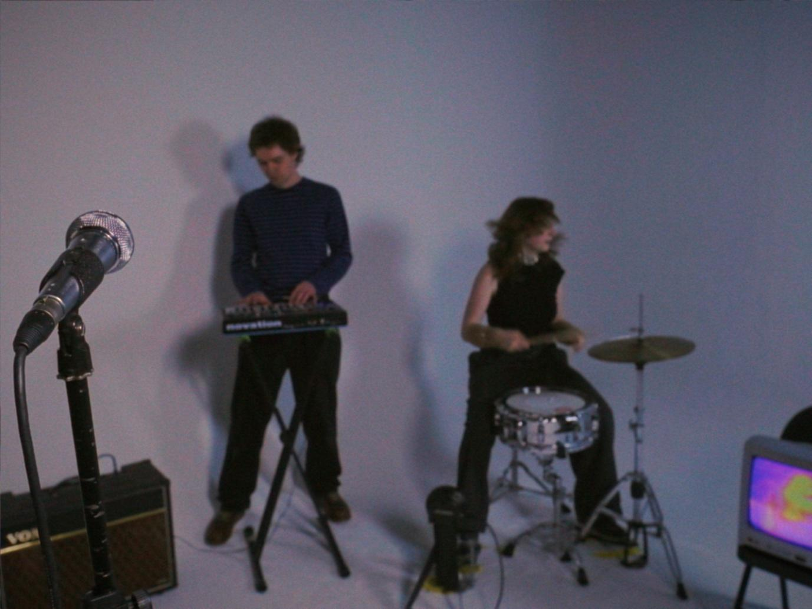
‘No More Sprechgesang’ video still [alternative imagery here]

The Itch share their new single ‘No More Sprechgesang’ ahead of debut album It’s The Hope That Kills You arriving this Friday [10th April] via Fiction/I OH YOU.

A crowd favourite, ‘No More Sprechgesang’ is one of the first tracks that The Itch made together and has long been a cornerstone of the duo’s live show.

Frontman Simon Tyrie:
“I wrote the words 'no more sprechgesang' a few years ago in a notebook at a really bad gig, being deadly serious, along with a long list of other things I wanted to see the back of. But when I rediscovered the line in my notebook I just found it really funny and stupid. Now when I sing 'no more sprechgesang' it feels less like a call to arms and more like a melancholic ode to the scene we once belonged to, which at the time of writing I wanted to burn down. Journalists and musos alike love it because it makes them feel seen and everyone else likes it because it's stupid and fun and has a lot of cowbell. Everyone's a winner.”

Watch ‘No More Sprechgesang’ video here

Over the course of a debut album which finds harmony in juxtaposition, Simon & Georgia pool a hundred different touchstones to create something entirely singular. It’s The Hope That Kills You is crisp yet dishevelled. Introspective yet exuberant. And delivered with candid conviction while wry sarcasm consistently looms moments away.

Remixes for each of ITHTKY’s singles will see The Itch teaming up with The Twins, 1-800 GIRLS and Tom Sharkett.

Since first arriving in 2024 with a single headline performance, The Itch re-emerged in the summer of 2025 - now armed with a record deal and embryonic versions of the tracks which would go on to become It's The Hope That Kills You - Simon & Georgia played a sweaty midnight set at The Great Escape which saw an hour-long queue jostling for entry and has since gained cult-like status in its own right.

The duo have since made a habit of selling tickets to their underground basement parties via SMS, with their most recent sellout show – a headline and album announce party – in the iconic basement of Swiss restaurant St Moritz in Soho. The venue, which has seen everyone from Lou Reed to Metallica pass through its doors, has been under the same ownership since 1961 and still has the 1960s Soho licence that allows it to stay open every night until 3am. It’s no surprise then that The Itch wanted to bring it back as a party spot.
It’s The Hope That Kills You will be released in a collaborative record deal between Fiction Records [The Cure, Kae Tempest] and I OH YOU [Confidence Man, Rolling Blackouts Coastal Fever]. Vocoder-topped europop gem ‘Space in the Cab’ and The Itch’s metamorphic, 7-minute long debut single ‘Ursula’ feature in the albums tracklist alongside ‘Drugdealer’.

Pairing undulating dancefloor fillers with disenchanted pop songwriting, Simon & Georgia have captured a moment in time to conjure a debut offering which is both a product of and an antidote to an age of pessimism.

May’s headline dates include stops in Leeds, Glasgow, Manchester, Amsterdam, Paris and London, where The Itch will play at Brixton’s Club Cheek.

Pre-order It’s The Hope That Kills You Here

Live Dates

9 Apr - Rough Trade (Bristol) instore
10 Apr - Rough Trade (Denmark St, London) instore
11 Apr - Ram Jam (Kingston) outstore w/ Banquet Records
12 Apr - Resident (Brighton) instore
17 Apr - The Castle (Luton)
8 May - Headrow House (Leeds)
9 May - The Hug and Pint (Glasgow)
13-16 May - Great Escape Festival (Brighton)
20 May - Club Cheek (London)
22 May – Venue TBA (Manchester)
23 May - Dot to Dot Festival (Bristol)
24 May - Dot to Dot Festival (Nottingham)
20-23 Aug - Green Man Festival, Wales

The Itch - It’s The Hope That Kills You

Space In The Cab
No More Sprechgesang!
Can’t Afford This
Pirate Studios
Drugdealer
Radio Frequencies
It’s The Hope That Kills You
Aux Romanticiser
Ursula
Never Change
Switch It Off

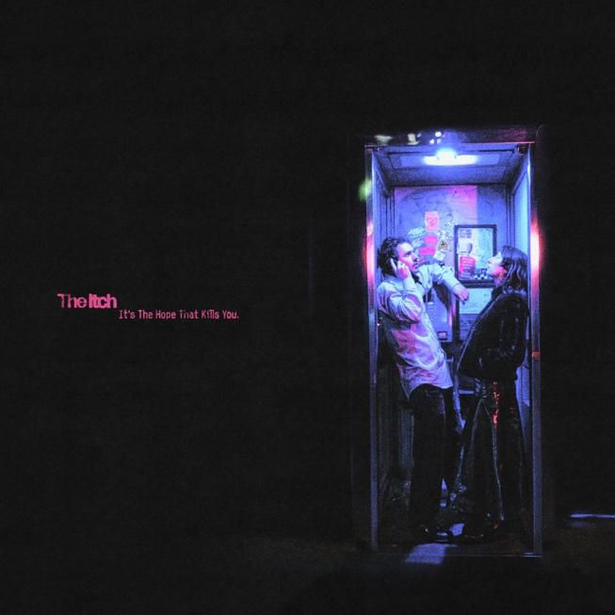

DISCOVER THE ITCH
Website | Instagram | YouTube | Spotify

For more info contact Warren Higgins
warren@chuffmedia.com

