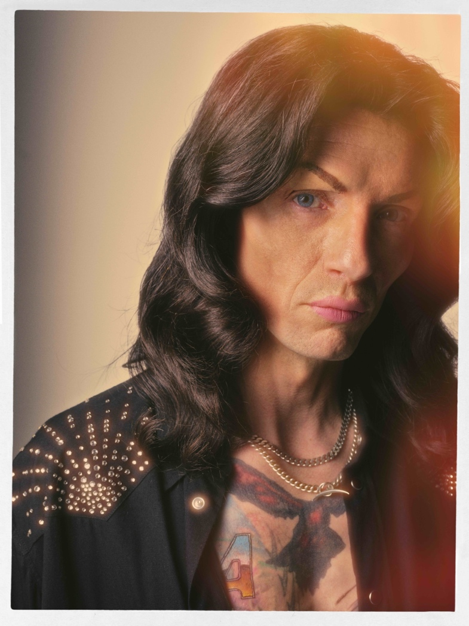

Photo Credit: Simon Emmett – [download here](https://drive.google.com/drive/folders/1xezrX6i5zSnlY1Cqn1aGh5YdSUM0MyZ8?usp=sharing)

**‘I HATE MYSELF’**

**VIDEO RELEASED**

[**WATCH HERE**](https://youtu.be/T4ZugUa-6l0)

***DREAMS ON TOAST***

**NEW ALBUM OUT MARCH 28th 2025**

**VIA COOKING VINYL**

[PRE-ORDER HERE](https://thedarkness.lnk.to/dreamsontoastPR)

**TOURING UK IN MARCH 2025**

**WITH SUPPORT FROM ASH**

[TICKETS ON SALE NOW HERE](https://www.thedarknesslive.com/)

The Darkness have released the video for their new single ‘I Hate Myself’, the latest song to be taken from their forthcoming eighth studio album *Dreams On Toast* which isout on March 28th via Cooking Vinyl. Pre-order the album now [here](https://thedarkness.lnk.to/dreamsontoastPR).

Directed by Simon Emmett, the ‘I Hate Myself’ video has been captured in one take, unedited, and portrays frontman Justin Hawkins as he has never been seen before. Playing with gender roles, and channelling the spirit of a world-weary, chain-smoking diva with immaculate makeup and long flowing hair, the singer is in self-reflective mode as he chronicles the breakdown of a relationship, while pointing the finger squarely at himself.

Regarding the video Justin says, *"I love working with Simon Emmett. Everything we have collaborated on has turned out great so far. This is no exception. The concept is related to the self-loathing that the song itself lyrically explores. And I feel like the visual accompaniment has taken this song to the next level, and it was already my favourite Darkness song ever. I can't wait for everybody to see it - it means a lot to me… and I'm here for the conversation. I love you all. I just hate myself."*

The video the self-deprecating glam punk rock song premiered last night on Justin’s widely popular *Justin Hawkins Rides Again* YouTube channel, where he was joined in the first-look viewing party by his brother and guitarist Dan Hawkins.

Today The Darkness also reveal the track listing for the upcoming album *Dreams On Toast,* a 10 song magnum opus destined to continue to cement the four piece, completed by bassist Frankie Poullain and drummer Rufus ‘Tiger’ Taylor, as one of Britain’s most important rock bands. Continuing to push boundaries over two decades deep into their multi-platinum, award-winning career, offering up unexpected surprises to bedazzle and amaze fans with this new record in 2025.

Produced by Dan Hawkins, *Dreams On Toast* flawlessly captures The Darkness in their finest form, celebrating their influences, strengthening their sound, while also embarking on avenues never heard from the band before in a grand display from a passionate, hungry and inspired collective.

From the likes of the jaunty ‘70s pop genius of lead single ‘The Longest Kiss’, searing hard rock of ‘Rock And Roll Party Cowboy’, heartfelt ‘60s pop balladry of ‘Hot On My Tail’, huge swaggering anthems such as ‘Mortal Dread’ and ‘Walking Through Fire’, while even creating a country classic with ‘Cold Hearted Woman’, *Dreams On Toast* brings all of the wildest fantasies of The Darkness to life.

***DREAMS ON TOAST* TRACK LISITING**

1. Rock And Roll Party Cowboy
2. I Hate Myself
3. Hot On My Tail
4. Mortal Dread
5. Don’t Need Sunshine
6. The Longest Kiss
7. The Battle For Gadget Land
8. Cold Hearted Woman
9. Walking Through Fire
10. Weekend In Rome

*Dreams On Toast* album artwork designed by Grammy nominated artist [Perry Shall](https://www.perryshall.com/)

The Darkness closed 2024 with a special treat for fans at a series of six intimate Rough Trade in stores across the UK where they performed songs from *Dreams On Toast* live for the very first time. The band will now hit the road in 2025 on a much larger scale and the *Dreams On Toast*UK headline tour will see them play 18 shows across the country finishing at London’s OVO Wembley Arena on March 29th.

Support comes from Northern Irish indie-rock heroes Ash, who first supported The Darkness on their legendary ‘Permission To Land Tour’ over 20 years ago. Tickets are on sale now via [https://www.thedarknesslive.com/](https://wilfulpublicity.us9.list-manage.com/track/click?u=4ed22b50518a2d4aaa7dcb375&id=bee927c92f&e=77f4d10718)

**THE DARKNESS 2025 HEADLINE TOUR DATES**

06/03 - Ipswich, Regent’s Theatre (SOLD OUT)

07/03 - Ipswich, Regent’s Theatre (SOLD OUT)

08/03 - Oxford, New Theatre (SOLD OUT)

09/03 - Swansea, Arena

11/03 - Guildford, G Live (SOLD OUT)

12/03 - Hull, Connexin Arena

14/03 - Liverpool, Guild Of Students (SOLD OUT)

15/03 - Wolverhampton, Civic Hall

17/03 - York, Barbican (SOLD OUT)

18/03 - Edinburgh, Usher Hall

20/03 - Glasgow, Royal Concert Hall

21/03 - Newcastle, O2 City Hall (SOLD OUT)

22/03 - Manchester, O2 Apollo (SOLD OUT)

24/03 - Bristol, Beacon Theatre (SOLD OUT)

25/03 - Portsmouth, Guildhall (SOLD OUT)

27/03 - Leicester, De Montford Hall (SOLD OUT

28/03 - Cambridge, Corn Exchange (SOLD OUT)

29/03 - London, OVO Arena Wembley

**For all media enquiries please contact** [**warren@chuffmedia.com**](mailto:warren@chuffmedia.com)