**The Dare Announces UK and EU Tour**

**(**TICKETS [HERE](https://linktr.ee/itsthedare?utm_source=linktree_profile_share&ltsid=2a971e6f-59f6-43f9-9997-9b95d379d37c)**)**

**Debut album *What’s Wrong With New York?***

***OUT NOW***

([LISTEN](https://thedare.lnk.to/wwwny.uk))

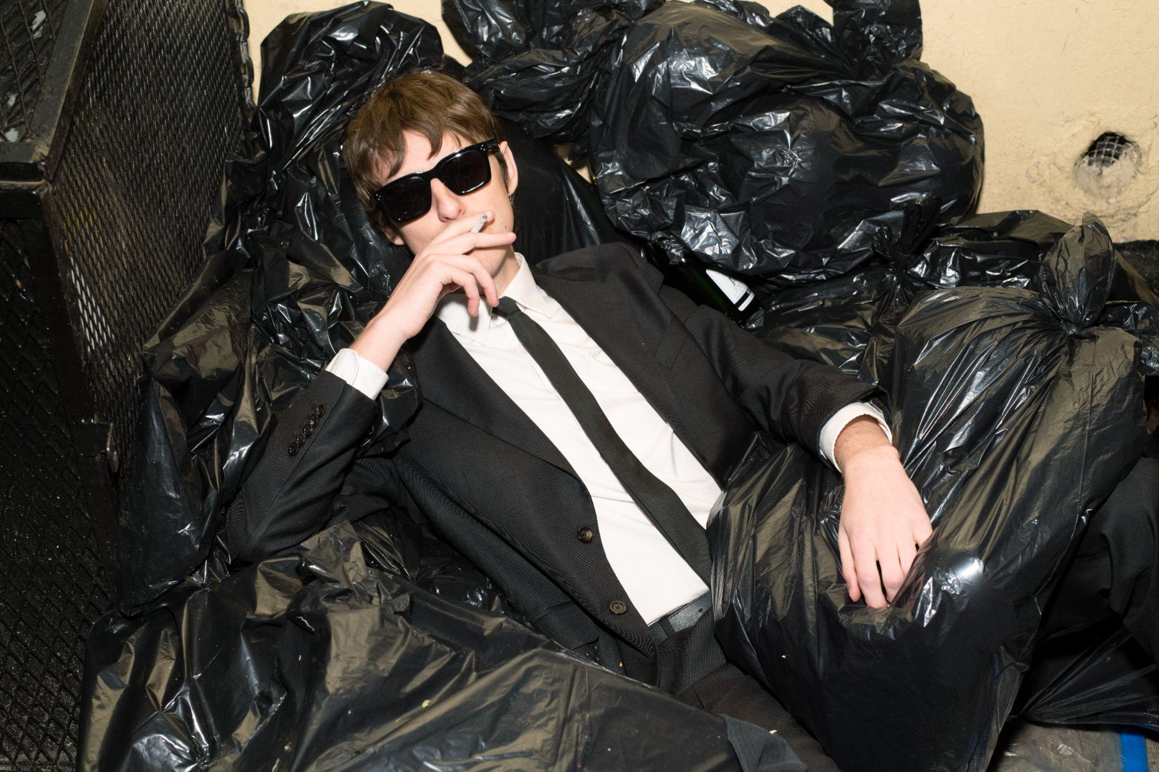

*(Press photo, credit Richard Kern)*

*“If there was ever a Dionysus for the music industry, then The Dare is it. Inspiring carnage, frenzy and a little bit of debauchery, with his debut album ‘What’s Wrong With New York?’ he injects some much-needed ecstasy and pleasure into the world.”* **5/5 DORK**

*“A hedonistic pop bible. Coming at the end of BRAT summer, The Dare’s debut intercepts the baton perfectly…ingeniously timed for an audience hungry for stylish and nostalgic catharsis.” -* **4.5/5 DIY**

“Tastefully rambunctious, ‘What’s Wrong With New York?’ is a sonic melting pot of millennial and Gen Z sounds. Don’t throw out the cigarettes just yet. ‘brat summer’ may be over, but I have a feeling that we’re in for a *Dare-*ingautum” **8/10 CLASH**

“A superstar in the making” - **THE GUARDIAN**

The Dare today announces details of his upcoming UK and Europe tour, in celebration of his debut album ***What’s Wrong With New York?***, released via Polydor/Republic Records on September 6th. Fresh from kicking off his first-ever North American headline tour with a sold-out show at New York’s Webster Hall, Harrison Patrick Smith will be bringing his vivacious live show to crowds across the UK and Europe from November this year. The UK run of the tour will include headline shows in London (Heaven), Brighton (The Arch) and Leeds (Belgrave Music Hall). Tickets will be on general sale from September 20th, ticket presale **here.**

***What’s Wrong With New York?*,** recorded over the last year between The Dare’s home and studio in New York, features The Dare’s ubiquitous first single ‘[Girls](https://www.youtube.com/watch?v=utvDi43sXvI)’ - now a bona fide hit with million streams to date - as well as the previously shared ‘[You’re Invited](https://thedare.lnk.to/youreinvited/youtube),’ ‘[Perfume](https://www.youtube.com/watch?v=oWiB8eVLS9o)’ and ‘[Good Time](https://www.youtube.com/watch?v=X8conJjSzZA).’ The album includes further collaborations with Dylan Brady (100 gecs), Emile Haynie (Lana Del Rey, FKA twigs, Dua Lipa), Romil Hemnani (Brockhampton), Chris Greatti (Yves Tumor, Yeule), Isaac Eiger (Strange Ranger) and more.

The album comes on the heels of a whirlwind few weeks for The Dare, who earned his first U.K. #1 alongside **Charli xcx** and **Billie Eilish** with their track ‘[**Guess**](https://www.youtube.com/watch?v=huGd4efgdPA),’ which he produced for the deluxe edition of *Brat*. He’s spent the summer opening for Charli at a slew of shows, most recently at her Boiler Room in Ibiza, as well as at her first-ever *Brat* live performances in New York and Los Angeles.

The Dare is the solo project of vocalist, songwriter and producer Harrison Patrick Smith. Bursting onto the scene with ’[Girls](https://www.youtube.com/watch?v=YXXbck3y5C8),’ his much lauded [*The Sex EP*](https://thedare.lnk.to/TheSexEPPR) drew widespread praise from critics and fellow artists alike. His explosive live shows have sold out across North America and Europe, and his legendary DJ sets, honed at his signature downtown Manhattan party Freakquencies, have soundtracked parties for Gucci, Celine and many more. He has shared stages and collaborated with Charli xcx, Yves Tumor, Water From Your Eyes and a host of others.

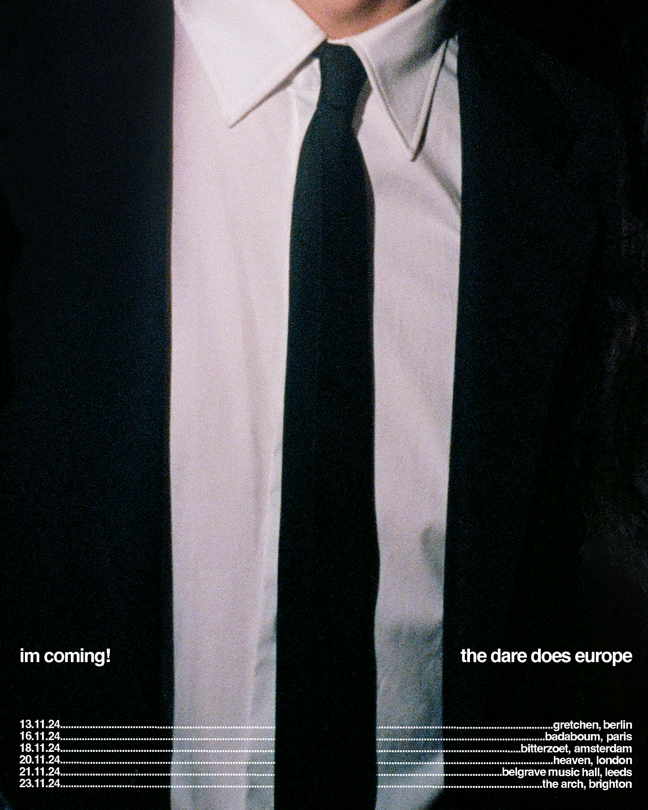

**UK and EU Tour Dates:**

Nov 13 Berlin, Germany - Gretchen

Nov 15 Paris, France - Silencio

Nov 16 Paris, France - Badaboum

Nov 18 Amsterdam, Netherlands - Bitterzoet

Nov 20 London, UK - Heaven

Nov 21 Leeds, UK - Belgrave Music Hall

Nov 23 Brighton, UK - The Arch

**Follow The Dare**

[Instagram](https://www.instagram.com/itsthedare/) | [YouTube](https://www.youtube.com/channel/UCbuiGebmWRrPSJgM_Bk8K4w) | [Spotify](https://open.spotify.com/artist/2mqiqsaX4LzFnUP7PmHGAb?si=1BtINbmOSxSO1nxCFKUHZw) | [TikTok](https://www.tiktok.com/@itsthedare) | [X](https://twitter.com/itsthedare)

**For more information and press enquiries please contact**

**Jenny Entwistle** [**Jenny@chuffmedia.com**](mailto:Jenny@chuffmedia.com)