**The Dare Announces Further UK and EU Tour Dates**

**(**TICKETS [HERE](https://linktr.ee/itsthedare?utm_source=linktree_profile_share&ltsid=2a971e6f-59f6-43f9-9997-9b95d379d37c)**)**

**Debut album *What’s Wrong With New York?***

***OUT NOW***

([LISTEN](https://thedare.lnk.to/wwwny.uk))



*(Press photo, credit Jason Omar Al-Taan)*

*“If there was ever a Dionysus for the music industry, then The Dare is it. Inspiring carnage, frenzy and a little bit of debauchery, with his debut album ‘What’s Wrong With New York?’ he injects some much-needed ecstasy and pleasure into the world.”* **5/5 DORK**

*“A hedonistic pop bible. Coming at the end of BRAT summer, The Dare’s debut intercepts the baton perfectly…ingeniously timed for an audience hungry for stylish and nostalgic catharsis.” -* **4.5/5 DIY**

“Tastefully rambunctious, ‘What’s Wrong With New York?’ is a sonic melting pot of millennial and Gen Z sounds. Don’t throw out the cigarettes just yet. ‘brat summer’ may be over, but I have a feeling that we’re in for a *Dare-*ingautum” **8/10 CLASH**

“A superstar in the making” - **THE GUARDIAN**

The Dare today announces new tour dates across the UK and Europe for March 2025. The additional dates will follow a sold-out run of shows in November this year in celebration of his debut album ***What’s Wrong With New York?***. This March run will include headline shows across Bristol, Manchester, Dublin and Glasgow in the UK, in addition to headline shows in London (Heaven), Brighton (The Arch) and Leeds (Belgrave Music Hall) next month. See full tour routing including EU shows below. Tickets will be available for presale on Thursday 31st Oct @ 10am local, and general sale on Friday 1st Nov @ 10am local.

***What’s Wrong With New York?*,** recorded over the last year between The Dare’s home and studio in New York, features The Dare’s ubiquitous first single ‘[Girls](https://www.youtube.com/watch?v=utvDi43sXvI)’ - now a bona fide hit with million streams to date - as well as the previously shared ‘[You’re Invited](https://thedare.lnk.to/youreinvited/youtube),’ ‘[Perfume](https://www.youtube.com/watch?v=oWiB8eVLS9o)’ and ‘[Good Time](https://www.youtube.com/watch?v=X8conJjSzZA).’ The album includes further collaborations with Dylan Brady (100 gecs), Emile Haynie (Lana Del Rey, FKA twigs, Dua Lipa), Romil Hemnani (Brockhampton), Chris Greatti (Yves Tumor, Yeule), Isaac Eiger (Strange Ranger) and more.

The album comes on the heels of a whirlwind few weeks for The Dare, who earned his first U.K. #1 alongside **Charli xcx** and **Billie Eilish** with their track ‘[**Guess**](https://www.youtube.com/watch?v=huGd4efgdPA),’ which he produced for the deluxe edition of *Brat*. He’s spent the summer opening for Charli at a slew of shows, most recently at her Boiler Room in Ibiza, as well as at her first-ever *Brat* live performances in New York and Los Angeles.

The Dare is the solo project of vocalist, songwriter and producer Harrison Patrick Smith. Bursting onto the scene with ’[Girls](https://www.youtube.com/watch?v=YXXbck3y5C8),’ his much lauded [*The Sex EP*](https://thedare.lnk.to/TheSexEPPR) drew widespread praise from critics and fellow artists alike. His explosive live shows have sold out across North America and Europe, and his legendary DJ sets, honed at his signature downtown Manhattan party Freakquencies, have soundtracked parties for Gucci, Celine and many more. He has shared stages and collaborated with Charli xcx, Yves Tumor, Water From Your Eyes and a host of others.

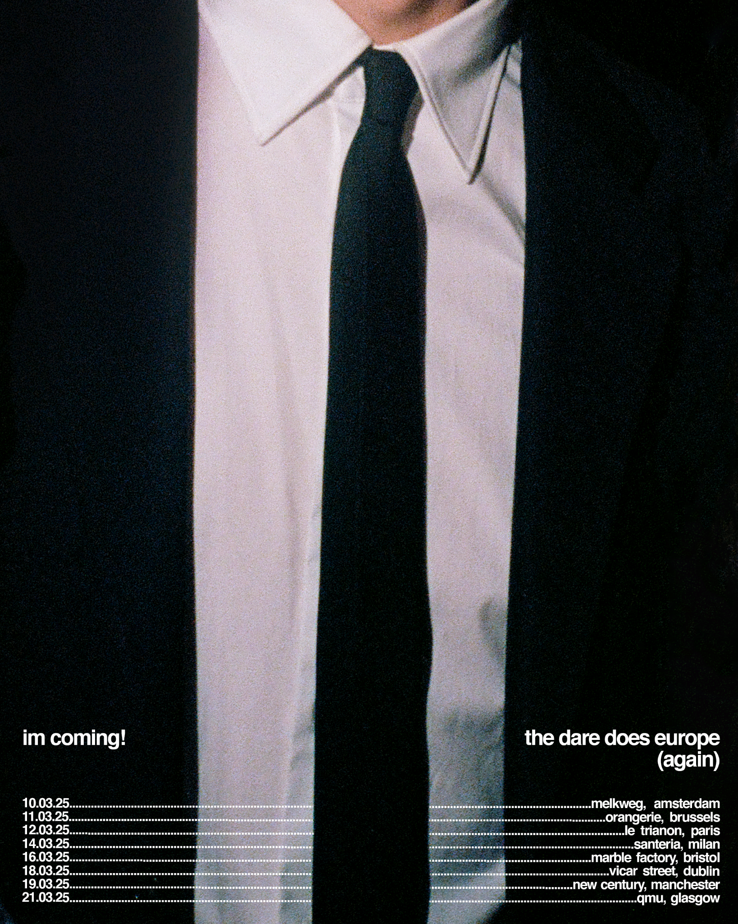

**UK and EU Tour Dates:**

Nov 13 Berlin, Germany - Gretchen

Nov 15 Paris, France - Silencio

Nov 16 Paris, France - Badaboum

Nov 18 Amsterdam, Netherlands - Bitterzoet

Nov 20 London, UK - Heaven

Nov 21 Leeds, UK - Belgrave Music Hall

Nov 24 Brighton, UK - The Arch

Mar 10 Amsterdam, Netherlands (Melkweg – Headline)  
Mar 11 Brussels, Belgium (Orangerie – Headline)

Mar 12 Paris, France (Le Trianon – Headline)  
Mar 14 Milan, Italy (Santeria – Headline)  
Mar 16 Bristol, UK (Marble Factory – Headline)

Mar 18 Dublin, Ireland (Vicar Street – Headline)

Mar 19 Manchester, UK (New Century – Headline)

Mar 21 Glasgow, UK (QMU - Headline)

**Follow The Dare**

[Instagram](https://www.instagram.com/itsthedare/) | [YouTube](https://www.youtube.com/channel/UCbuiGebmWRrPSJgM_Bk8K4w) | [Spotify](https://open.spotify.com/artist/2mqiqsaX4LzFnUP7PmHGAb?si=1BtINbmOSxSO1nxCFKUHZw) | [TikTok](https://www.tiktok.com/@itsthedare) | [X](https://twitter.com/itsthedare)

**For more information and press enquiries please contact**

**Jenny Entwistle** [**Jenny@chuffmedia.com**](mailto:Jenny@chuffmedia.com)