The Big Moon Announce UK + EU Live Dates for December 2023

Listen To New Track ‘Summer Still Comes’

Taken From Upcoming Deluxe Version of Third Album Here Is Everything

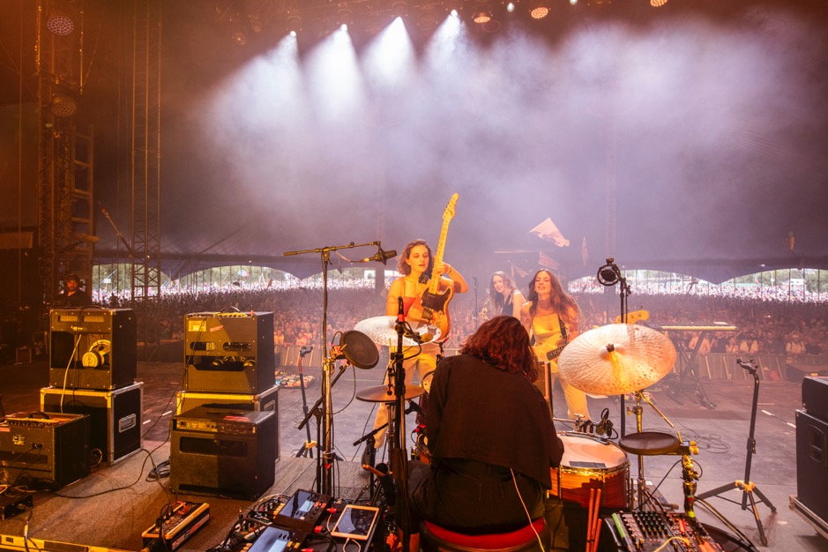
Credit Aaron Parsons
Download Here

Acclaim for Here Is Everything

“makes you want to dance and cry at the same time” – The Guardian
“Creatively ambitious, pushing the quartet into new ground, but with a renewed sense of fun” – DIY Magazine
“This is the sound of four friends leaving everything on the table” – Loud & Quiet
“their deepest, most emotional album yet” – NME
“Perhaps their most accomplished album yet…” – CLASH
“another string of indie bangers from the heart” - DORK

Following a storming summer of festivals, including a packed slot at Glastonbury in June, The Big Moon have announced a run of UK + EU shows for December this year. The tour kicks off in Genk on 5th December, taking in Paris, Glasgow, Manchester, Leeds, Birmingham, Bristol and Oxford, finishing up at London’s Union Chapel for a very special stripped-back performance on 18th December.

The London quartet have also released new track ‘Summer Still Comes’, a stunning waltzing synth-led rumination that further showcases the band’s innate ability to write smart, sharp alt-pop triumphs. The track is taken from the upcoming deluxe version of Here Is Everything, due for release on 13th October (the first anniversary of Here Is Everything) which will also include a further bonus track ‘Round Forever’, which features lead vocals from bassist Celia Archer, and remixes from Marika Hackman and Art School Girlfriend.

Listen here.

Juliette Jackson on the track –

“It’s a song about longing for your friends and loved ones. Experiences just don’t really mean anything to me unless I can share them with someone else. And the changes of the seasons feel so relentless and unforgiving when your life isn’t moving at the same speed.”

Here is Everything documented the arrival of that baby in real time, and the simultaneous arrival of a new mother, full of excitement and fear. Meanwhile, the rest of the band doubled-down in the studio, taking Jules’ embryonic song frameworks and stepping forward as one, revelling in an innate, giddy togetherness and with a clutch of genuinely fantastic tunes.

Here Is Everything was mostly self-produced, with the expert guidance and expertise of co-producers CECIL (Self Esteem, Jehnny Beth, PJ Harvey) and the Grammy Award winning producer Ben Allen (Gnarls Barkley, Deer Hunter, and the producer of Walking Like We Do).

More news coming soon.

UK + EU Tour Dates

5th December Genk, Effort
6th December Paris, Backstage
9th December Glasgow, SWG3 Warehouse
10th December Manchester, New Century Hall
13th December Birmingham, The Mill
14th December Bristol, The Marble Factory
15th December Oxford, O2 Academy 1
18th December London, Union Chapel (stripped-back performance)

Tickets available at http://www.thebigmoon.co.uk/

Here Is Everything bonus tracks -

- Summer Still Comes
- Round Forever
- Marika Hackman Remix (Track TBA)
- Art School Girlfriend Remix (Track TBA)

For more on info contact warren@chuffmedia.com

