Deliver Heartwarming Title Single From Anticipated Album
I’ve Loved You For So Long Out June 2 Via Red Bull Records
Tickets On Sale Today for World Headline Tour Across 30+ Dates
Stream the Single Here | Watch the Music Video Here
Pre-Order the Album Here
Purchase Tickets Here
Four-piece indie-pop band The Aces today released the final single ahead of their anticipated third studio album, I’ve Loved You For So Long out June 2 on Red Bull Records. As the first song on the album, the title track evokes the heartwarming feeling of falling in love with someone again and again, discovering new things to love as time goes on. The acoustic guitar-driven melodies are reminiscent of The Cranberries, setting the tone for several 90s-tinged tracks on the package. The band dedicates the song to each other, knowing the greatest love of their lives is in their chosen family and the music they’ve made together since they were kids. The official music video reflects the endearing nature of their relationship and brings this nostalgic era of The Acesto life.
Lead singer Cristal Ramirez shares, “The greatest love of my life is this band. It was something that subtlety dawned on me after writing the title track for our third record, ‘I’ve Loved You For So Long’ - a line Alisa wrote that felt grand and romantic. We were exploring what love looks like in a long-term relationship, of loving someone for so long that they almost feel like a part of you. Although, when we were writing it, we were referencing experiences from our romantic relationships, I quickly realized, the love of my life is this band.”
She continues, “I was recalling making our first record in New York. From being 10 years old in the basement picking out guitar chords, to touring the world together. Stumbling through life, relationships, the good and bad, always having the band to fall back on. The only truly consistent thing in a chaotic ever-changing world. I realize that I’ve never really loved anything like I love this band. And that even through times of dulled inspiration, of questioning everything, I’m always softly reminded that this is exactly where I’m supposed to be.”
Alongside the single, The Aces announced their triumphant return to the live space with two headline runs across Europe/UK and North America, spanning 30+ dates starting August 14th. Following several festival performances in addition to their sold-out album release event at Camden Assembly in London, they’ll bring the new album to fans in Birmingham at The Mill, Glasgow at King Tuts, Manchester at Gorilla and Cardiff at The Globe. Throughout the tour, The Aces will partner with Sound Mind Live, a non-profit organization that focuses on building a community and open dialogue around mental health through music, to provide mental health resources to fans in each city. Find the full routing below, with tickets available here.
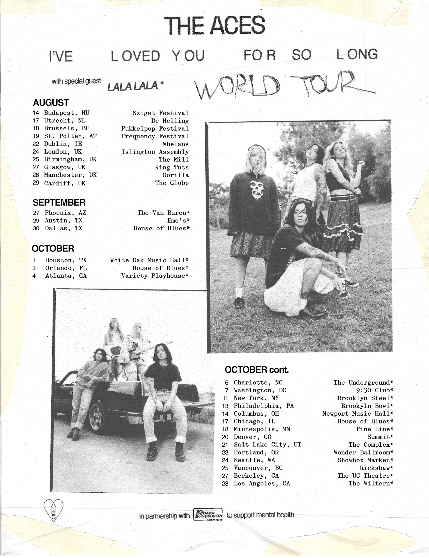
UK Tour Dates 2023:
August 24th – Koko, London
August 25th - The Mill, Birmingham
August 27th – SWG3 Studio Warehouse, Glasgow
August 28th – Manchester Academy 2, Manchester
August 29th - The Globe, Cardiff

ABOUT THE ACES
In the years since The Aces released their acclaimed sophomore album, Under My Influence in 2020, the band has been on a journey of self-discovery. Faced with the realities of a global pandemic, sisters Cristal and Alisa Ramirez (lead vocals/guitar and drums, respectively), Katie Henderson (lead guitar/vocals), and McKenna Petty (bass) used quarantine as a time to reflect, confronting personal mental health issues as well as processing experiences they’d had growing up together in Provo, Utah, as part of the Mormon church. When The Aces returned to the studio, their vision — and the honesty and trust between them — felt stronger than ever.
The result of this growth period is I’ve Loved You For So Long, the band’s third LP. Written and executive-produced by the group (along with Keith Varon, the sole collaborator on the project), the album is a sparkling indie-rock record that’s by far their most personal and self-assured work to date. From tracks that ruminate on mental health and self-sabotage to searing anthems about love, longing, and heartbreak, I’ve Love You For So Long is a record that’ll work its way into your head and heart — and will have you singing along all the way through.
I’ve Loved You For So Long is also an opportunity for The Aces to reach new heights and build on their many previous successes. To date, the group has earned over 205 million career streams; Under My Influence alone garnered more than 75 million (including 35 million on its lead single “Daydream”). The album also appeared on numerous charts, including #53 on Billboard’s Top Albums list. Further, The Aces have toured with the likes of 5 Seconds of Summer, X Ambassadors, The Vamps, and COIN, and have played at festivals all over the world, including NY Pride, Lollapalooza, Firefly, Bonnaroo, OUTFEST, and more. After selling out their last U.S. headline tour in 2021, the band will hit the road again this year, with dates soon to be announced.
THE ACES ONLINE
Website | YouTube | Instagram | TikTok | Twitter | Facebook
For more information please contact
Warren Higgins warren@chuffmedia.com

