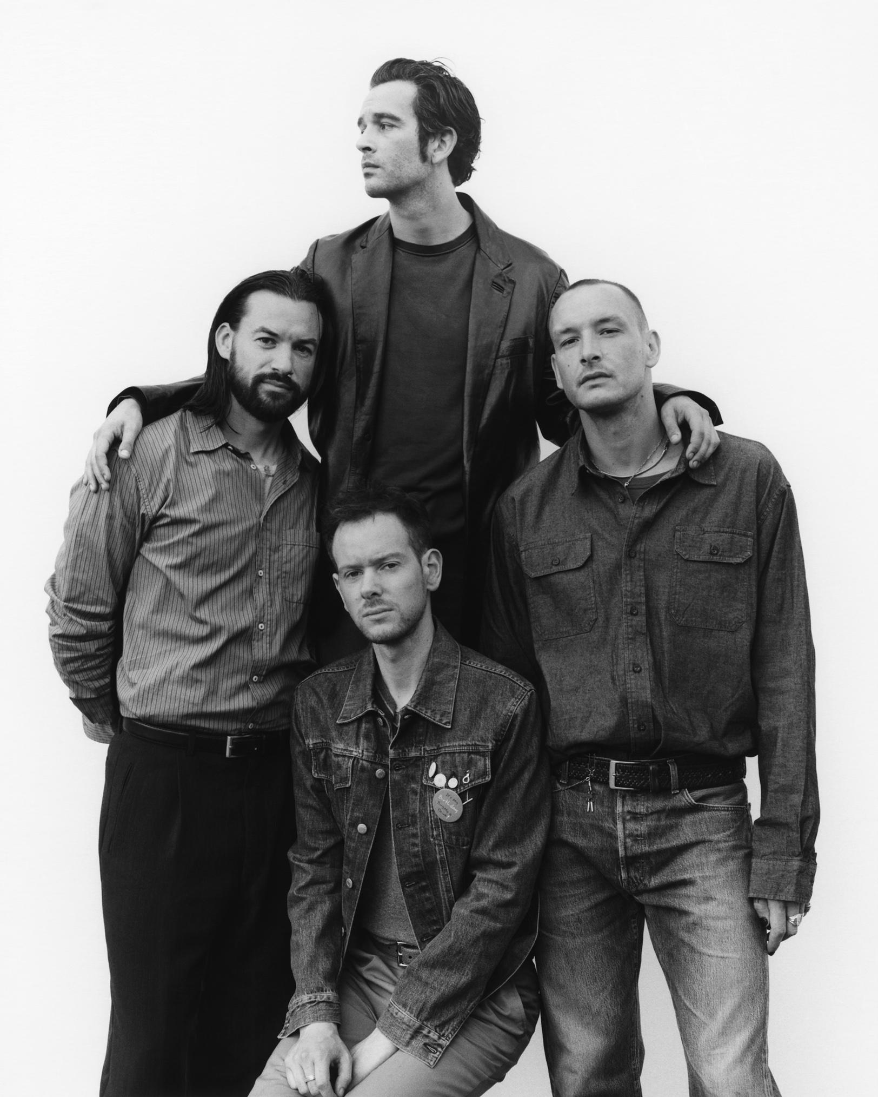
[Photo credit: Samuel Bradley]

[Friday 9th December, London]

The 1975 today release the official video for ‘Oh Caroline’ - taken from their critically acclaimed Number 1 album ‘Being Funny In A Foreign Language’.

You can watch the Samuel Bradley-directed video HERE.

Released in October, ‘Being Funny In A Foreign Language’, outsold the rest of the Top 5 combined to land the band their fifth Official UK Number 1 album in a row - their first on an independent label. The album also landed at Number 1 in Ireland and Australia too.

In support of ‘Being Funny In A Foreign Language’, the band are currently touring their brand new ‘At Their Very Best’ show across the US and Canada before a run of arena shows in the UK and Ireland in January 2023 and Australia, New Zealand and Asia in April.. Tickets are on sale now HERE.

Between the slick staging, impressive setlist, high concept performance art, surprise appearances from friends like Phoebe Bridgers & Jack Antonoff and the plethora of viral moments, such as eating raw meat on stage, the ‘At Their Very Best’ tour has been lauded as a band truly in their prime. To date, the band have sold over 500,000 tickets to the tour.

Formed in Manchester in 2002, The 1975 have established themselves as one of the defining bands of their generation with their distinctive aesthetic, ardent fanbase and unique sonic approach.

The band’s legacy is unparalleled; they were named NME’s ‘Band of the Decade’ in 2020 after being crowned ‘Best Group’ at the BRIT Awards in both 2017 & 2019. Their third studio album, ‘A Brief Inquiry Into Online Relationships’, also won ‘Mastercard British Album of the Year’ at the 2019 ceremony.

The 1975 ‘At Their Very Best’ Tour Dates:

Fri 12/9/22 - Chicago, IL - Byline Bank Aragon Ballroom - Sold Out
Sat 12/10/22 - Milwaukee, WI - The Eagles Ballroom - Sold Out
Mon 12/12/22 - Toronto, ON - Scotiabank Arena - Sold Out
Wed 12/14/22 - Minneapolis, MN - Armory - Sold Out
Fri 12/16/22 - Newport, KY - PromoWest Pavilion at OVATION - Sold Out
Sat 12/17/22 - Pittsburgh, PA - UPMC Events Center - Sold Out

Sun 08/01/23 - Brighton - The Brighton Center - Sold Out
Mon 09/01/23 - Bournemouth - Bournemouth International Center - Sold Out
Tue 10/01/23 - Exeter - Westpoint Arena
Thu 12/01/23 - London - The O2 - Sold Out
Fri 13/01/23 - London - The O2 - Sold Out
Sun 15/01/23 - Birmingham - Resorts World Arena
Mon 16/01/23 - Cardiff - Motorpoint Arena - Sold Out
Tue 17/01/23 - Cardiff - Motorpoint Arena - Sold Out
Thu 19/01/23 - Glasgow - SSE Hydro - Sold Out
Fri 20/01/23 - Manchester - Manchester Arena - Sold Out
Sun 22/01/23 - Nottingham - Motorpoint Arena - Sold Out
Mon 23/01/23 - Leeds - First Direct Arena
Weds 25/01/23 - Newcastle - Utilita Arena - Sold Out
Thu 26/01/23 - Liverpool - M&S Bank Arena
Sun 29/01/23 - Dublin - 3Arena - Sold Out
Mon 30/01/23 - Belfast - The SSE Arena

Sat 18/03/23 - Buenos Aires, Argentina - Lollapalooza Argentina
Sun 19/03/23 - Santiago, Chile - Lollapalooza Chile
Wed 23/03/23 - Bogota, Colombia - Festival Estereo Picnic
Fri 25/03/23 - São Paulo, Brazil - Lollapalooza Brasil
31/03 - 02/04 - Monterrey, Mexico - Tecate Pa’l Norte

Tue 04/04/23 - Bangkok, Thailand - IMPACT Arena
Sat 08/04/23 - Perth - Red Hill Auditorium
Mon 10/04/23 - Adelaide - AEC Theatre
Tues 11/04/23 - Melbourne - Rod Laver Arena
Wed 12/04/23 - Melbourne - Rod Laver Arena - Sold Out
Fri 14/04/23 - Sydney - ICC Sydney - Sold Out
Sat 15/04/23 - Brisbane - Riverstage - Sold Out
Wed 19/04/23 - Wellington, NZ - TSB Arena
Fri 21/04/23 - Auckland, NZ - Spark Arena
Wed 26/04/23 - Yokohama - PIA Arena
Thu 27/04/23 - Yokohama - PIA Arena
Sat 29/04/23 - Nagoya - Aichi Sky Expo
Sun 30/04/23 - Osaka - Jo Hall

Wed 03/05/23 - Pasay, Metro Manila - Mall of Asia Arena - Sold Out
Thu 04/05/23 - Pasay, Metro Manila - Mall of Asia Arena

Sat 03/06/23 - Warsaw, Poland - Orange Warsaw Festival
08-11/06/23 - Hradec Kralove, Czechia - Rock For People Festival
15-17/06/23 - Oslo, Norway - Piknik i Parken
16-18/06/23 - Neuhausen ob Eck, Belgium - Southside Festival
16-18/06/23 - Scheeßel, Netherlands - Hurricane Festival

Sun 09/07/23 - Glasgow - TRNSMT Festival

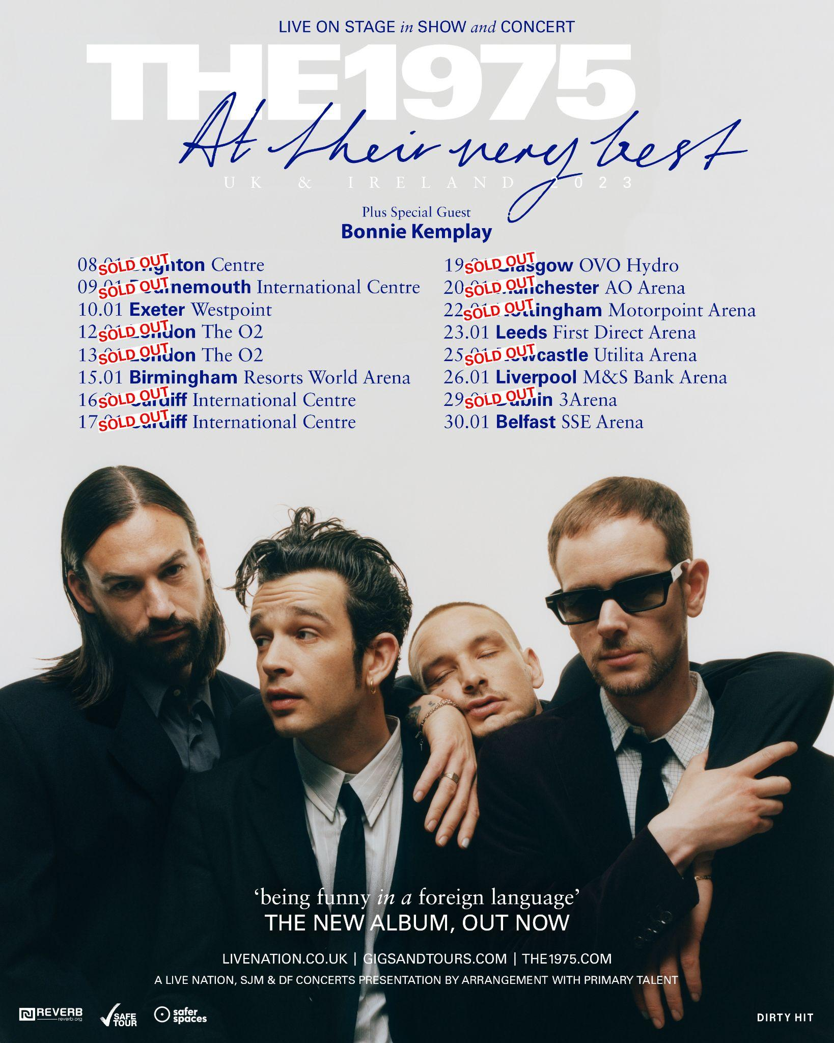
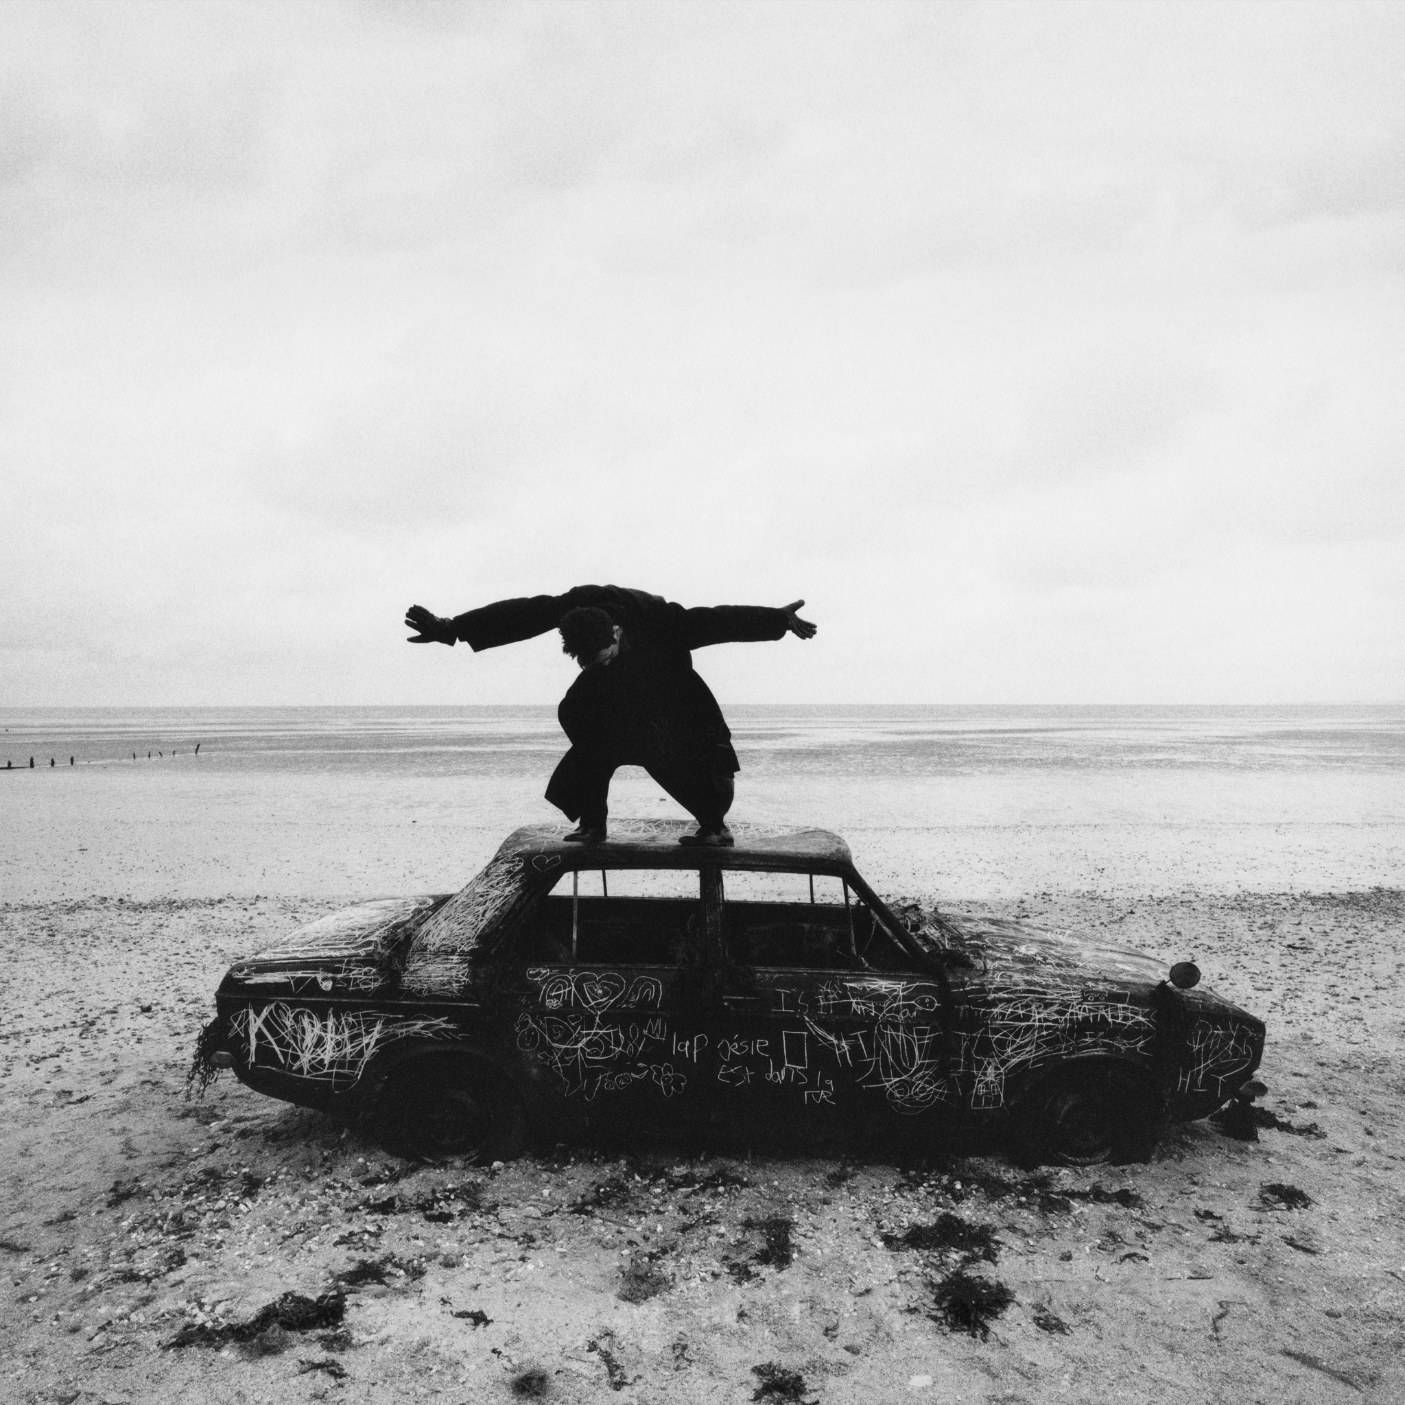
Being Funny In A Foreign Language Artwork [Photo credit: Samuel Bradley]

##

https://the1975.com/
https://twitter.com/the1975
https://www.instagram.com/the1975
https://www.tiktok.com/@the1975

www.instagram.com/trumanblack
https://www.instagram.com/bedforddanes75
https://www.instagram.com/1975adam
https://www.instagram.com/rass1975

##

For more on info contact warren@chuffmedia.com

