IT IS GOING TO BE A TERRIBLE SUMMER!

BIRMINGHAM STAGE COMPANY RETURN THIS SUMMER WITH THIRD WEST END RUN OF

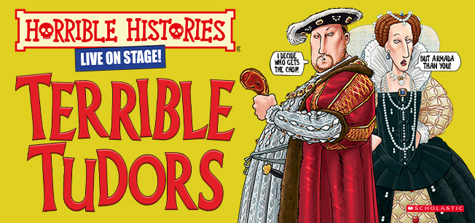

Apollo Theatre, Shaftesbury Avenue, London
25 July – 1 September 2024
Press performances: Tuesday 30th July 11am & 2pm

Media assets here

‘Ideal for children - and parents of all ages! Gore-geously grisly!’
Daily Mail 
‘This boisterous production hits the holiday sweet spot!’
Sunday Times
‘Wickedly hilarious - a must-see for families!’
All Things Theatre

Building upon two horribly successful summer runs, Birmingham Stage Company have announced the return of Horrible Histories – Terrible Tudors for their third year at the West End’s Apollo Theatre. Audiences will be taken on a whistle stop tour full of the gruesome details about the Tudor dynasty, from the horrible Henries to the end of evil Elizabeth. Find out the fate of Henry's wives and his punch up with the Pope - meet Bloody Mary and see Ed fall dead in his bed!

Hear the legends (and the lies!) about the torturing, Terrible Tudors when the production opens on the 25th July and plays until the 1st September.

Actor/Manager of Birmingham Stage Company Neal Foster says, “There are three things that make our third year back in the West End with Terrible Tudors so special. My acting partner Emma Swan is hilariously brilliant to work with; the Apollo is my favourite West End playhouse; and it’s a dream to be back in town with the Tudors for our third summer in a row. It doesn’t get any better!”

Celebrating twenty years since the best-selling books from Teary Deary were first brought to the stage by Birmingham Stage Company, the family phenomenon also celebrates the unlucky (for some) milestone of its 13 years in the West End; thrilling families and tourists alike with its unique take on the gruesome past of the British Isles and beyond. Their award-winning productions include favourites such as Horrible Christmas, Rotten Royals, Barmy Britain and Groovy Greeks.

Horrible Histories shows are recommended for ages 5 to 105 (106 year olds may not like them!)

Horrible Histories – Terrible Tudors is directed by Neal Foster, starring Neal Foster and Emma Swan, designed by Jacqueline Trousdale, with lighting by Jason Taylor, music by Matthew Scott, sound by Nick Sagar, with choreography by Kenn Oldfield.

Twitter: @HHLiveOnStage / Facebook: birminghamstage / Instagram: @HHLiveOnStage

Horrible Histories: Terrible Tudors
Apollo Theatre
Shaftesbury Avenue, London W1D 7EZ
Box Office: 0330 333 4809
terribletudors.com

Tickets from £18.50

25 July – 1 September
Press performances: Tuesday 30th July 11am & 2pm
Running time: 70 minutes (no interval)

FOR MORE INFORMATION AND ALL MEDIA ENQUIRIES FOR
TERRIBLE TUDORS PLEASE CONTACT

Warren Higgins & Jenny Entwistle at Chuff Media
warren@chuffmedia.com / 07762 130510
jenny@chuffmedia.com

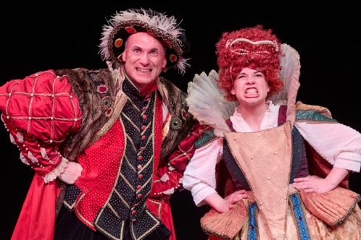

***NOTES TO EDITORS***

Written by Terry Deary and illustrated by Martin Brown, HORRIBLE HISTORIES® is the world’s bestselling children’s history book series and celebrated its 30th anniversary in 2023. Over 30 million copies are in print and the series has been translated into 38 languages since the books were first published by Scholastic in 1993. Uniquely funny, fact-filled and unflinching, the books have inspired award-winning TV series, sell-out West End and international stage-shows and a feature film. Brand licensing also includes exhibitions, attractions, magazines, costumes, games, stationery and heritage products. HORRIBLE HISTORIES has been described as: ‘A cultural phenomenon’ (Daily Telegraph), ‘Brilliant’ (Mail on Sunday), ‘Anarchic’ (Daily Express), ‘A winning formula’ (Evening Standard), ‘Anti-establishment’ (Metro) and ‘The cultural behemoth that has been merrily illustrating the gruesome corners of the past since 1993’ (The Times). The latest HORRIBLE HISTORIES book is PAWS, CLAWS AND JAWS about the horrible history of animals.

Neal Foster performs, co-writes and directs Terrible Tudors. He is Actor/Manager of Birmingham Stage Company which since its foundation in 1992 has staged over one hundred productions. The company has become one of the world's leading producers of theatre for children and their families, including Horrible Histories Live on Stage for twenty years in the UK, Dubai, Abu Dhabi, Qatar, Bahrain, Hong Kong, Singapore, New Zealand and Australia. Foster has directed and co-written all of the most recent Horrible Histories shows including Barmy Britain - Parts One, Two, Three, Four and Five, and Terrible Tudors (Garrick Theatre, Apollo Theatre and Sydney Opera House), Groovy Greeks and Incredible Invaders for a national tour and Wicked Warwick at Warwick Castle. His first fictional adaptations were David Walliams' Gangsta Granny and Billionaire Boy, both of which transferred to the Garrick Theatre, and were nominated for an Olivier Award. His brand-new production of David Walliams’ Awful Auntie has just begun a UK tour.

Emma Swan trained at Drama Studio London and the University of St Andrews. Recent theatre credits include: Salerio in The Merchant of Venice (Royal Shakespeare Company); Mum in Horrible Christmas (Barbican Hall and UK Tour, Birmingham Stage Company); Drabb in Terrible Tudors (Garrick Theatre and UK Tour); Anne Brontë in I Am No Bird (Stephen Joseph Theatre and UK tour); Sparky in Sparky the Elf and the Secret Toyshop (Queen’s Theatre Hornchurch). Film Credits: Tracy in Sweet Sue (Somesuch Productions/ BBC Films). Other Credits: Pippa in Doctor Who: The Diary of Riversong, Dell in Doctor Who: Ghosts (Big Finish), Hermia/Quince in A Midsummer Night’s Dream (BBC Education), Narrator for Me and My 10 Kids (Channel 5 Seasons 1 and 2). Recently, Emma was nominated for Audible’s Audiobook Narrator of the Year and won Best Newcomer at the Musical Comedy Awards.
Twitter/ Instagram: @emmalittleswan

Nimax Theatres is an entrepreneurial and innovative company that owns and operates 6 prestigious theatres in the heart of London’s West End: the Palace, Lyric, Apollo, Garrick, Vaudeville and Duchess and operates @ sohoplace, an exciting new theatre on Charing Cross Road. Nimax was founded in 2005 and is co-owned by Chief Executive Nica Burns OBE, an award-winning producer of over 100 productions, and Max Weitzenhoffer, a veteran American theatre producer. The theatres have a combined capacity of 5,600 seats and in addition to hosting some of the UK’s most critically acclaimed plays and musicals, present a busy and varied programme of comedy, concerts and children’s theatre. Current productions at the group include Harry Potter and the Cursed Child at the Palace, Six at the Vaudeville and The Little Big Things musical @ sohoplace.

