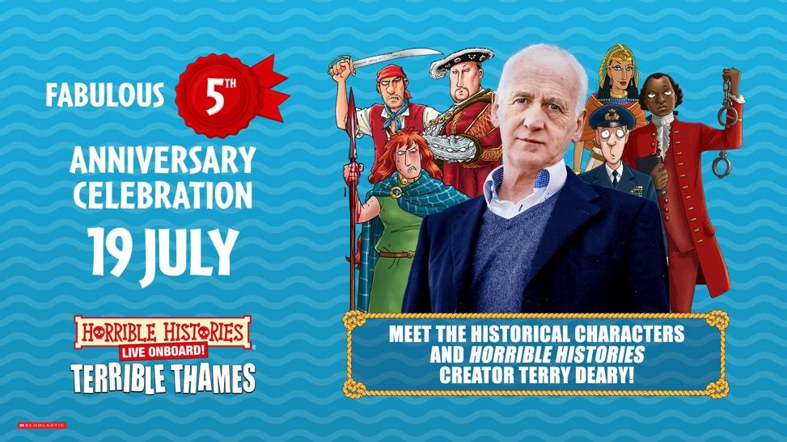

THE HORRIBLE HISTORIES WICKED BOAT TOUR
TERRIBLE THAMES

ANNOUNCES A FABULOUS FIFTH ANNIVERSARY CELEBRATION!

FOR ONE DAY ONLY, MEET THE HISTORICAL CHARACTERS OF THE THAMES, PLUS HORRIBLE HISTORIES CREATOR TERRY DEARY!

SAILINGS RETURN DAILY FOR SUMMER ON SATURDAY 12TH JULY
TICKETS ON SALE NOW

Priced from
Adult £25 (16+) | Child £15 (3-15) | Senior (65+) £20 | 0-3 Go Free
Family & Group tickets available
terriblethames.com
WATCH THE TRAILER HERE

Ahoy landlubbers! To mark the occasion of Horrible Histories TERRIBLE THAMES’ fabulous fifth birthday, we’re making a splash on Saturday 19th July with a rambunctious riverside rendezvous of famous figures from the Thames’ terrible past!

Throughout this special day our passengers will come face-to-face with the river’s riotous royals and reprobates. Meet the likes of Queen Boudica, King Henry VIII, Queen Anne Boleyn, Guy Fawkes, Captain Kidd, Olaf the Viking and Julius Caesar who’ll be lurking by the quay, ready to share their terrible tales before you embark on London’s hilariously historical attraction!

And if that wasn’t enough; Horrible Histories creator (and master of the macabre and mischievous) TERRY DEARY will be popping by to meet fans of all ages during the day! Come say hello, grab a photo and chat with the man who’s been delighting (and disgusting) generations with his brilliantly beastly books.

Departing from Tower Bridge Quay, TERRIBLE THAMES incorporates immersive theatre as it delivers its unique take on London. Whether you love Horrible Histories or just want a sensational sightseeing tour of the Thames, this is the trip for you and your family!

The 45-minute immersive tour from Tower Bridge to the Palace of Westminster and back via Execution Dock has been acclaimed by critics and the public for the wonderfully entertaining way it brings London to life, whilst the audience cruise in comfort.

So, grab your first mate, hoist the anchor, and join us for a voyage through time to learn all about the mysterious waters of our greatest river, where every bend holds tales of treachery, tyranny and triumph! Horrible Histories TERRIBLE THAMES is filled with facts that will make you shiver your timbers, with sea shanties to sing along with!

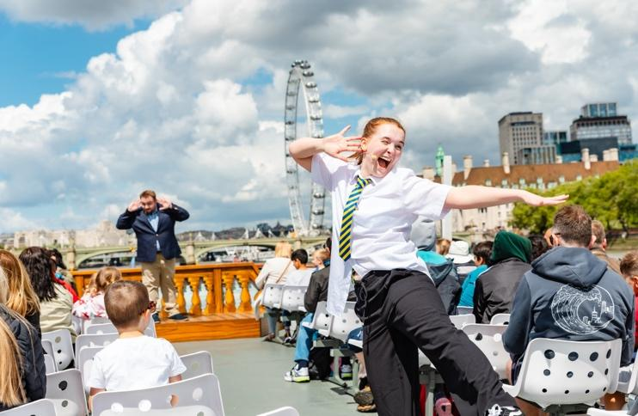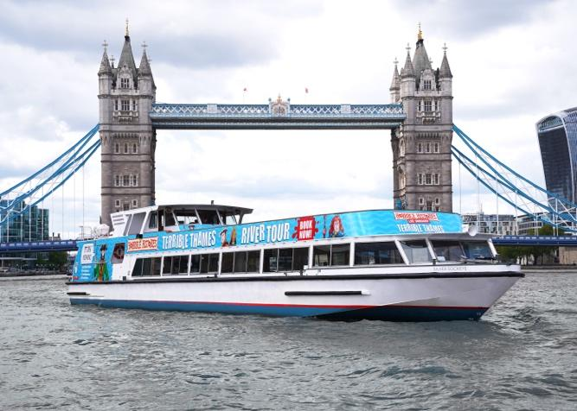

Tickets: terriblethames.com

TERRIBLE THAMES is hosted aboard Silver Sockeye, one of Woods Silver Fleet’s premier luxury sightseeing cruisers.

Birmingham Stage Company and Woods Silver Fleet are dedicated to improving the accessibility for all visitors to this experience and ask that any assisted wheelchair access that is required is booked in advance. Please email customerservices@terriblethames.com for more information.

WE CAN’T WAIT TO SEA YOU THERE!

Be sure to give us a wave on social media…

Instagram – X - Facebook

FOR MORE INFORMATION AND ALL MEDIA ENQUIRIES FOR
TERRIBLE THAMES PLEASE CONTACT
Jenny Entwistle at Chuff Media
jenny@chuffmedia.com / 07584 303 097

***NOTES TO EDITORS***

HORRIBLE HISTORIES® is the world’s bestselling children’s history book series – written by Terry Deary, illustrated by Martin Brown and published by Scholastic. Over 30 million copies are in print, and the series has been translated into 38 languages since the books first published over 30 years ago. Uniquely funny, fact-filled and unflinching, the books have inspired award-winning TV series, sell-out West End and international stage-shows and a feature film. Brand licensing includes exhibitions, attractions, magazines, games and heritage products. Horrible Histories has been described as: ‘A cultural phenomenon’ (Daily Telegraph), ‘Brilliant’ (Mail on Sunday), ‘Anarchic’ (Daily Express), ‘A winning formula’ (Evening Standard), ‘Anti-establishment’ (Metro) and ‘The cultural behemoth that has been merrily illustrating the gruesome corners of the past since 1993’ (The Times).
The latest Horrible Histories book is The Truly Terrible History of the Toilet – out in paperback now (Scholastic).

BIRMINGHAM STAGE COMPANY
Since its foundation in 1992, the Birmingham Stage Company has become one of the world’s leading producers of theatre for children and their families. This year marks the 20th anniversary of Horrible Histories live on stage. The company launched the world premiere of Terrible Tudors and Vile Victorians in 2005 and since produced eighteen Horrible Histories shows including Awful Egyptians, Groovy Greeks, Ruthless Romans and its record-breaking West End series Barmy Britain, which is back this summer at the Apollo with The Best of Barmy Britain. Their shows tour the length and breadth of the UK, including Hampton Court Palace, Kensington Palace, Tower of London, Hillsborough Castle, Warwick Castle and travel internationally to Dubai, Abu Dhabi, Qatar, Bahrain, Hong Kong, Singapore, New Zealand and Australia, including the Sydney Opera House.

WOODS SILVER FLEET
The Woods family have been Thames Watermen since 1866. They launched into the 20th Century with sightseeing tours by Lillian and Alfred Woods from the Tower of London. Lillian encouraged her son Alan’s inspired idea to gradually build the ‘Silver Fleet’ in the 1960s, each vessel handcrafted for the River Thames, in Kent and Suffolk shipyards.

In the decades since, Woods’ Silver Fleet have become highly sought after London ‘hideaways’ with yacht interiors, finishes and hospitality. The Silver Sturgeon, Silver Barracuda and Silver Darling have been privately chartered for film stars, politicians and British Royalty for decades.

Chair, Alan Woods was awarded an MBE for Services to River Travel in 2020. He is also a Past Master of the Company of Watermen & Lightermen and has been Extra Waterman to HM Queen Elizabeth II and HM the King.

In 2025, CEO, Tom Woods joined his father as a Royal Waterman to King Charles III.

After nearly twenty years in the roles, siblings Thomas, Kate & William Woods navigate the Silver Fleet into the 21st century, pushing the boundaries of events & shipbuilding on the Thames, all from their new central London home, Woods Quay.

