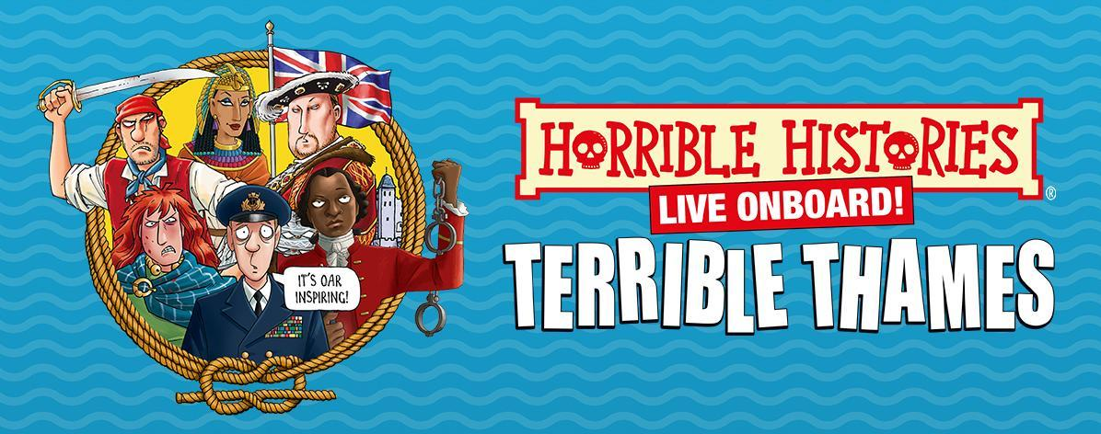
AHOY MATEYS!

THE HORRIBLE HISTORIES’ WICKED BOAT TOUR
TERRIBLE THAMES
RETURNS FOR THE FOURTH YEAR!

‘A rip-roaring, riotous sightseeing tour kids and adults will never forget!’
THE SUN

‘A fun, enjoyable, spirited alternative to more po-faced London tourism – may it sail on and on!’
TIME OUT

SAILINGS RETURN 23RD MARCH FROM TOWER BRIDGE QUAY

TICKETS ON SALE NOW

Priced from
Adult £25 (15+) | Child £15 (4-14) | Senior £20 | 0-3 Go Free
Family & Group tickets available
terriblethames.com
WATCH THE TRAILER HERE

After an incredible hat-trick entertaining and educating up and down the Thames, London’s favourite hilariously historical tourist attraction is back for its FOURTH year! Whether ye be a seasoned sailor or a landlubber, there's something for everyone aboard the TERRIBLE THAMES. A uniquely exhilarating boat tour from the Horrible Histories team, it’s the history of the Thames with the nasty bits left in!

Departing from Tower Bridge Quay, the journey incorporates immersive theatre as it delivers its unique take on London, thrilling both children and adults alike. Since 2021 the seafaring spectacle has welcomed over a quarter of a million explorers aboard.

So, grab your first mate, hoist the anchor, and join us for a voyage through time to learn all about the murky waters of our greatest river, where every bend holds tales of treachery, tyranny and triumph!

Horrible Histories TERRIBLE THAMES is filled with facts that will make you shiver your timbers, with sea shanties to sing along with!

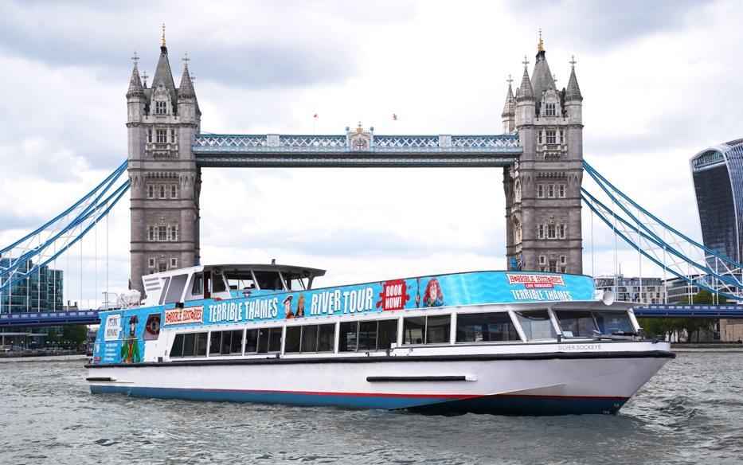

ADVANCE TICKETS
Adult £25 (15+) | Child £15 (4-14) | Senior £20 | 0-3 Go Free
Family Ticket £60 (2x Adult | 2x Children) and £70 (2x Adult | 3 x Children)

Tickets: terriblethames.com

TERRIBLE THAMES is hosted aboard Silver Sockeye, one of Woods Silver Fleet’s premier luxury sightseeing cruisers.

Birmingham Stage Company and Woods Silver Fleet are dedicated to improving the accessibility for all visitors to this experience and ask that any assisted wheelchair access that is required is booked in advance. Please email customerservices@terriblethames.com for more information.

WE CAN’T WAIT TO SEA YOU THERE!

Be sure to give us a wave on social media…

Instagram – Twitter - Facebook

FOR MORE INFORMATION AND ALL MEDIA ENQUIRIES FOR
TERRIBLE THAMES PLEASE CONTACT
Jenny Entwistle & Warren Higgins at Chuff Media
jenny@chuffmedia.com / 07584 303 097
warren@chuffmedia.com

***NOTES TO EDITORS***

HORRIBLE HISTORIES® is the world’s bestselling children’s history book series. Over 30 million copies are in print and the series has been translated into 38 languages since the books first published in 1993. Uniquely funny, fact-filled and unflinching, the books have inspired award-winning TV series, sell-out West End and international stage-shows and the first feature film in 2019. Brand licensing also includes exhibitions, attractions, magazines, costumes, games, stationery and heritage products. Horrible Histories has been described as: ‘A cultural phenomenon’ (Daily Telegraph), ‘Brilliant’ (Mail on Sunday), ‘Anarchic’ (Daily Express), ‘A winning formula’ (Evening Standard), ‘Anti-establishment’ (Metro) and ‘The cultural behemoth that has been merrily illustrating the gruesome corners of the past since 1993’ (The Times).

The latest Horrible Histories books are Up in the Air about the horrible history of flight and bold new re-launched editions of Rotten Romans, Terrifying Tudors, Vile Victorians and Woeful Second World War – out in paperback now (Scholastic).

BIRMINGHAM STAGE COMPANY
Since its foundation in 1992, the Birmingham Stage Company has become one of the world’s leading producers of theatre for children and their families. The company launched the world premiere of Horrible Histories Live on Stage in 2005 and has since produced eighteen Horrible Histories shows including Terrible Tudors, Awful Egyptians, Vile Victorians, Groovy Greeks, Ruthless Romans and its record-breaking West End series Barmy Britain, which enjoyed its tenth year with the launch of Barmy Britain – Part Five!. Their shows tour the length and breadth of the UK, including Hampton Court Palace, Kensington Palace, Tower of London, Hillsborough Castle, Warwick Castle and tour internationally to Dubai, Abu Dhabi, Qatar, Bahrain, Hong Kong, Singapore, New Zealand and Australia, including the Sydney Opera House.

WOODS SILVER FLEET
The Woods family have been Thames Watermen since 1866. They launched into the 20th Century with sightseeing tours by Lillian and Alfred Woods from the Tower of London. Lillian encouraged her son Alan’s inspired idea to gradually build the ‘Silver Fleet’ in the 1960s, each vessel handcrafted for the River Thames, in Kent and Suffolk shipyards.

In the decades since, Woods’ Silver Fleet have become highly sought after London ‘hideaways’ with yacht interiors, finishes and hospitality. The Silver Sturgeon, Silver Barracuda and Silver Darling have been privately chartered for film stars, politicians and British Royalty for decades.

The Terrible Thames Tour will set sail on their newly refurbished luxury sightseeing cruiser, Silver Sockeye.

Chair, Alan Woods was awarded an MBE for Services to River Travel in 2020. He is also a Past Master of the Company of Watermen & Lightermen and is an ‘Extra Waterman to HM the Queen’.

After nearly twenty years in the roles, siblings Thomas, Kate & William Woods navigate the Silver Fleet into the 21st century, pushing the boundaries of events & shipbuilding on the Thames, all from their new central London home, Woods Quay.

