THE LAST DINNER PARTY UNLEASH THIRD SINGLE,
‘MY LADY OF MERCY’

WATCH VIDEO HERE

UK HEADLINE TOUR COMMENCES 8TH OCTOBER + LONDON ROUNDHOUSE SHOW ANNOUNCED FOR 1ST FEBRUARY (ON SALE NOW)

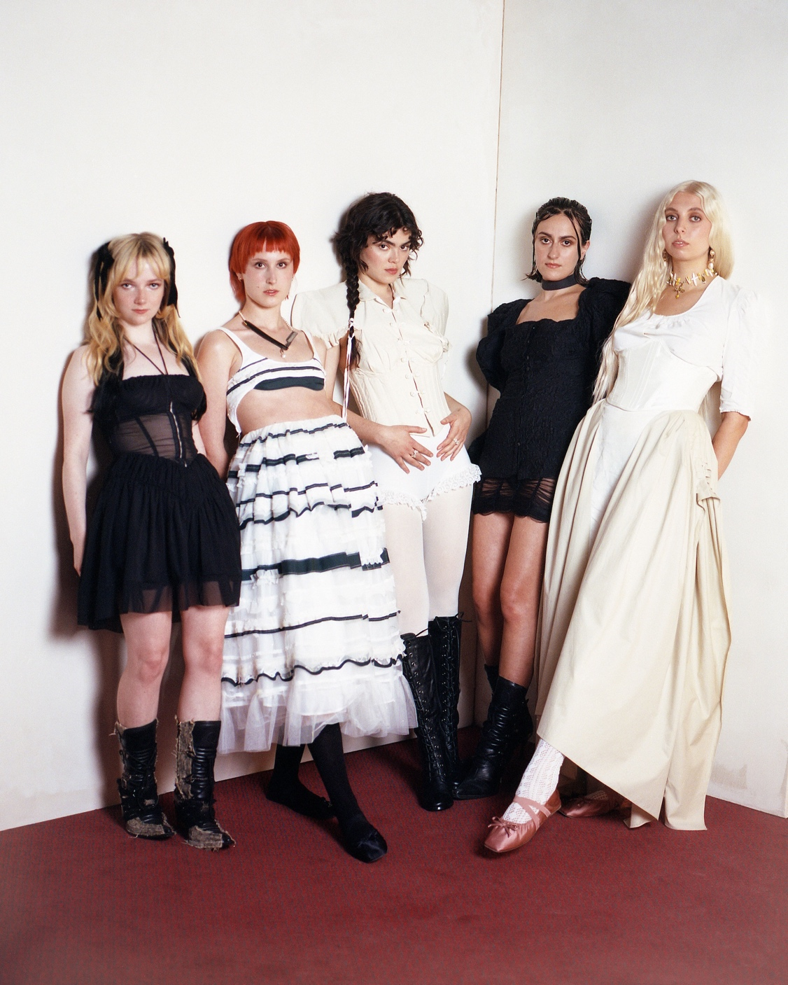
Credit: Cal McIntyre
The Last Dinner Party are excited to share their third track, My Lady of Mercy. It is streaming now via Island Records, and follows the widespread acclaim for their debut singles, Sinner and Nothing Matters.

Produced alongside James Ford, My Lady of Mercy can already be described as a live favourite, featuring on the fan-filmed live sets that peppered YouTube before the band had officially released a note of music. It’s darker toned than its predecessors too, a scorched guitar work-out almost gothic in atmosphere. But at its heart remains what’s made The Last Dinner Party such an alluring proposition to date, a smartly crafted alt. rock song with appeal far beyond any genre-specifics.

Watch the monochromatic video for ‘My Lady of Mercy’ here which was directed by the band alongside Harv Frost and Dora Paphides. Stream the track here

The Last Dinner party on My Lady Of Mercy:

“My Lady of Mercy is about being a girl. A girl looking up at a painting of Joan of Arc for the first time and thinking that she looks so brave and so beautiful that she wants to kiss her. And maybe she also wants to kiss the girl who stands next to her in the school choir.

We are expanding the world of The Last Dinner Party to encompass a darker, heavier atmosphere. The lyrics explore the anguish of a teenage crush that can only be described through the bloody, carnal language of religious experience, as the soundworld takes cues from Nine Inch Nails, PJ Harvey and Roxy Music.”

The Last Dinner Party have been out on the road extensively since April’s explosive release of Nothing Matters, packing tents at the likes of Glastonbury, Reading and Leeds, Electric Picnic, Latitude, Green Man, and End of the Road. The Summer also included support slots for Lana Del Rey, Florence & The Machine, and First Aid Kit.

The band’s forthcoming near sold out eight date UK tour kicks off at Blackpool’s Central Library on the 8th October, and concludes at The Fleece in Bristol on 22nd October. The run includes two sell out performances at London’s EartH on 17th and 18th October, and follows their run of London sell-out shows at Moth Club, Camden Assembly, and Oslo in quick succession. The band will conclude 2023 across UK and Europe arenas in support of Hozier, interspersed with their first trip out to the US for a string of headline dates.

Last week the band announced a show at London’s Roundhouse on 1st February 2024.

Remaining tickets for all UK and US headline dates are on sale now via https://www.thelastdinnerparty.co.uk/live/

The Last Dinner Party live:
8th October – Blackpool Central Library SOLD OUT
9th October – SWG3, Glasgow
10th October – The Cluny, Newcastle SOLD OUT
12th October – Academy 2, Manchester SOLD OUT
14th October – Live At Leeds In The City
15th October – The Welly, Hull
17th October – EartH, London SOLD OUT
18th October – EartH, London SOLD OUT
19th October – Portland Arms, Cambridge SOLD OUT
21st October – SWN Festival, Swansea
22nd October – Fleece, Bristol SOLD OUT
27th – 28th October – London Calling, Amsterdam
31st October – The Atlantis, Washington D.C. SOLD OUT
2nd November – Bowery Ballroom, New York SOLD OUT
4th November – Johnny Brenda’s, Philadelphia SOLD OUT
6th November – El Rey Theatre, Los Angeles
9th November – Bottom Lounge, Chicago
26th November – Avicii Arena, Stockholm (w/ Hozier)
28th November – Ziggo Dome, Amsterdam (w/ Hozier)
29th November – Zenith, Paris (w/ Hozier)
2nd December – Velodrome, Berlin (w/ Hozier)
3rd December – Wiener Stadthalle, Vienna (w/ Hozier)
5th December – Sporthall, Hamburg (w/ Hozier)
6th December – Sportovni Hala Fortuna, Prague (w/ Hozier)
8th December – Forest National, Brussels (w/ Hozier)
10th December – M&S Bank Arena, Liverpool (w/ Hozier)
11th December – OVO Hydro, Glasgow (w/ Hozier)
13th December – Resorts World Arena, Birmingham (w/ Hozier)
15th December – OVO Wembley Arena, London (w/ Hozier)
17th December – SSE Arena, Belfast (w/ Hozier)
19th December – The Workman’s Club, Dublin SOLD OUT

2024
1st February – The Roundhouse, London NEW DATE

For more information and press enquiries please contact

Warren Higgins
warren@chuffmedia.com

