**ANNOUNCE** [***PRELUDE TO ECSTASY: ACOUSTICS AND COVERS***](https://tldp.lnk.to/deluxealbumPR)

**LISTEN TO ‘**[**THIS TOWN AIN’T BIG ENOUGH FOR BOTH OF US (SPARKS COVER)**](https://tldp.lnk.to/thistownPR)**’ HERE**

**SOLD OUT 22-DATE UK TOUR COMMENCES IN SEPTEMBER**

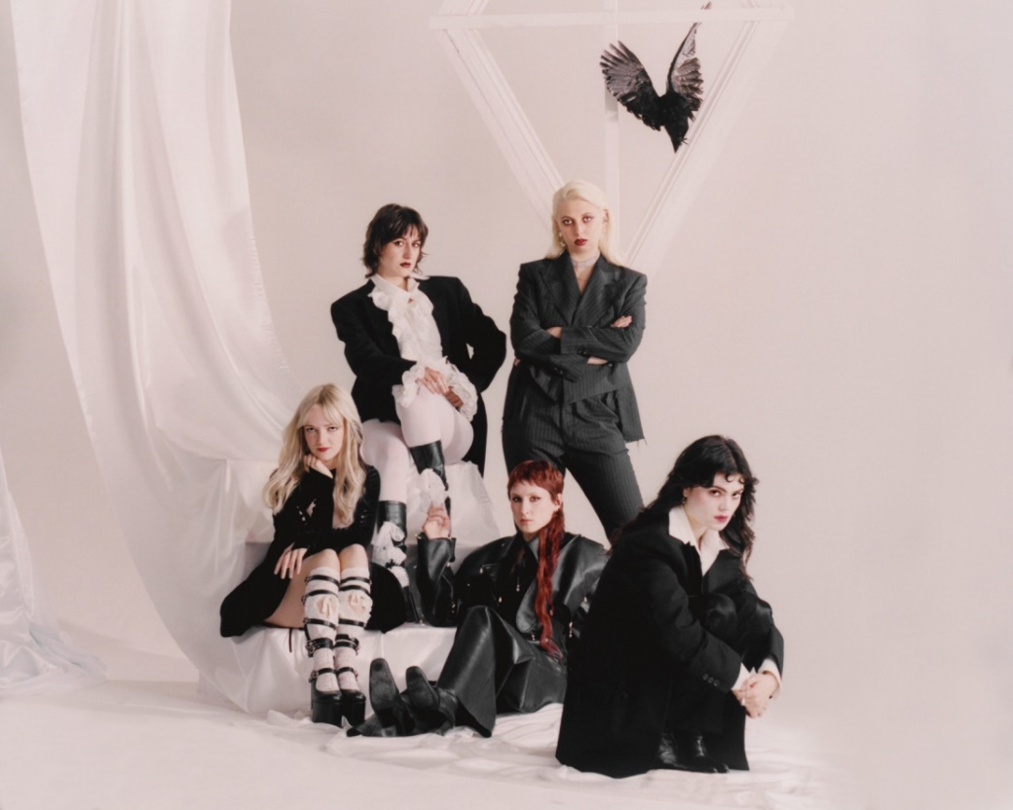

[credit: Cal McIntyre (hi-res here)](https://www.dropbox.com/scl/fo/et13amvbj2kmj3p6jfz25/APEbOGhWo9mPgrcABcXp0HY?rlkey=vehjkck4yjsjucqjulj4y6arf&st=cu60z1ji&dl=0)

The Last Dinner Party are pleased to announce the 11th October arrival of *Prelude To Ecstasy: Acoustics and Covers* - a deluxe edition of their Mercury Prize-shortlisted debut which includes reimagined versions of the band’s own songs alongside unique covers of their favourite tracks from other artists.

The Last Dinner Party’s cover of Sparks’ 1974 single ‘This Town Ain’t Big Enough For Both Of Us’ arrives alongside a tour montage video; made with footage shot over the band’s recent trips to Japan, The United States and their recent performance at Reading Festival.

[**WATCH ‘THIS TOWN AIN’T BIG ENOUGH FOR BOTH OF US’ VIDEO HERE**](https://tldp.lnk.to/thistownPR)

A short *Prelude To Ecstasy* film will be screened at a Soho Cinema and live-streamed to The Last Dinner Party’s YouTube channel on 12th September. Fans will have the opportunity to win tickets to the Leicester Square screening via the band’s mailing list.

[**WATCH *PRELUDE TO ECSTASY THE FILM* TRAILER HERE**](https://www.youtube.com/watch?v=-oryTliHnt0)

To sum up the impact The Last Dinner Party have had, or simply to try and summarise the highlights of their last twelve months would inevitably be doing the band an injustice. With sell out tours across the globe, chart-bothering singles, a fastest-selling number one album by a debuting band for years, a Rising Star BRIT Award, BBC Sound of 2024 winners, reams of acclaim and now an inclusion on the Mercury Prize - Albums of the Year shortlist: you’d be hard pushed to liken it to any new artist introducing themselves within the last decade, perhaps further beyond. The wildest of rides.

But amongst all the deafening noise stand five smart young musicians trying to ignore what they cannot control and instead leave a permanent impression out on the stages they’d always dreamed of performing on. A mesmerising, captivating live act, The Last Dinner Party started this journey honing their craft on the basement stages of London’s grassroots venues and have been telling their story to bigger capacity rooms across the UK, Europe and the US ever since.

Having commenced the summer with a spree of stellar festival appearances including Radio 1 Big Weekend, Primavera Sound, TRNSMT and a scene-stealing return to Glastonbury, The Last Dinner Party have now wrapped their debut run of shows in bassist Georgia’s home country of Australia and an appearance at Japan’s Fuji Rock Festival, before the band complete a collection of sold out dates on both sides of the Atlantic: culminating in 3 nights at London’s Eventim Apollo.

Britain’s “most likely to” have emphatically become Britain’s most in-demand, and Britain’s most exciting.

[**Pre-order** ***Prelude To Ecstasy: Acoustics and Covers* here**](https://tldp.lnk.to/deluxealbumPR)

[**R.S.V.P here to join The Last Dinner Party’s mailing list**](https://www.thelastdinnerparty.co.uk/)

***Prelude To Ecstasy: Acoustics and Covers* tracklisting*:***

**LP 1:**

**Side A**

Prelude to Ecstasy

Burn Alive

Ceaser On A TV Screen

The Feminine Urge

On Your Side

Beautiful Boy

**Side B**

Gjuha

Sinner

My Lady of Mercy

Portrait of A Dead Girl

Nothing Matter

Mirror

**LP 2:**

**Side C**

Ceaser On A TV Screen (Acoustic)

Sinner (Acoustic)

My Lady of Mercy (Acoustic)

Nothing Matters (Live)

Mirror (Live)

**Side D**

This Town Ain’t Big Enough For Both Of Us (Cover)

Up North (Cover)

Wicked Game (Cover)

Army Dreamers (Cover

**The Last Dinner Party Live:**

18th September – The Telegraph Building, Belfast SOLD OUT

20th September – O2 Academy, Glasgow SOLD OUT

21st September – O2 Victoria Warehouse, Manchester SOLD OUT

23rd September - O2 City Hall, Newcastle SOLD OUT

24th September - O2 Academy, Leeds SOLD OUT

25th September – Octagon Centre, Sheffield SOLD OUT

27th September – The LCR, UEA, Norwich SOLD OUT

28th September – The Engine Shed, Lincoln SOLD OUT

29th September – Tramshed, Cardiff SOLD OUT

1st October - O2 Academy, Birmingham SOLD OUT

2nd October – Rock City, Nottingham SOLD OUT

4th October – O2 Academy, Bristol SOLD OUT

5th October – O2 Guildhall, Southampton SOLD OUT

7th October – 3Olympia Theatre, Dublin SOLD OUT

8th October – 3Olympia Theatre, Dublin SOLD OUT

10th October – O2 Academy, Glasgow SOLD OUT

11th October – O2 Victoria Warehouse, Manchester SOLD OUT

12th October – Mountford Hall, Liverpool SOLD OUT

14th October – Corn Exchange, Cambridge SOLD OUT

16th October – Eventim Apollo, London SOLD OUT

17th October – Eventim Apollo, London SOLD OUT

19th October – Eventim Apollo, London SOLD OUT

28th October – L’Olympia, Paris SOLD OUT

29th October – Cirque Royal, Brussels SOLD OUT

31st October – Paradiso, Amsterdam SOLD OUT

2nd November – E-Werk, Cologne SOLD OUT

3rd November – TivoliVredenburg, Ultrecht SOLD OUT

5th November – L’Épicerie Moderne, Lyon SOLD OUT

6th November – Tonhalle, Munich

7th November – Astra Kulturhaus, Berlin

9th November – Inside Seaside Festival, Gdansk

10th November – Sasazu, Prague

12th November – MuseumsQuartier – Halle E, Vienna SOLD OUT

13th November – X-TRA, Zurich

14th November – Barezzi Festival @ Teatro Regio, Parma

16th November – Rockhal Club, Luxembourg

17th November – 013 Poppodium, Tilburg

**For more information, please contact**

**Warren@chuffmedia.com on 07762 130 510**