Present
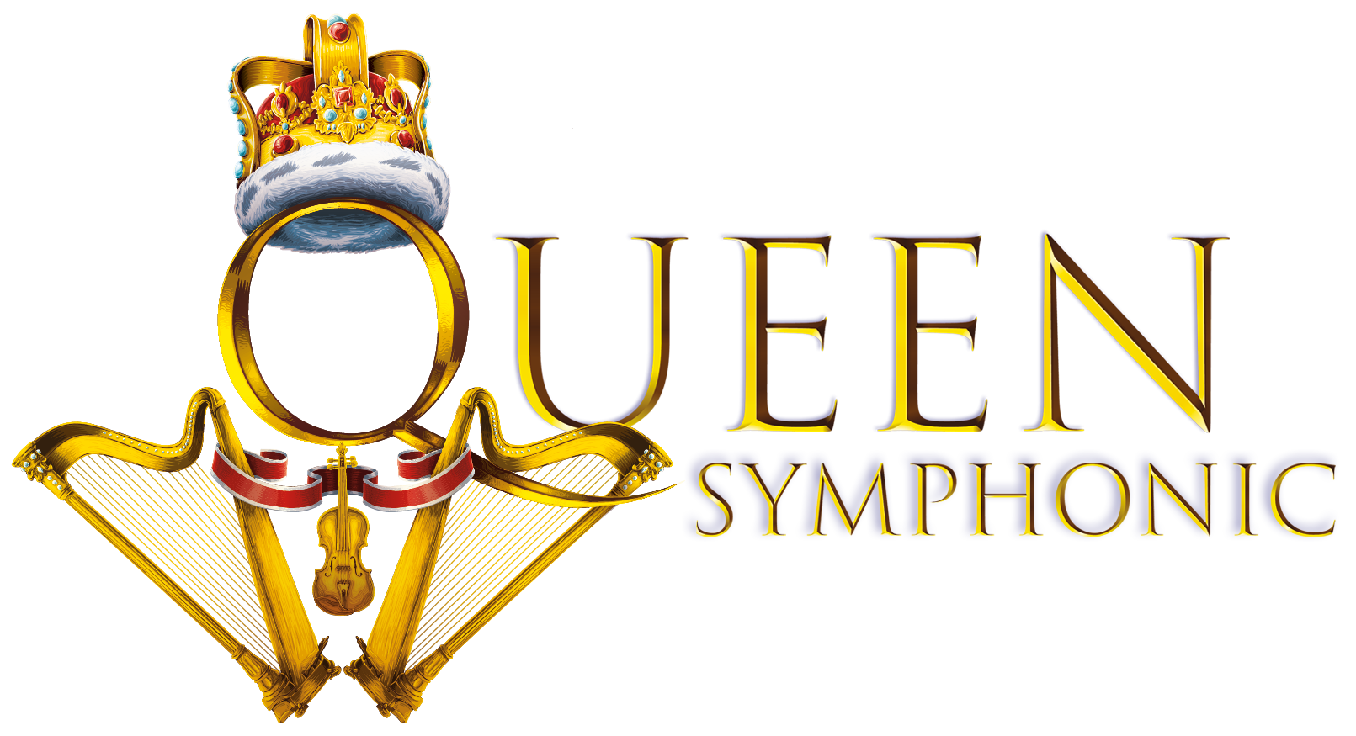

FRIDAY 22ND JULY 2022
NEWMARKET RACECOURSES

Join in the conversation online #JCLive
The Show Must Go On! The Jockey Club Live and Newmarket Racecourses welcome QUEEN SYMPHONIC to the Newmarket Nights summer season. The rock and orchestral spectacular will be headlining on Friday 22nd July.

QUEEN SYMPHONIC celebrates the greatest and most treasured hits of QUEEN, bringing together international stars from the award-winning musical We Will Rock You, an incredibly talented rock band and a symphony orchestra. Since its premiere in 2007, QUEEN SYMPHONIC has been enjoyed by hundreds of thousands of Queen fans across the globe, giving them the opportunity to hear the hits as never before.

With Queen’s epic catalogue of hits lending itself perfectly for rock and classical interpretation, expect to experience beloved tracks such as We Will Rock You, Bohemian Rhapsody, Radio Ga Ga, We Are The Champions, A Kind of Magic, Who Wants To Live Forever, Killer Queen, Don’t Stop Me Now, Fat Bottomed Girls, Somebody to Love and many, many more.

With over 40 performers on stage, this concert is truly worthy of the world of symphonic rock.

Sophie Able, General Manager of Newmarket Racecourses, said
“The music of Queen is timeless and loved by generations. Queen Symphonic continue their legacy performing the classics in a dazzling spectacle which I’m sure will have The July Course dancing the night away on 22nd July!”

2021 saw a season of incredible live shows at The Jockey Club racecourses, ranging from a sold-out show for Tom Jones to an afternoon of joyful singalongs with McFly at Newmarket Racecourses. Despite the challenges of staging a season in 2021, the events marked the return to live music for thousands of fans. The Jockey Club Live events continue to be renowned for combining an electric evening at the races with a spectacular evening concert in an informal and relaxed open-air setting.

Looking forward to a full-strength line-up in 2022, the likes of Anne-Marie, Paloma Faith, The Script, Pete Tong & The Heritage Orchestra are already confirmed with more announcements to come…

2022
17th June – Paloma Faith – Newmarket Racecourses
15th July - The Script - Newmarket Racecourses
22nd July – Queen Symphonic – Newmarket Racecourses
29th July – Anne-Marie – Newmarket Racecourses
12th August - Pete Tong & The Heritage Orchestra - Newmarket Racecourses

Tickets for QUEEN SYMPHONIC at Newmarket Racecourses will be on sale at 10am on Friday 11th February via thejockeyclublive.co.uk, with a presale available to customers at 10am on Wednesday 9th February. Tickets are priced starting at £28 including booking fee. There will be hospitality packages available to suit all budgets. Tickets for all other shows are available now at thejockeyclub.com/live.

FOR MORE INFORMATION AND ALL MEDIA ENQUIRIES FOR
THE JOCKEY CLUB LIVE PLEASE CONTACT

Warren Higgins & Jenny Entwistle at Chuff Media
warren@chuffmedia.com / jenny@chuffmedia.com
About The Jockey Club Live
The Jockey Club Live is an innovative event entertainment promoter specialising in combining live music and racing. Since its launch in 2014 the Jockey Club Live has promoted more than 120 concerts with a combined attendance of more than 1 million and was revealed by Music Week as the UK’s 6th largest music promoter. The Jockey Club Live’s vision is to bring the biggest names in pop music to racing events across the country; giving consumers an exceptional experience of live music and racing.
http://www.thejockeyclublive.co.uk

About Newmarket Racecourses
Newmarket’s two magical racecourses, the Rowley Mile and the July Course, together form the greatest venue in the East of England. Hosting exhilarating world class Flat racing, pulsating music nights, great value family days, award-winning restaurants and exceptional conferences, in 2016 Newmarket Racecourses proudly celebrated 350 years of extraordinary royal patronage.

One of the largest sports businesses operating in the UK today (2019 turnover: £216.5 million), The Jockey Club is at the heart of so many aspects of Britain’s second-biggest spectator sport. We run 15 of the UK’s leading racecourses – large and local, where we’re charged with looking after some of the nation’s biggest events, including the Randox Grand National at Aintree, The Festival at Cheltenham, The Cazoo Derby Festival at Epsom Downs and the QIPCO Guineas Festival in Newmarket. We welcome thousands of racehorses a year to our training centres in Newmarket, Lambourn and Epsom. We run The National Stud in Newmarket and our charity, Racing Welfare, makes help available to all of racing’s people. We are governed by Royal Charter to act for the long-term benefit of British Racing and our Patron is Her Majesty The Queen.

