Present
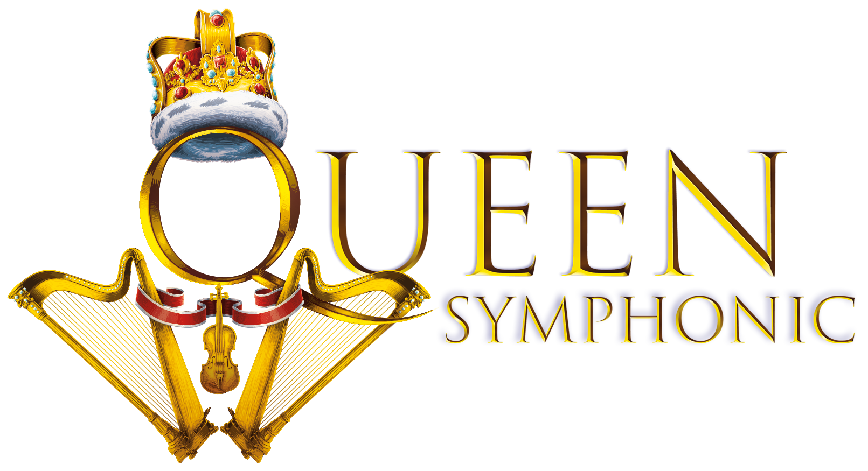
FRIDAY 3RD JUNE 2022

AN OPEN AIR CONCERT AT MARKET RASEN RACECOURSE

Join in the conversation online #JCLive22
To mark the celebration of Her Majesty the Queen’s Platinum Jubilee, The Jockey Club Live and Market Rasen Racecourse are delighted to present QUEEN SYMPHONIC, a rock and orchestral spectacular, for a full headline concert after racing on Friday 3rd June.

QUEEN SYMPHONIC celebrates the greatest and most treasured hits of QUEEN, bringing together international stars from the award-winning musical We Will Rock You, an incredibly talented rock band and a symphony orchestra. Since its premiere in 2007, QUEEN SYMPHONIC has been enjoyed by hundreds of thousands of Queen fans across the globe, giving them the opportunity to hear the hits as never before.

With Queen’s epic catalogue of hits lending itself perfectly for rock and classical interpretation, expect to experience beloved tracks such as We Will Rock You, Bohemian Rhapsody, Radio Ga Ga, We Are The Champions, A Kind of Magic, Who Wants To Live Forever, Killer Queen, Don’t Stop Me Now, Fat Bottomed Girls, Somebody to Love and many, many more.

With over 40 performers on stage, this concert is truly worthy of the world of symphonic rock.

Market Rasen Racecourse will be hosting QUEEN SYMPHONIC as part of the Platinum Jubilee Garden Party celebrations, with a host of activities taking place throughout the day in recognition of this historic occasion.

Joe Callan, Interim General Manager, Market Rasen Racecourse, said:
“With our Platinum Jubilee Garden Party swiftly becoming a not-to-be-missed highlight of the Summer, we’re overjoyed to welcome Queen Symphonic to the celebrations. Queen’s music transcends generations and will be the perfect soundtrack to what will hopefully be a warm summer’s evening on the green.”

Welcoming live music back to Market Rasen, The Jockey Club Live are leading promoters on the UK live scene, delivering spectacular line-ups of some of the hottest chart talent and legendary household names to some of the world’s most famous racecourses. The Jockey Club Live concerts at Market Rasen Racecourse are a staple in the region’s social calendar and over the past few years have hosted thousands of fans of live music, with performances from artists including Paloma Faith, Olly Murs, Kaisers Chiefs and Tom Jones.

Tickets will be on sale at 10am on 11th February via thejockeyclublive.co.uk, with a presale available to customers at 10am on Wednesday 9th February. Tickets are priced starting at £28 for adults and £16.80 for children (inclusive of booking fees). A family package is available for the Lawn Enclosure. All T&C’s are available on marketrasen.thejockeyclub.co.uk. There will be hospitality packages available to suit all budgets.

FOR MORE INFORMATION AND ALL MEDIA ENQUIRIES FOR
THE JOCKEY CLUB LIVE PLEASE CONTACT

Warren Higgins & Jenny Entwistle at Chuff Media
warren@chuffmedia.com / jenny@chuffmedia.com

About The Jockey Club Live

The Jockey Club Live is an innovative event entertainment promoter specialising in combining live music and racing. Since it’s launch in 2014 the Jockey Club Live has promoted over 100 concerts with a combined attendance of over 900,000 and was revealed by Music Week as the UK’s 6th largest music promoter. The Jockey Club Live’s vision is to bring the biggest names in pop music to racing events across the country; giving consumers an exceptional experience of live music and racing.

About Market Rasen Racecourse

Market Rasen Racecourse, which is part of The Jockey Club, stages 21 jump racing meetings and attracts over 60,000 visitors each year. It has been chosen by the Racehorse Owners Association as one of the top six smaller racecourses in Britain for the last three years. More information is available at marketrasenraces.co.uk.

One of the largest sports businesses operating in the UK today (2019 turnover: £216.5 million), The Jockey Club is at the heart of so many aspects of Britain’s second-biggest spectator sport. We run 15 of the UK’s leading racecourses – large and local, where we’re charged with looking after some of the nation’s biggest events, including the Randox Grand National at Aintree, The Festival at Cheltenham, The Cazoo Derby Festival at Epsom Downs and the QIPCO Guineas Festival in Newmarket. We welcome thousands of racehorses a year to our training centres in Newmarket, Lambourn and Epsom. We run The National Stud in Newmarket and our charity, Racing Welfare, makes help available to all of racing’s people. We are governed by Royal Charter to act for the long-term benefit of British Racing and our Patron is Her Majesty The Queen.

