Present

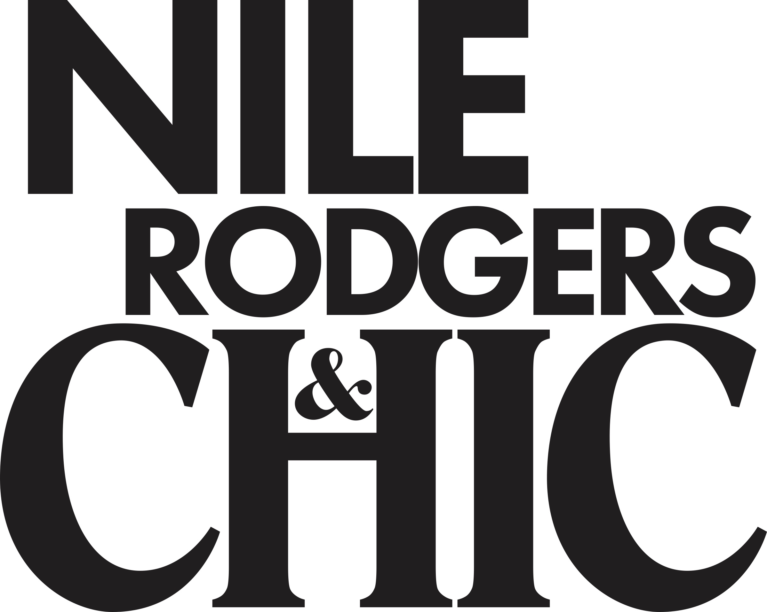

RESCHEDULED TO SUMMER 2022 AT SANDOWN PARK RACECOURSE
Since the release of the UK Government roadmap, The Jockey Club Live have been working hard behind the scenes regarding the return of live music this summer at Sandown Park Racecourse.

Due to Nile Rodgers & CHIC postponing their 2021 summer shows, we are unfortunately having to reschedule their Sandown Park Racecourse performance from the 28th July 2021 to Wednesday 27th July 2022. Craig David will still be headlining this summer after an evening of racing on Thursday 5th August.

Phil White, Regional Director, London Region, Jockey Club Racecourses said:
“We're sorry to announce that the Nile Rodgers & CHIC headline concert is being postponed and rescheduled for summer 2022. We know fans will be disappointed that this concert is not taking place this year, but we can promise it will be worth the wait.”

Nile Rodgers said:
“Over the last few years we’ve really enjoyed playing for The Jockey Club Live as it’s always an amazing and festive atmosphere that’s perfect for CHIC music. It’s disappointing that we won’t be able to play this summer due to Covid restrictions but we can’t wait to see all of our friends for good times in 2022!”

Tickets for Nile Rodgers & CHIC will automatically be transferred to the new date, however ticket holders will be contacted and given the option of requesting a full refund or e-voucher to attend a future music night or racing fixture of their choice.
The Jockey Club Live events are renowned for combining a fun-filled evening at the races with a spectacular evening concert in the informal and relaxed open-air setting of the hallowed turf.

The Jockey Club racecourses’ have world-class customer facilities, featuring an array of award-winning restaurants that cater for all tastes, from fine dining through to delicious bistro food. The Jockey Club’s racecourses welcome more than 2 million people a year for some of the UK’s biggest racing events so you can be sure of a fantastic evening.

In addition to Sandown Park, The Jockey Club Live will be hosting live concerts across Newmarket, Aintree and Haydock Park and this summer.

For all media information, including previews, interviews, reviews etc for
The Jockey Club Live, contact Warren or Jenny at Chuff Media
Name@chuffmedia.com

About The Jockey Club Live
The Jockey Club Live is an innovative event entertainment promoter specialising in combining live music and racing. Since its launch in 2014 the Jockey Club Live has promoted more than 120 concerts with a combined attendance of more than 1 million and was revealed by Music Week as the UK’s 6th largest music promoter. The Jockey Club Live’s vision is to bring the biggest names in pop music to racing events across the country; giving consumers an exceptional experience of live music and racing.
http://www.thejockeyclublive.co.uk

About Sandown Park Racecourse
Founded in 1875, Sandown Park Racecourse has provided the backdrop to some of the greatest moments in horse racing history. A day at the races at Sandown Park has it all with top-level racing throughout the year including the bet365 Jump Finale, Coral-Eclipse Summer Festival and Betfair Tingle Creek Christmas Festival meetings as well as the popular Music Nights. More information is available at www.sandown.co.uk.

Sandown Park Racecourse is part of The Jockey Club, one of the largest sports businesses operating in the UK today (2019 turnover: £216.5 million), The Jockey Club is at the heart of so many aspects of Britain’s second-biggest spectator sport. We run 15 of the UK’s leading racecourses – large and local, where we’re charged with looking after some of the nation’s biggest events, including the Randox Grand National at Aintree, The Festival™ supporting WellChild at Cheltenham, The Cazoo Derby Festival at Epsom Downs and the QIPCO Guineas Festival in Newmarket. We welcome thousands of racehorses a year to our training centres in Newmarket, Lambourn and Epsom. We run The National Stud in Newmarket and our charity, Racing Welfare, makes help available to all of racing’s people. We are governed by Royal Charter to act for the long-term benefit of British Racing and our Patron is Her Majesty The Queen.

For more information please visit www.thejockeyclub.co.uk.

