Present

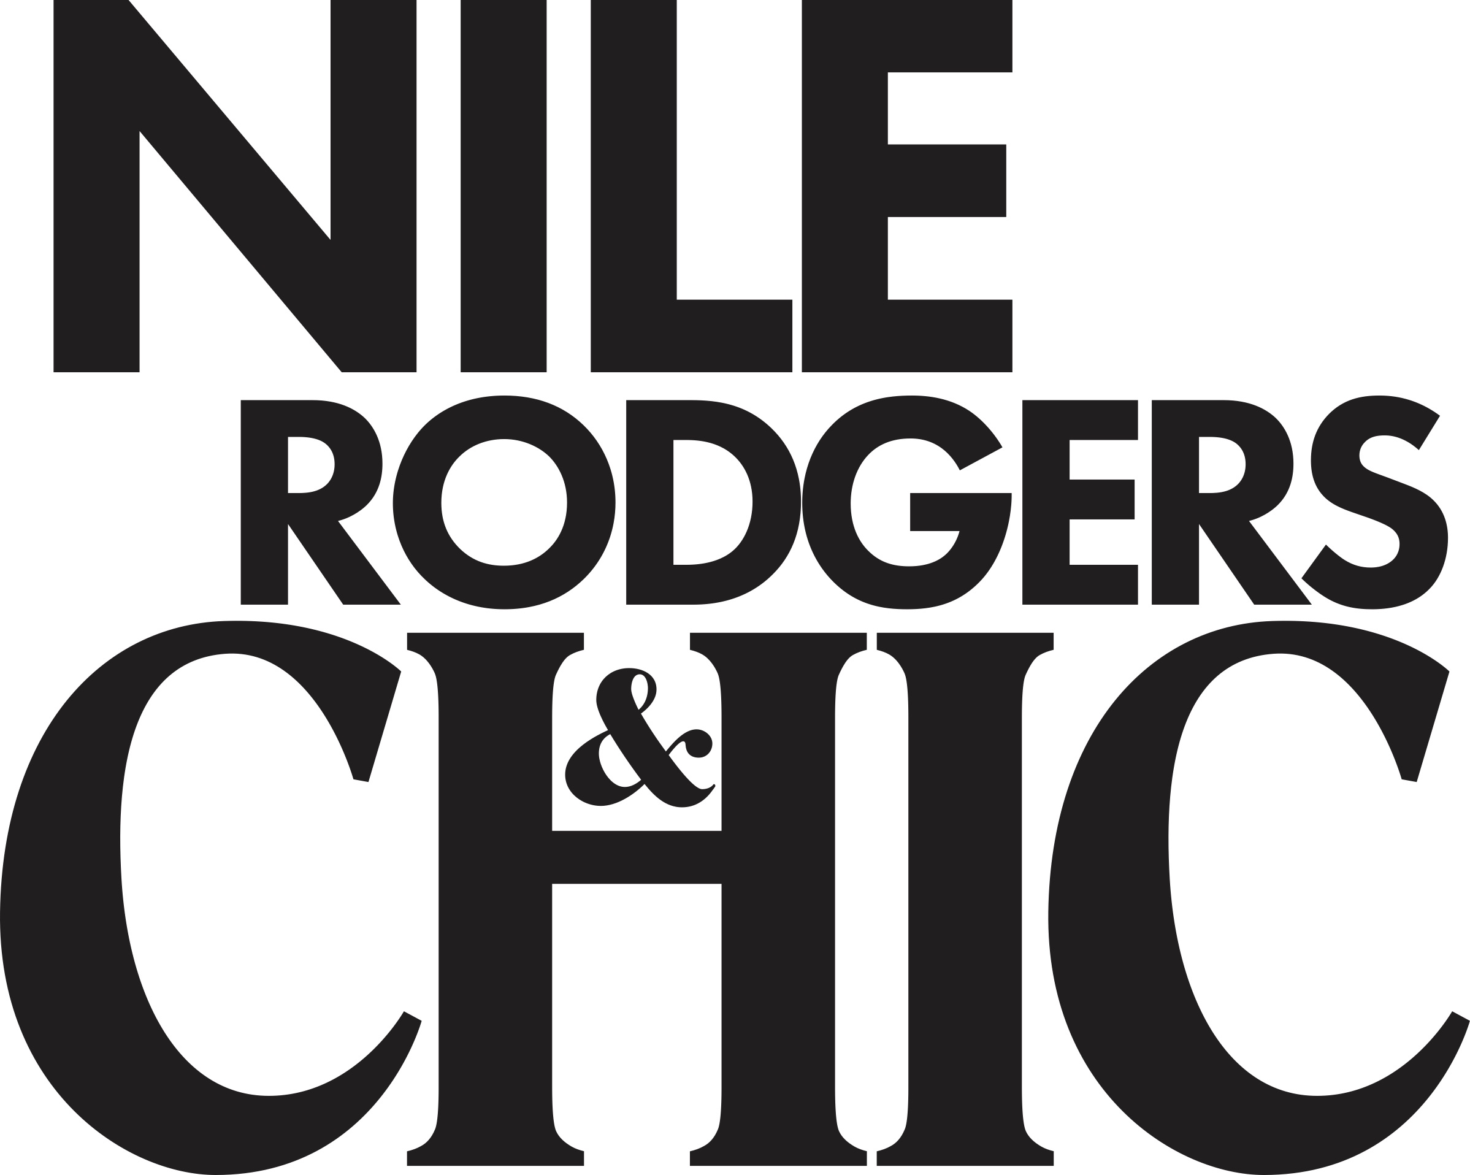

RESCHEDULED TO SUMMER 2022 AT AINTREE RACECOURSE
Since the release of the UK Government roadmap, The Jockey Club Live have been working hard behind the scenes regarding the return of live music this summer at Aintree Racecourse.

With the planned reopening of large-scale events scheduled for the 21st June, we are unfortunately having to reschedule Nile Rodgers & CHIC from the 11th June 2021 to Friday 10th June 2022.

Dickon White, Regional Director of Jockey Club Racecourses North West:
“We're sorry to announce that due to the government restrictions in place before 21st June, the Nile Rodgers & CHIC headline concert is being postponed and rescheduled for summer 2022. We know fans will be disappointed that this concert is not taking place this year, but we can promise it will be worth the wait!”

Nile Rodgers said:
“Over the last few years we’ve really enjoyed playing for The Jockey Club Live as it’s always an amazing and festive atmosphere that’s perfect for CHIC music. It’s disappointing that we won’t be able to play in June due to Covid restrictions but we can’t wait to see all of our friends for good times in 2022!”

Tickets will automatically be transferred to the new date, however ticket holders will be contacted and given the option of requesting a full refund or e-voucher to attend a future music night or racing fixture of their choice.
The Jockey Club Live events are renowned for combining a fun-filled evening at the races with a spectacular evening concert in the informal and relaxed open-air setting of the hallowed turf.

The Jockey Club racecourses’ have world-class customer facilities, featuring an array of award-winning restaurants that cater for all tastes, from fine dining through to delicious bistro food. The Jockey Club’s racecourses welcome more than 2 million people a year for some of the UK’s biggest racing events so you can be sure of a fantastic evening.

In addition to Aintree, The Jockey Club Live will be hosting live concerts across Newmarket, Sandown Park and Haydock Park and this summer.

For all media information, including previews, interviews, reviews etc for
The Jockey Club Live, contact Warren or Jenny at Chuff Media
Name@chuffmedia.com

About The Jockey Club Live
The Jockey Club Live is an innovative event entertainment promoter specialising in combining live music and racing. Since its launch in 2014 the Jockey Club Live has promoted more than 120 concerts with a combined attendance of moe than 1 million and was revealed by Music Week as the UK’s 6th largest music promoter. The Jockey Club Live’s vision is to bring the biggest names in pop music to racing events across the country; giving consumers an exceptional experience of live music and racing.
http://www.thejockeyclublive.co.uk

About Aintree Racecourse
Aintree is home to The Randox Grand National, the most famous horse race in the world which is the climax to a three-day Festival meeting in April every year. The racecourse hosts five other fixtures and is a leading conference centre in the north west of England. More information is available at aintree.thejockeyclub.co.uk.

Aintree is part of About The Jockey Club which stages thrilling sporting occasions including The Randox Health Grand National, The Cheltenham Festival and The Investec Derby. Millions of people every year enjoy the special experiences we offer through racing, music, food and entertainment. Governed by Royal Charter, every penny we make goes back into British Racing to help the sport thrive. We were founded in 1750 and today we are the largest commercial group in Britain’s second-biggest spectator sport, operating 15 racecourses nationwide, The National Stud, Jockey Club Estates, Jockey Club Catering, Jockey Club Live and our charity, Racing Welfare. For more information visit www.thejockeyclub.co.uk.

