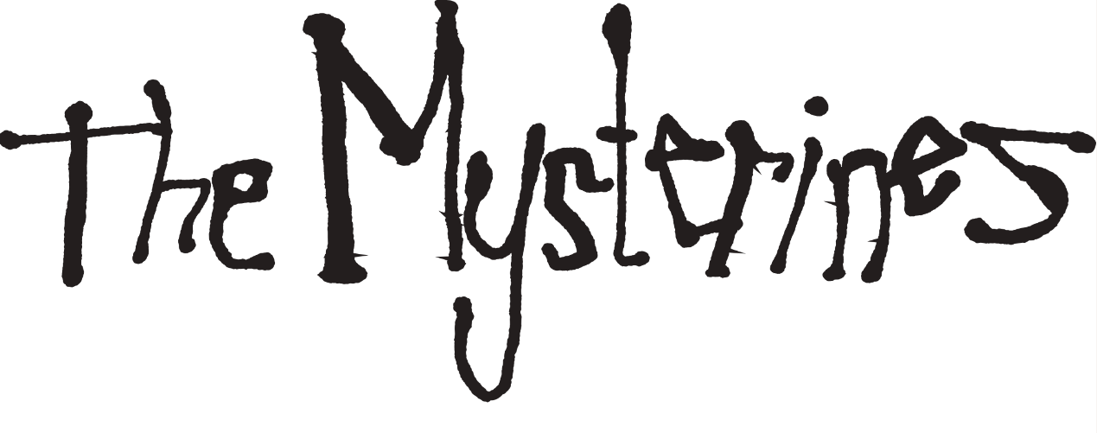
RELEASE NEW SINGLE ‘SINK YA TEETH’
LISTEN HERE

NEW ALBUM ‘AFRAID OF TOMORROWS’
OUT ON 7TH JUNE VIA FICTION RECORDS
PRE-ORDER HERE

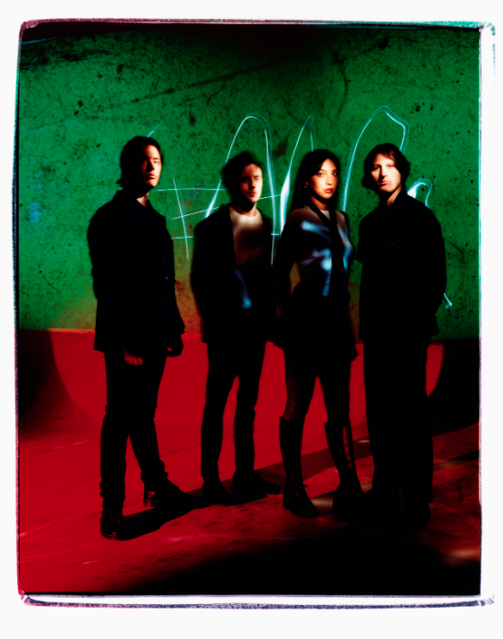
Photo Credit: Steve Gullick
DOWNLOAD HI RES IMAGE HERE

Merseyside alternative rock band The Mysterines have released a thrilling new single ‘Sink Ya Teeth’, the second track to be taken from their highly-anticipated new album ‘Afraid of Tomorrows’, due for release on 7th June via Fiction Records. Listen here.

Underpinned by a heavy bass riff with a steady, danceable drumbeat and topped off with frontwoman Lia Metcalfe’s powerhouse vocals, ‘Sink Ya Teeth’ shows the band at the height of their powers.

Lia comments on the song: “Sink Ya Teeth is a testament to the brutality of real love. Written during a time where the boundaries of pain and passion were warped amidst the chaos of addiction and desire.”

Formed in Liverpool, The Mysterines – frontwoman Lia Metcalfe, drummer Paul Crilly, bassist George Favager and guitarist Callum Thompson – have undergone a radical transformation over the past few years. Fresh with new purpose and reinvigorated from songwriting sessions while secluded away in the countryside (in between playing to 60,000-strong crowds while on tour with the Arctic Monkeys), the band are now about to release the best music of their career.

Recorded and produced by Grammy Award winning producer John Congleton (St. Vincent, Angel Olsen) in LA, ‘Afraid of Tomorrows’ is a deeper and darker foray into The Mysterines’ psyche than its predecessor, and reflects the maturity and growth of the band. “Afraid of Tomorrows is a mirror where you find you’re nothing more than a formless being, one made from celestial constellations - of traumas, of the old and new, mistakes, addiction, fear and happiness, loneliness, but ultimately a desire for life and the fight to keep living. It’s a collage of what’s been lost and of love unbounded”, says Lia.

The Mysterines are set to embark on their biggest headline tour to date this Autumn. The 16-date run will kick off in Dublin on 18th October and include a stop at London’s iconic O2 Shepherds Bush Empire, culminating in Paris on 8th November. Multiple dates are already sold out - remaining tickets are available here.

The band will play a string of exciting shows this summer, including at Crystal Palace Park as special guests to Bloc Party for their huge 20th anniversary show on 7th July, and numerous festivals all over the UK and Europe including Live at Leeds in the Park, 2000 Trees, Truck Festival, Tramlines and Best Kept Secret.

The Mysterines - ‘Afraid of Tomorrows’ Album Artwork
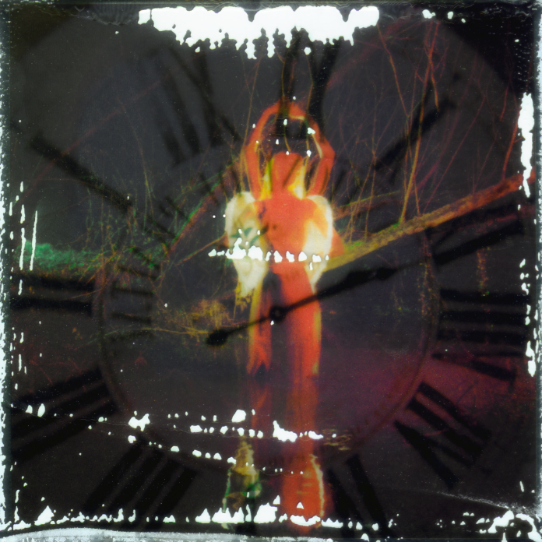
DOWNLOAD HI-RES ARTWORK HERE

The Mysterines - ‘Afraid of Tomorrows’ Track List:

1. The Last Dance
2. Stray
3. Another Another Another
4. Tired Animal
5. Jesse You're A Superstar
6. Hawkmoon
7. Sink Ya Teeth
8. Junkyard Angel
9. Goodbye Sunshine
10. Inside A Matchbox
11. So Long
12. Afraid of Tomorrows

The Mysterines 2024 Live Dates

Summer Shows:
10th May - FOCUS Wales 2024, UK
11th May - Are You Listening? Festival, Reading, UK
17th May - London Calling, Amsterdam, Netherlands
24th May - In It Together Festival, Wales, UK
25th May - Live at Leeds in the Park, Leeds, UK
9th Jun - Best Kept Secret, Netherlands
21st Jun - Southside Festival, Germany
23rd Jun - Hurricane Festival, Germany
7th Jul - Crystal Palace Park, London (supporting Bloc Party)
11th Jul - 2000 Trees Festival, Cheltenham, UK
20th Jul - Tsunami Festival, Spain
25th Jul - Truck Festival, Steventon, UK
26th Jul - Tramlines Festival, Sheffield, UK
2nd Aug - Y Not Festival, UK
3rd Aug - Rocken Am Brocken, Germany

5th Oct - Manchester Venue TBA

Headline Tour:
18th Oct - Whelan's, Dublin
19th Oct - Ulster Sports Club, Belfast
20th Oct - Saint Luke's, Glasgow *SOLD OUT*
22nd Oct - Rescue Rooms, Nottingham *SOLD OUT*
23rd Oct - Thekla, Bristol *SOLD OUT*
24th Oct - O2 Shepherd's Bush Empire, London
26th Oct - Olympia, Liverpool
28th Oct - Antwerp, Belgium
30th Oct - Molotow Skybar, Hamburg
31st Oct - Badehaus, Berlin
2nd Nov - Niebo, Warshaw
3rd Nov - Futurum, Prague
4th Nov - Kranhalle, Munich
6th Nov - Biko, Milan
7th Nov - Exil, Zurich
8th Nov - La Boule Noire, Paris

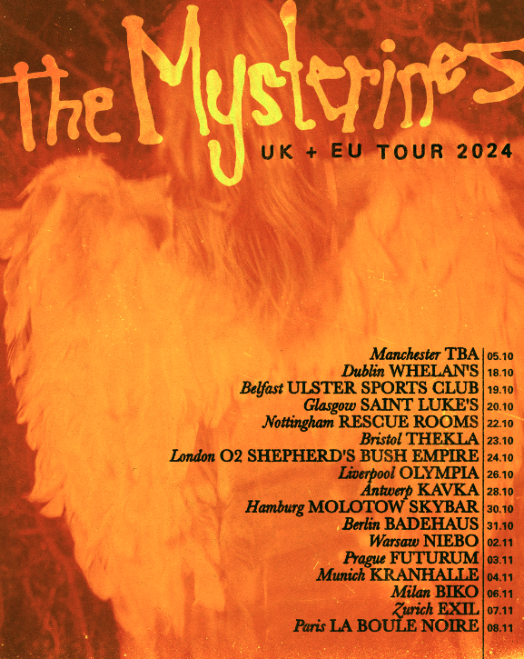

The Mysterines are:
Lia Metcalfe (vocals/guitar)
George Favager (bass)
Callum Thompson (guitar)
Paul Crilly (drums)

THE MYSTERINES ONLINE
INSTAGRAM | TWITTER | FACEBOOK | SPOTIFY

For more information please contact
Warren@chuffmedia.com on 07762 130 510

