**THE HORRORS**

**ANNOUNCE UK + IE TOUR**

**NEW ALBUM** [NIGHT LIFE](https://thehorrors.lnk.to/NightLifePR) **OUT NOW VIA FICTION RECORDS**

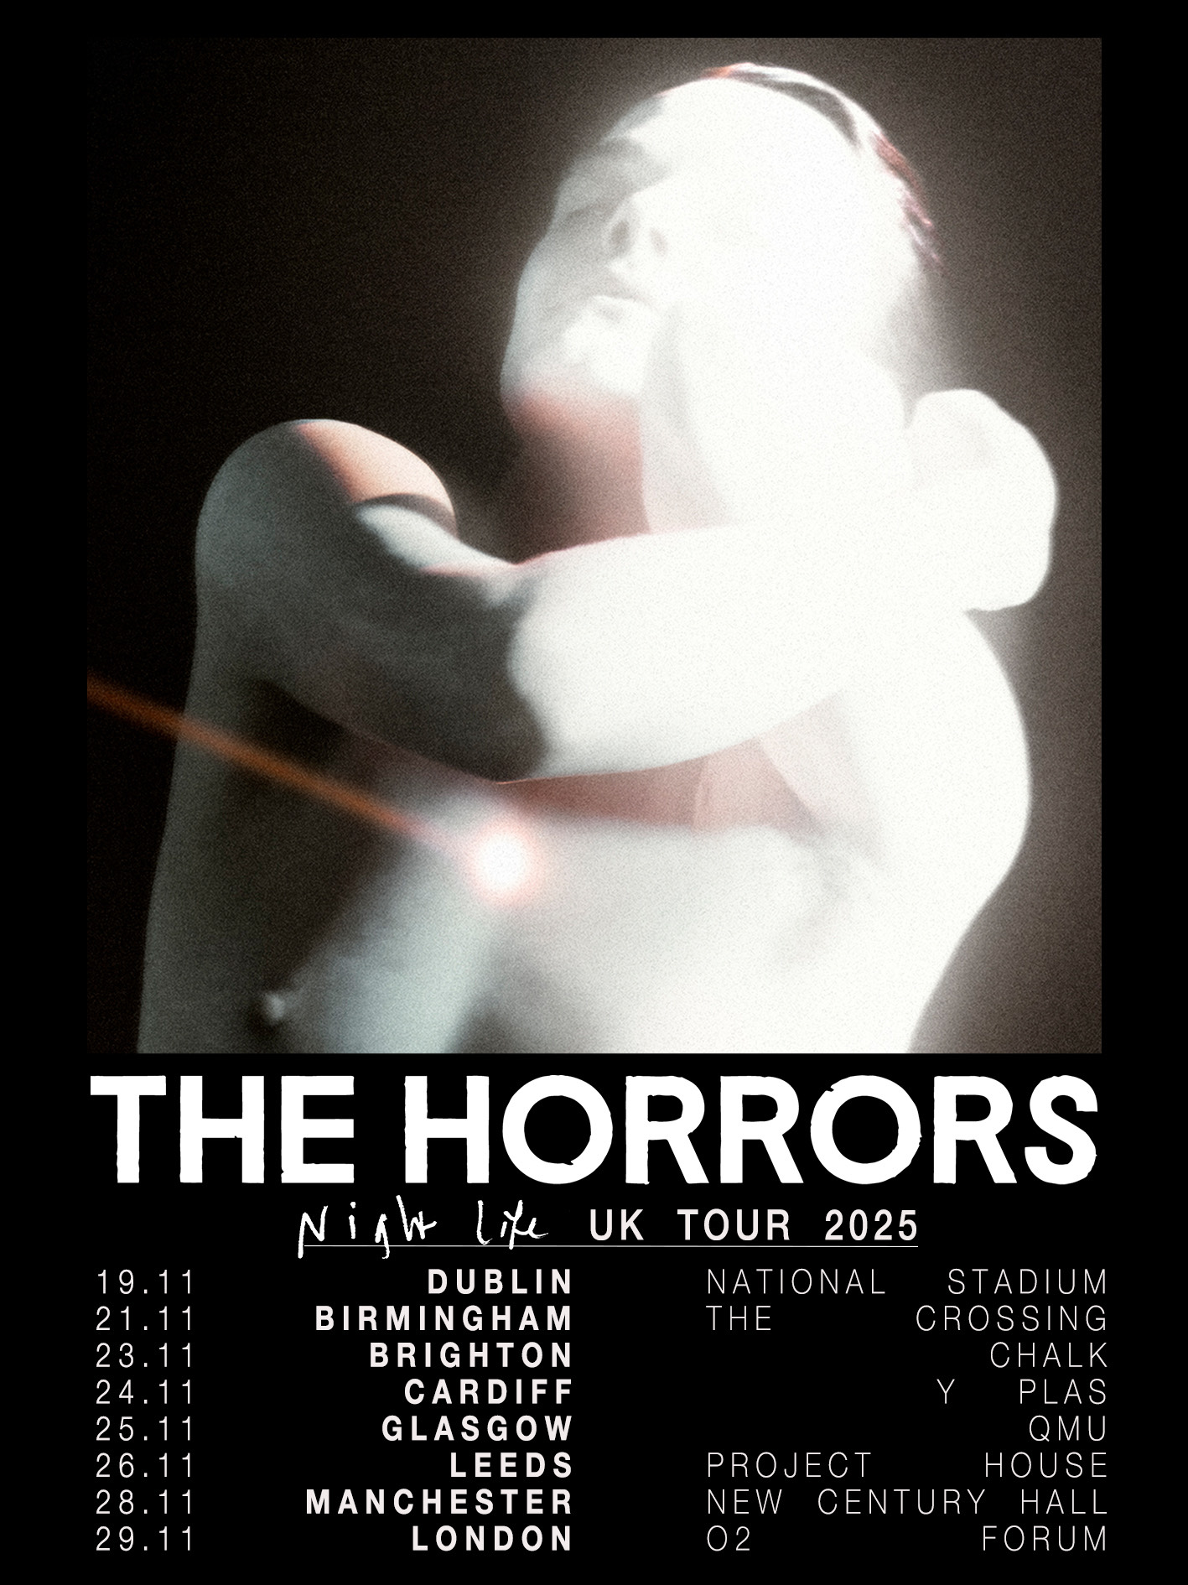

**…**

*“They have returned with a new line-up, dug deep into their gothic roots and come up with a gem”* - **The Sunday Times 4* Album of the Week**

*“an impressive return” -* **NME 4\***

*“All consuming”* - **The Guardian**

*“Further Horrors classics for that ‘best of’ yet to come” -* **Mojo 4\***

*“Their best album since Skying” -* **The Line of Best Fit 8/10**

*“He’s done some of the finest writing of his career here, on a record where The Horrors burn the midnight oil with a new intensity”* - **DIY, 4\***

*“The Horrors are reliably brilliant”* - **DORK, 4\***

…

Following the release of their critically acclaimed sixth studio album, ***Night Life*** last week via Fiction Records, The Horrors have announced a UK and Ireland tour for November 2025 including O2 Forum Kentish Town - full dates below. Album purchases will unlock ticket presale, on now, with general sale from this Friday 28th.

[LISTEN TO NIGHT LIFE HERE](https://thehorrors.lnk.to/NightLifePR)[WATCH THE VISUALISER FOR ‘LA RUNAWAY’ HERE](https://thehorrors.lnk.to/LARunawayPR/youtube)

As The Horrors approach their 20th anniversary as a band, *Night Life*sees them shapeshift into a new form, with a new sonic outlook and a new line up centred around the core duo of vocalist **Faris Badwan** and bassist **Rhys Webb**, now joined by **Amelia Kidd** on keys and Telegram’s **Jordan Cook** on drums, making the new album the band’s first to not feature all 5 original members.

*Night Life* is a record of weight and space, of melancholy and euphoria; a record that has the ability to make bedfellows of seemingly disparate ideas as only The Horrors can. The ‘Night Life’ here is not the vim and vigour of pubs and clubs. It’s the thoughts that happen under the cover of darkness; the places your mind takes you when the rest of the world is asleep. A record born out of a desire to revive the raw, instinctive spirit of the band’s early work.

After nearly 20 years making music, there are few bands who’ve created a canon as determinedly innovative and consistently critically-acclaimed as **The Horrors**. Emerging as zeitgeist-shaking garage-goths on their 2007 debut **‘Strange House’**, before taking a sharp left turn for their Mercury-nominated follow up **‘Primary Colours’**, since the beginning they’ve roamed freely between genres. 2011’s ‘**Skying’** won the NME Award for Best Album; **‘V’** was heralded as “a triumph” in a five-star Guardian review, while 2021’s pair of EPs - **‘Lout’** and **‘Against The Blade’** - marked a new chapter with their most industrial, uncompromising output yet.



**…**

**THE HORRORS LIVE DATES**

**Thu 20th Mar - Banquet, Pryzm, Kingston (Instore)**

**Fri 21st Mar - Rough Trade East, London (Instore)**

**Sat 22nd Mar - Resident, Brighton (Instore)**

**Sun 23rd Mar - Rough Trade, Bristol (Instore)**

**Tue 25th Mar - Rough Trade Liverpool (Instore)**

**Wed 26th Mar - Piccadilly, Night & Day Cafe, Manchester (Instore)**

**Thu 27th Mar - Crash, Brudenell Social Club, Leeds (Instore)**

3rd April - Sala Capitol, Santiago de Compostela

5th April - Barcelona Psych Fest, Paral-lel 62, Barcelona

6th April - Sala Mon, Madrid

7th April - Sala Moon, Valencia

9th April - Hard Club, Porto

10th April – Republica Da Musica, Lisbon

23rd May - A Stone’s Throw Festival, Newcastle

24th/25th May - Dot To Dot Festival (Headline)

27th June Sofia Live Festival, Bulgaria on

12th July Siren Festival, Santa Severa Italy

6th Sept Misty Fields, Netherlands

**Wed 19 Nov – National Stadium, Dublin**

**Fri 21 Nov – The Crossing, Birmingham**

**Sun 23 Nov – CHALK, Brighton**

**Mon 24 Nov – Y PLAS, Cardiff**

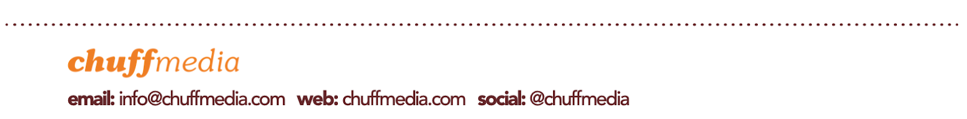**Tue 25 Nov – QMU, Glasgo**w

**Wed 26 Nov – Project House, Leeds**

**Fri 28 Nov – New Century Hall, Manchester**

**Sat 29 Nov - O2 Forum Kentish Town, London**

…

**THE HORRORS SOCIALS**

[INSTAGRAM](https://www.instagram.com/thehorrors/?hl=en) **|** [X (FORMALLY TWITTER)](https://x.com/horrorsofficial?ref_src=twsrc%255Egoogle%257Ctwcamp%255Eserp%257Ctwgr%255Eauthor) **|** [WEBSITE](https://www.thehorrors.co.uk/)

**For more info contact** [warren@chuffmedia.com](mailto:warren@chuffmedia.com)