**THE HORRORS**

**ANNOUNCE NEW ALBUM ‘NIGHT LIFE’**

**OUT MARCH 21ST**

**RELEASE NEW SINGLE**

**‘**[**THE SILENCE THAT REMAINS**](https://thehorrors.lnk.to/silencethatremainsPR)**’**

**ANNOUNCE INTIMATE WINTER UK SHOWS**

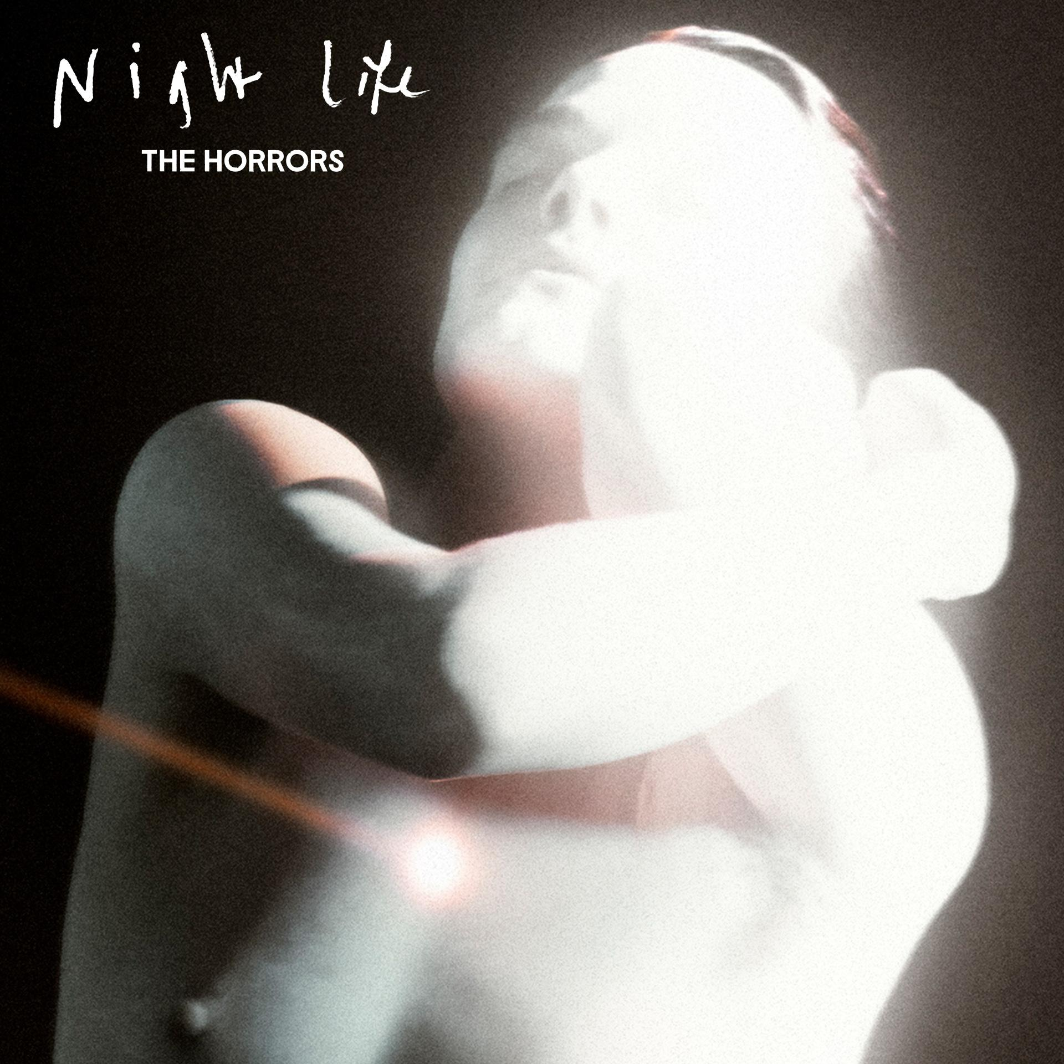

The Horrors today announce their sixth studio album ‘Night Life’, out March 21st via Fiction Records. The album announcement is accompanied by brand new single and video ‘The Silence That Remains’ as well as a winter string of intimate shows including London’s ICA on November 28th. Tickets available on presale from Friday 4th at 10am, full live dates below.

[**WATCH THE OFFICIAL VIDEO FOR ‘SILENCE THAT REMAINS’ HERE**](https://thehorrors.lnk.to/silencethatremainsPR/youtube)

Propulsive yet understated, ‘The Silence That Remains’ is an instant Horrors classic. Featuring duet vocals between Faris Badwan and new keyboardist Amelia Kidd, the release marks the beginning of a new era for the band, drawing their recent industrial experimentation together with The Horrors’ signature, motoring rhythms for a thrilling first taste of the album to follow.

*““The Silence that Remains” is a 3am insomnia walk through the city, retracing our steps and putting the past to bed. Our new chapter is beginning and we’re looking forward to taking you with us. The Horrors are never-ending”*

As The Horrors approach their 20th anniversary as a band, ‘Night Life’ sees them shapeshift into a new form, with a new sonic outlook and a new line up centred around the core duo of vocalist Faris Badwan and bassist Rhys Webb, now joined by Amelia Kidd on keys and Telegram’s Jordan Cook on drums, making the new album the band’s first to not feature all 5 original members. While demos began modestly in Webb’s basement flat in North London with the pair thriving on the immediacy of, as Faris describes, *“shortening the distance between having an idea and expressing it”*, the record truly took shape in LA under the guidance of producer Yves Rothman (Yves Tumor, Blondshell) before finishing touches were applied back in London along with guitarist Josh Hayward, with Kidd bouncing parts and production ideas remotely from Glasgow.

The resulting album is a record of weight and space, of melancholy and euphoria; a record that has the ability to make bedfellows of seemingly disparate ideas as only The Horrors can. The ‘Night Life’ here is not the vim and vigour of pubs and clubs. It’s the thoughts that happen under the cover of darkness; the places your mind takes you when the rest of the world is asleep. A record born out of a desire to revive the raw, instinctive spirit of the band’s early work.

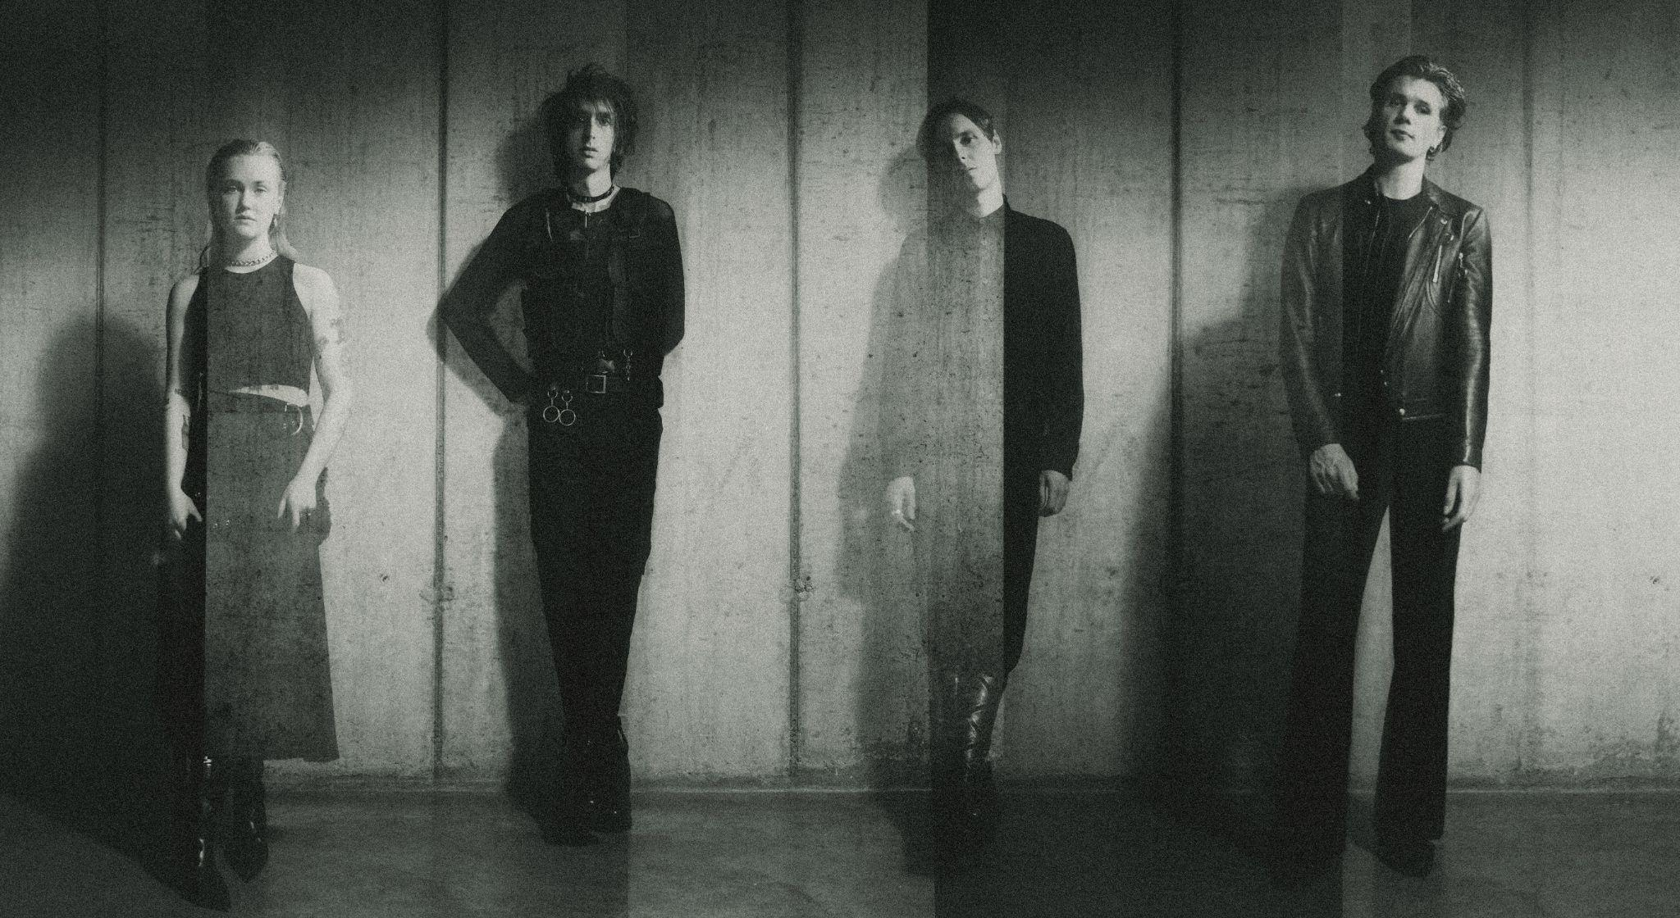

Credit: Sarah Piantadosi

After nearly 20 years making music, there are few bands who’ve created a canon as determinedly innovative and consistently critically-acclaimed as The Horrors. Emerging as zeitgeist-shaking garage-goths on their 2007 debut ‘Strange House’, before taking a sharp left turn for their Mercury-nominated follow up ‘Primary Colours’, since the beginning they’ve roamed freely between genres. 2011’s ‘Skying’ won the NME Award for Best Album; ‘V’ was heralded as “a triumph” in a five-star Guardian review, while 2021’s pair of EPs - ‘Lout’ and ‘Against The Blade’ - marked a new chapter with their most industrial, uncompromising output yet.

[**Preorder/Pre-save ‘Night Life’ HERE**](https://thehorrors.lnk.to/nightlifePR)

**The Horrors Live Dates:**

**Artist presale: 10am Friday 4th October - 6pm Tuesday 8th**

**General sale: 10am Friday 11th**

Wed 27 Nov 2024, Bedford, Esquires

Thu 28 Nov 2024, London, The ICA

Tue 3 Dec 2024, Manchester, Yes (Pink Room)

Wed 4 Dec 2024, Leeds, Belgrave Music Hall

Thu 5 Dec 2024, Glasgow, Room 2

Thu 12 Dec 2024, Blackpool, Bootleg Social

Fri 13 Dec 2024, Bristol, Strange Brew

Sat 14 Dec 2024, Southend, Chinnerys

**‘Night Life’ tracklisting:**

1. Ariel
2. Silent Sister
3. The Silence That Remains
4. Trial By Fire
5. The Feeling Is Gone
6. Lotus Eater
7. More Than Life
8. When The Rhythm Breaks
9. LA Runaway

[www.thehorrors.co.uk](https://www.thehorrors.co.uk/)

**For more info contact** [**warren@chuffmedia.com**](mailto:warren@chuffmedia.com)