THE AVALANCHES
ANNOUNCE THE RELEASE OF THEIR THIRD STUDIO ALBUM

‘WE WILL ALWAYS LOVE YOU’

SET FOR RELEASE DECEMBER 11 – AVAILABLE FOR PREORDER HERE NOW

*************************************

TWO NEW TRACKS FROM THE ALBUM REVEALED TODAY

‘TAKE CARE IN YOUR DREAMING’ (FEAT. DENZEL CURRY, TRICKY AND SAMPA THE GREAT)
&
‘MUSIC MAKES ME HIGH’

STREAM / DOWNLOAD HERE
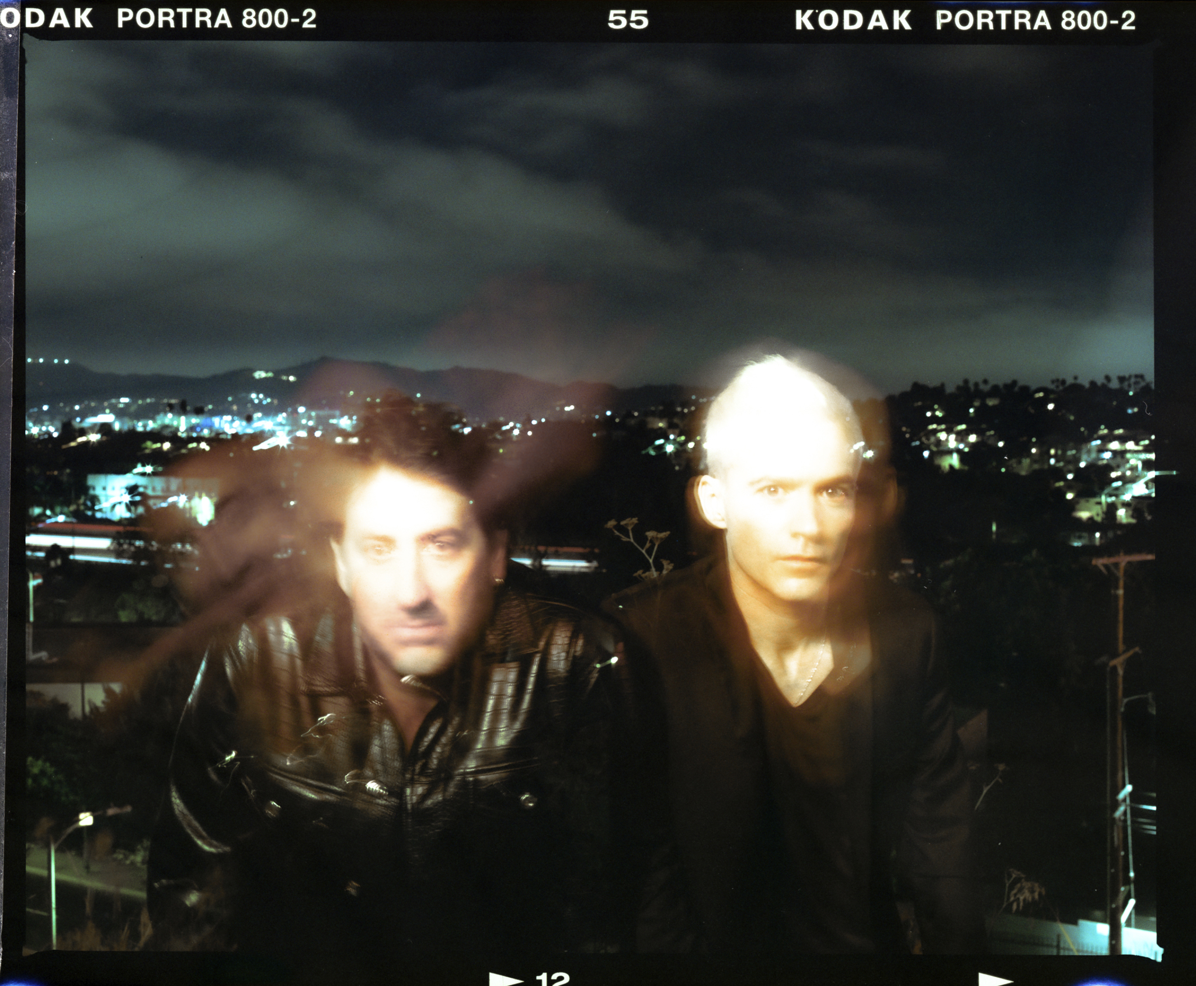

Building on the sample-based approach of their classic albums Since I Left You and Wildflower, but stepping boldly into new terrain, We Will Always Love You is the new full length masterpiece from The Avalanches. Set for release around the galaxy on December 11, We Will Always Love You is available for pre-order HERE now and features Ann Druyan (Director of the Voyager Golden Record Project) on the album cover, her cosmic love story with Carl Sagan inspiring this body of work.
An exploration of the vibrational relationship between light, sound and spirit, We Will Always Love You doubles as “an exploration of the human voice” and a spiritual reckoning via the big questions “who are we really? What happens when we die?’”. So says Robbie Chater, who alongside bandmate Tony DiBlasi and collaborator Andrew Szekeres has moved beyond the party-up exuberance of The Avalanches’s youthful music to a tender, reflective sound infused with hard-earned life wisdom.

If there’s a single spark for We Will Always Love You it’s the story of the love affair between Ann Druyan and Carl Sagan: “science communicators” whose writings and TV programs brought the ever-deepening mysteries of astronomy and astrophysics to the mass audience. Chater was profoundly moved by the fact that the couple’s romance was captured and carried into space, thanks to the Voyager Interstellar Message Project. Druyan served as Creative Director in charge of curating the Golden Record: earthling music and assorted terrestrial sounds gathered for the contemplation of any alien civilisations that might be out there and be advanced enough to construct a playback system.
Originally, Druyan was set to be a presence on We Will Always Love You: a studio was booked to record her telling her own story. That never transpired, but Druyan “gave us permission to use her photo on the album cover,” says Chater. “We photographed it off a static-y television set and ran it through a spectograph to make the cover image. So that was a beautiful way that Ann could still be part of the record. We turned her into sound and back again”
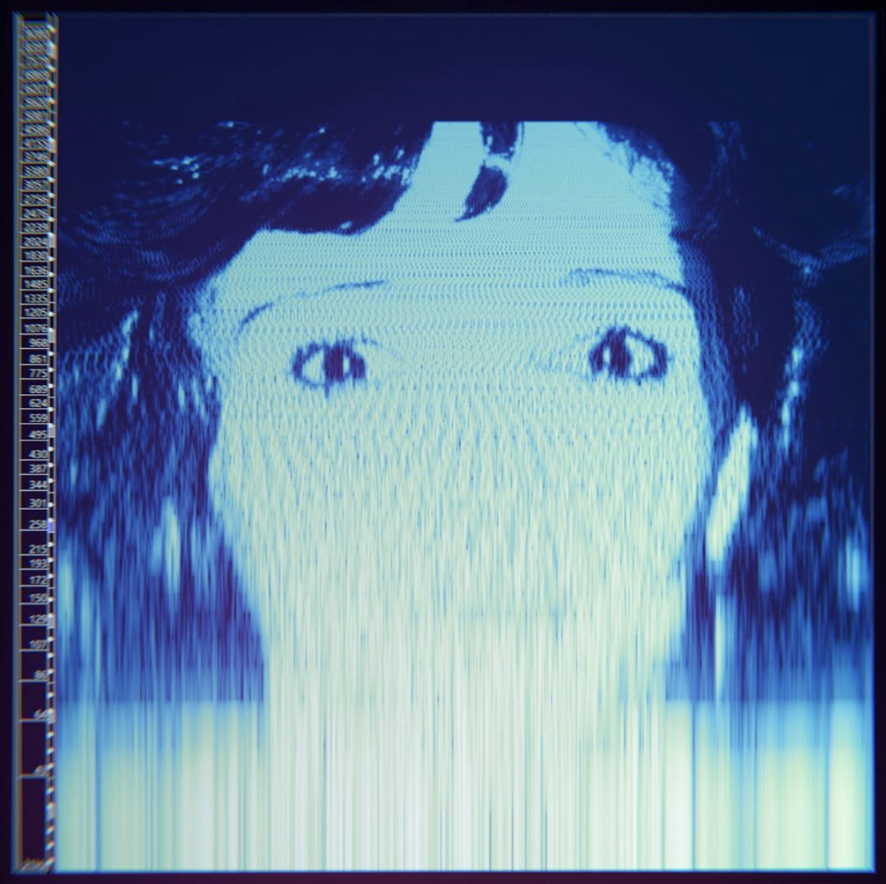

Sampling remains at the core of The Avalanches sound, but alongside all of the sample ghosts, We Will Always Love You features an array of living guests who contribute vocals and lyrics: Blood Orange, Rivers Cuomo, Pink Siifu, Jamie xx, CLYPSO, Denzel Curry, Tricky, Neneh Cherry, Sampa the Great, Sananda Maitreya and Vashti Bunyan and many more exciting collaborations to be revealed over the coming months. The Avalanches’s music has always dripped with melody, but because of this expanded role for guest singers and writers, We Will Always Love You is their most song-oriented album yet.

“For us, to make the same record again, no matter how well executed, wouldn’t have been satisfying," says Chater. "We were looking to do something that would open up possibilities for the future. Take a bit of a left turn that frees us up to do whatever we want to next.”
The Avalanches have been taste teasing their fans with samples of what to expect from the their forthcoming album with recent track releases We Will Always Love You (feat. Blood Orange), Running Red Lights (feat. Rivers Cuomo & Pink Siifu), Wherever You Go (feat. Jamiexx, Neneh Cherry & CLYPSO) and Reflecting Light (feat. Sananda Maitreya & Vashti Bunyan). Today the band release two more album tracks : Take Care In Your Dreaming (feat. Denzel Curry, Tricky and Sampa the Great) and Music Makes Me High.

Take Care In Your Dreaming featuring alt-rapper Denzel Curry, Tricky and Melbourne based Zambian rapper-singer Sampa The Great is a song about unrealised dreams and navigating unexpected journeys through life. “The song is a ‘careful what you wish for’ kind of thing.”

WATCH THE VISUALISER FOR TAKE CARE IN YOUR DREAMING HERE:

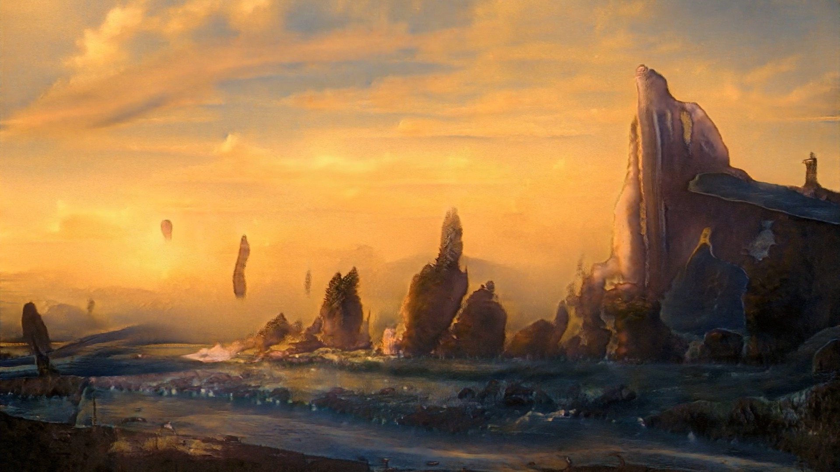

Music Makes Me High is truly an up tempo number, this disco-funk tune has a golden glow that simultaneously casts back to tunes like The Whispers’s “And The Beat Goes On” and to the filter-house echoes of that era such as Stardust “Music Feels Better With You” and Gusto’s “Disco’s Revenge”. “There’s a gospel choir on there, but very softly in the mix, singing over the ‘music makes me high’ sample.”

WATCH THE VISUALISER FOR MUSIC MAKES ME HIGH HERE:

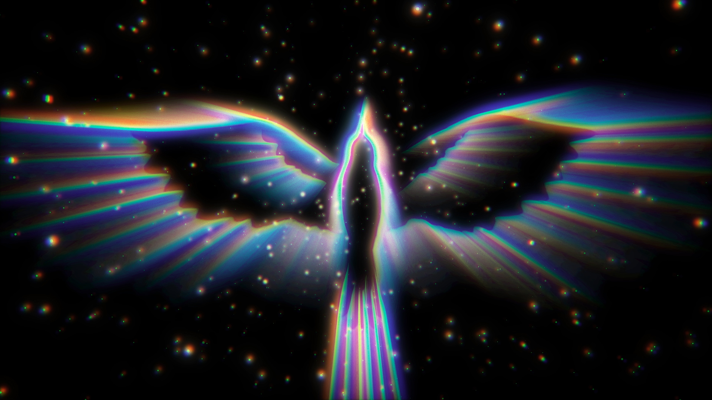

Sparkling with the treble frequencies that made Since I Left You such a dizzy thrill, We Will Always Love You is dedicated to probing “the vibrational relationship between light, sound and spirit.” But the goal now is elevation rather than intoxication.

Unlike its precursor Wildflower, We Will Always Love You came together “like a single thought, that was followed through in one process, quite quickly,” says Robbie. “It took only a couple of years from start to finish. “The conceptual heart of things is really important to me,’ he continues. “I can’t just be blindly creative, I need to find a feeling and a deeply personal place that gives me the energy to start making a record and a story to share. Wildflower changed so much over fifteen, sixteen years, whereas with this album, we knew what it was about right at the beginning, and then we did it, and it’s done.”
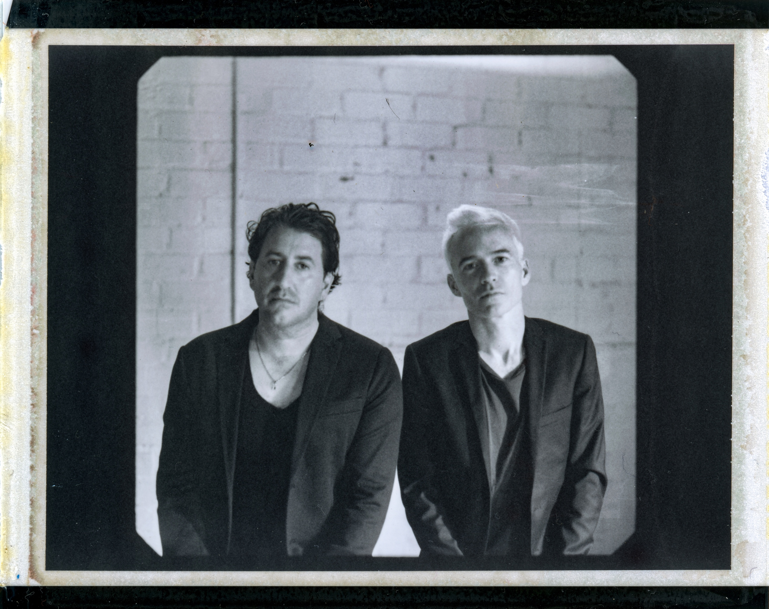
ABOUT THE AVALANCHES
On their groundbreaking debut, Since I Left You, The Avalanches presented the world with a totally unique sound, crafted by meticulously combining over 3,500 vinyl samples. This approach set a precedent for dance music, inspiring a whole generation of musicians and producers. Released in Australia in 2000 and in the U.S. and the U.K. (debuted at No.8) in 2001, Since I Left You is now regarded as a modern classic, It was named one of the year’s best albums by critics around the world and later placed in the Top 10 of Pitchfork’s Top 200 Albums of the 2000s and in the Top 20 of Rolling Stone’s Greatest EDM Albums of All Time. The video for the title track won Best Video at the 2001 MTV Europe Music Awards and was named as one of the top music videos of the 2000s by Pitchfork.
The release and subsequent touring in support of Since I Left You was followed by a 16-year radio silence, which was broken with the release of The Avalanches’ sophomore album, Wildflower (Modular Recordings). It charted top 10 in the UK, debuted at No. 1 on Billboard’s Vinyl Albums chart and atop the Australian Albums chart in 2016. Wildflower earned six ARIA Award nominations and international acclaim, with The Guardian hailing it as "a joyous journey" and Pitchfork proclaiming it “better than just about any music ever made” and “an album that could have been made by nobody but the Avalanches.”

FOLLOW THE AVALANCHES
WEBSITE: http://www.theavalanches.com/
TWITTER: https://twitter.com/theavalanches
INSTAGRAM: https://www.instagram.com/theavalanches/
YOUTUBE: https://www.youtube.com/user/avalanchesofficial

