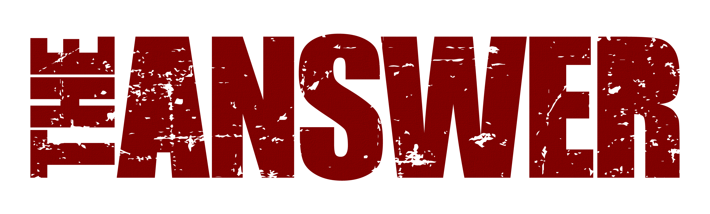
NEW TOUR DATES NOV/DEC 23
Following the success of their recently released and highly acclaimed Sundowners album, The Answer are thrilled to announce a further 5 new UK dates in November and December this year. Manchester, London, Wolverhampton, Glasgow and Belfast will get to see the band perform their latest stunning new show, peppered with hits and loads of material from the much-heralded new record.
“Challenging the boundaries of rock music, a ballsy mammoth 8 tracks from the new album peppered with some of their hits, everything about their comeback feels a little more deliberate, a reminder of how powerful this bands live performance can be” (Moshville Times, Mar ‘23)
“This show is fresh – good time positive feel, unapologetic rock ‘n’ roll (Rock ‘N’ Load Magazine, Mar ‘23)
“An evening of pure rock fury that no-one will forget anytime soon” (The Razors Edge, March ‘23).
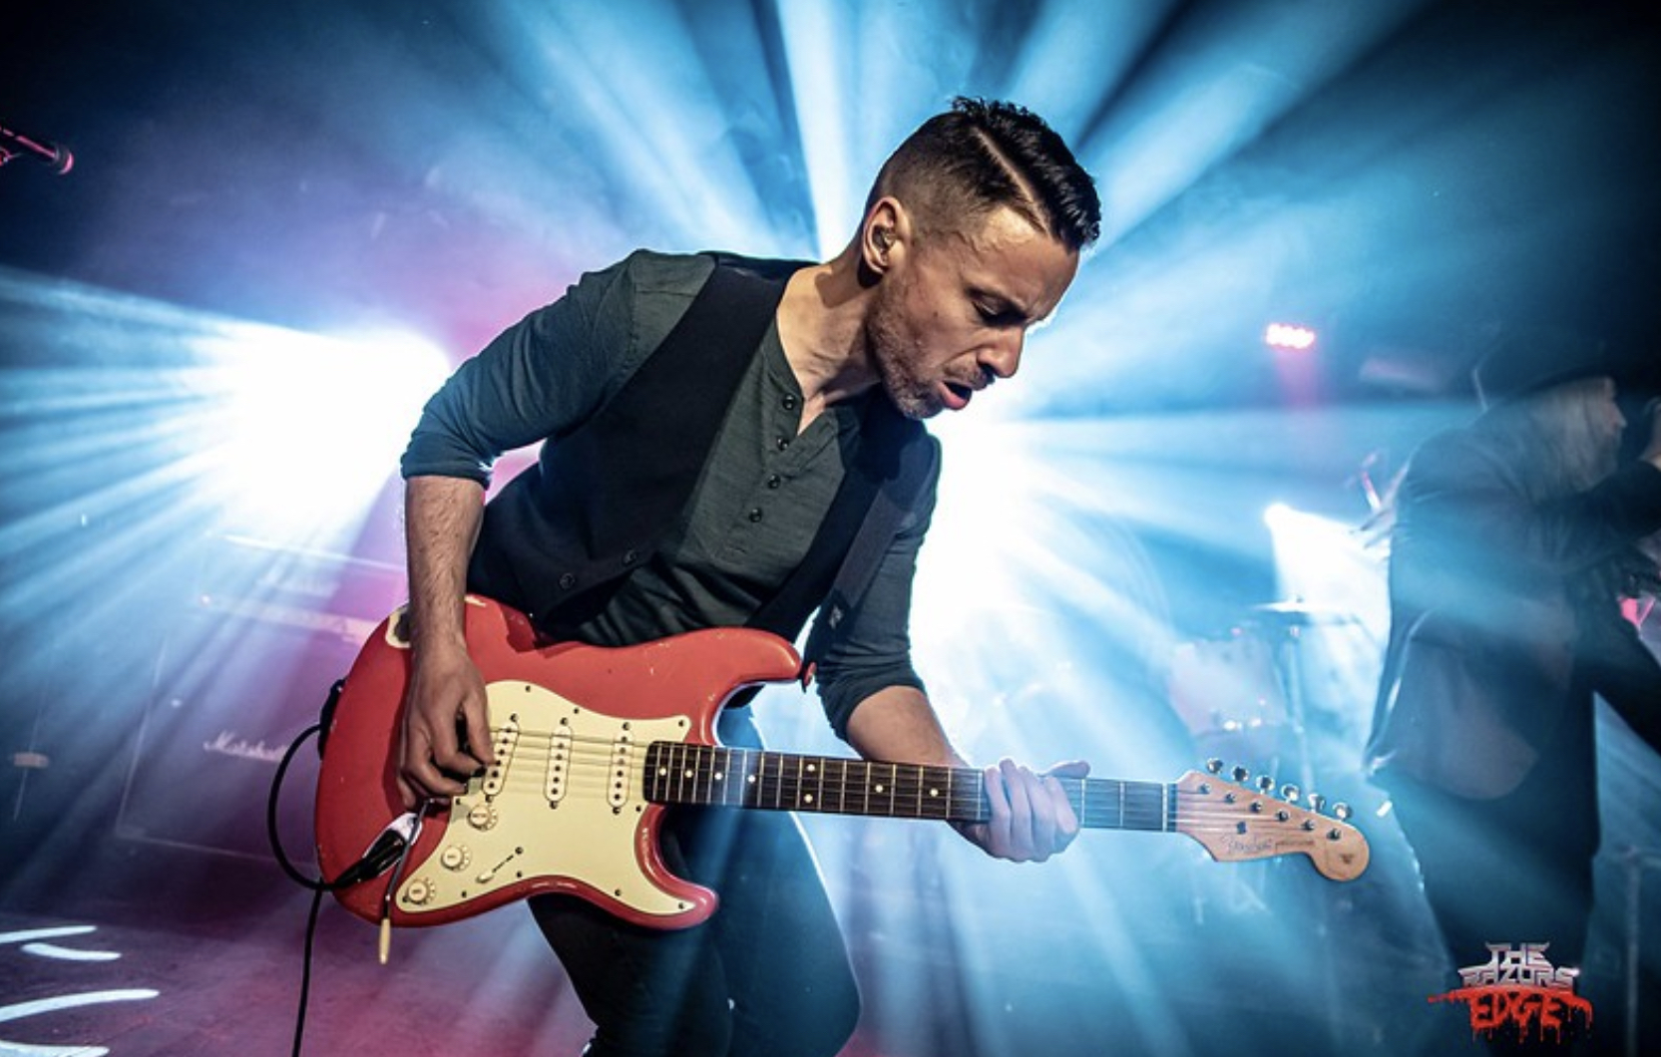
Says lead singer Cormac Neeson, “Our recent run of album showcases for the Sundowners release was the best time we’ve had on the road for many a decade! To get the reaction we did from fans in UK & Europe to the new material has been a shot in the arm for everyone. We’re so fired up to get back out again and go even further this time with our new live show. It’s going to be awesome, and this band of brothers are chomping at the bit to see you down the front again soon!!”

Sundowners was released on March 17th and achieved top 40 album chart positions in UK, Germany and Switzerland including number 1 in the UK national rock album chart. Produced by rising British producer Dan Weller, the album has received rave reviews across the board.

“A serious challenger for album of the year” (Get Ready To Rock) *****

“Don’t accept imitations, The Answer are truly showing everybody how this s**t is done. The kind of album truly great bands make” (Blabbermouth) ****

“This album is the sound of a band with nothing to prove to themselves or anyone else. They slot so neatly alongside the blues-rock giants that came before them.” (Classic Rock Magazine UK) ****

Tickets for the new tour go on sale Thursday April 27th, 10am.

UK TOUR DATES
Nov 15th Manchester Academy 2
Nov 16th London Islington Assembly Hall
Nov 17th Wolverhampton KK’s Steel Mill
Nov 18th Glasgow King Tuts
Dec 9th Belfast Limelight 1 (www.ticketmaster.ie)

All UK shows.
http://www.myticket.co.uk/artists/the-answer

SUMMER FESTIVALS
Sat Jun 3rd Bremen, Bassum Open Air - Germany
Fri Jun 16th Dessel, Graspop Metal Meeting - Belgium
Sun Jul 8th Knislinge, Time To Rock – Sweden
Sun Jul 30th Steelhouse Festival – Wales
Sat Aug 5th Wacken Festival – Germany
Fri Aug 11th Eschwege Open Air – Germany
Sat Aug 12th Firestorm Festival, UK
Sat Aug 26th Stonedead Festival, UK
Sat Sep 2nd Bern, Gravel Pit Festival, Switzerland
Tues Oct 10th Majorca, Full Metal Holiday, Spain

Tickets on www.theanswerrock.com

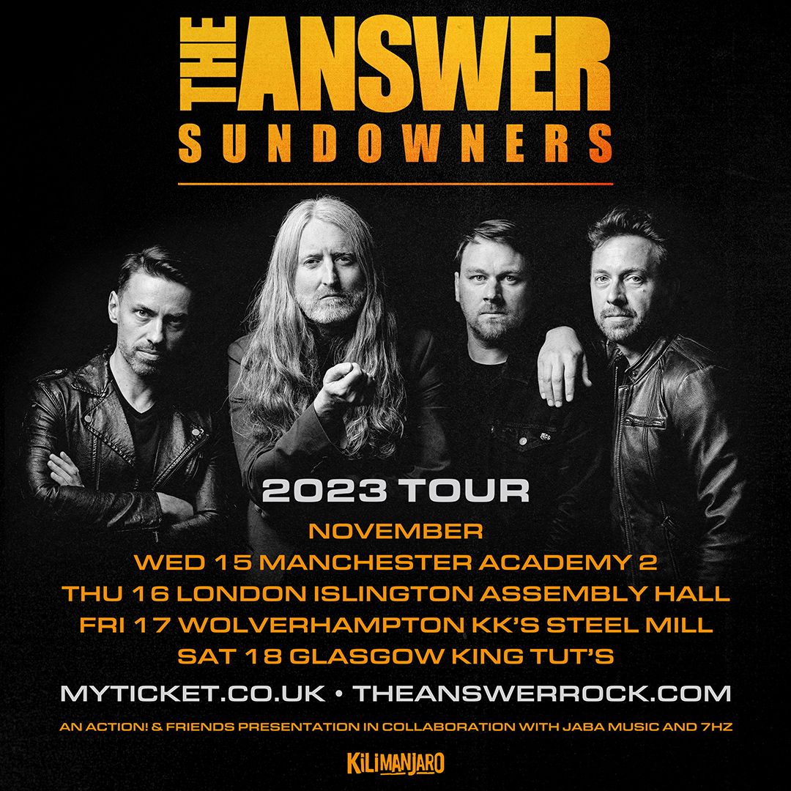

Contact: judith@goldenrobotrecords.com
Management: james@jabamusic.co.uk
Bookings: barry.campbell@fkpscorpio.co.uk
Label: https://7hzrecordings.com (UK & Europe)

Spotify: http://open.spotify.com/album/5c90Qv0wkAfHFu243e7qxX
Apple: https://music.apple.com/us/album/blood-brother/1640395077?ls=1
Deezer: www.deezer.com/album/347612407

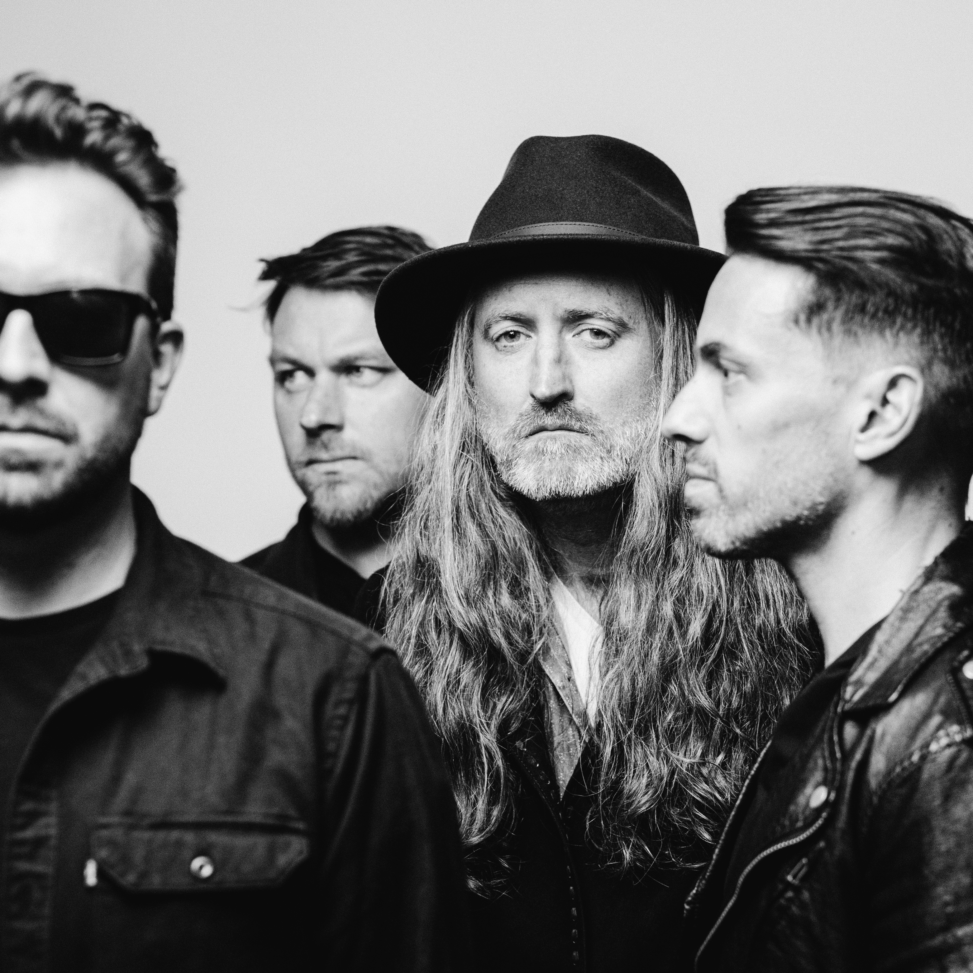

https://www.theanswerrock.com
https://www.facebook.com/theanswerrock
https://twitter.com/theanswerrocks
https://www.instagram.com/theanswerrock/?hl=en
https://open.spotify.com/artist/3STTKsLP1gSzGvOVCtNlWS?si=SYnSAgPTS3-Ji4AQvJbz4w

For more info contact warren@chuffmedia.com

