THE WARNING

ROCK’S HOTTEST RISING BAND ANNOUNCE NEW ALBUM KEEP ME FED OUT JUNE 28
PRE-ORDER/PRE-SAVE HERE

SHARE TWO NEW SINGLES “HELL YOU CALL A DREAM” & SPANISH-LANGUAGE “QUÉ MÁS QUIERES”
LISTEN HERE & HERE

SET TO EMBARK ON SOLD OUT EUROPEAN/UK HEADLINE TOUR THIS SPRING

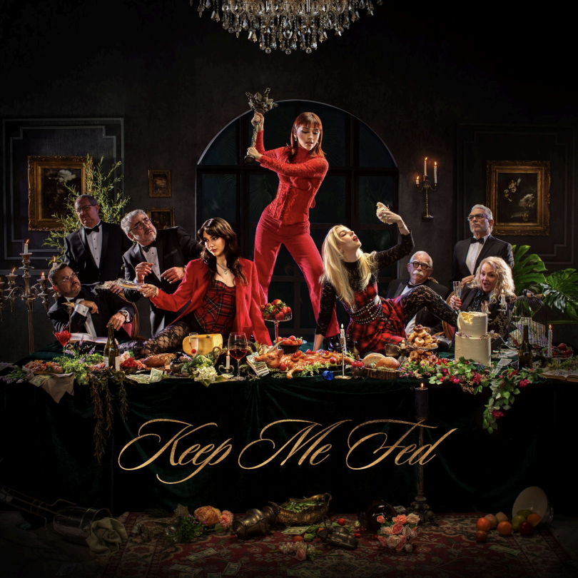

Returning with a big bang, the alternative sister-trio from Monterrey, Mexico, The Warning, proudly present their anxiously awaited new full-length album, Keep Me Fed [LAVA/Republic Records], out June 28, 2024. Physical products will be available at RepublicRecords.com, including CDs, vinyl, t-shirts, and fan packs [CD/t-shirt or vinyl/t-shirt].
In talking about the story behind the decision to name the album Keep Me Fed, “throughout the whole process, the work was consuming us,” says Pau. “By impacting everything we did, the album kept us fed both creatively and personally. We’re inviting other people to participate and consume it too.”

Bulldozing the way for the record’s arrival, they just unveiled two singles, namely “Hell You Call A Dream” and the Spanish-language “Qué Más Quieres.” Each song is also accompanied by its own lyric video.

Illuminating the band’s evolution, the tracks hint at the breadth of their stunning signature style. On “Hell You Call A Dream,” co-written and produced by Anton Delost [Highly Suspect, Mayday Parade] and Dan Lancaster [MUSE, Bring Me The Horizon], an arresting keyboard melody wraps around the punchy bassline. A distorted guitar groove anchors a hard-hitting hook, “Give me something to believe, in this hell you call a dream.” Dany notes, “‘Hell You Call A Dream’ tries to express a feeling most musicians find hard to express. When you’re touring, you experience the positives, the negatives, and the whole spectrum of emotion all at once. It’s about how something you love so much can be something that also weighs you down, but you continue to do it out of love. It’s fulfilling, but it’s tiring.”

The three-piece further flaunt their fiery versatility on “Qué Más Quieres.” It tempers a robust riff with an electronic flurry, giving way to a chantable chorus with the power to resonate worldwide. “The title translates to ‘What else do you want?’,” Pau reveals. “It’s about taunting and manipulating. We were thinking of the TikTok phrase, ‘Gaslight, Gatekeep, Girlboss’, and turned it into a song.” Dany goes on, “It means a lot to sing in our language and represent our country. Over the years, doors have finally opened for Mexican women in rock, and we’re actively participating in opening these doors where we can.”

Stay tuned for more soon.

Keep Me Fed also features “MORE”, which the band performed at the 2023 MTV VMAs, and the recently released fan favorite “S!CK” that is climbing the Active Rock charts. Revolver raved, “Like the Mexican sister-trio’s previous output, it's undeniably infectious,” and Classic Rock hailed it as a “shot-in-the-arm of propulsive, fire-spitting hard rock.” Rolling Stone pegged it as one of “All The Songs You Need To Know This Week.”

Next up, The Warning will perform at Mexico’s prestigious Pa’l Norte and Vive Latino Festivals followed by a month-long full-scale European tour this spring. It kicks off in Madrid at Sala La Riviera on April 4, canvases the continent, and concludes in London at O2 Forum Kentish Town on April 27.

The tour marks the band’s return to Europe after their own 2023 run of beyond sold out headline EU & UK dates in addition to their monumental run supporting MUSE & Royal Blood on their stadium tours. They also sold out shows across Mexico, South America including their largest show to date in Mexico City at the infamous Pepsi Center.

Check out the full confirmed itinerary below. Fans can purchase tickets here: www.thewarningband.com/tour

The Warning are as hungry as ever on Keep Me Fed, and they’re about to sink their teeth into 2024.

The Warning UK Tour Dates

4/21 Birmingham, UK O2 Institute 2
4/22 Leeds, UK Stylus
4/23 Glasgow, UK The Garage
4/25 Manchester, UK Academy 2
4/26 Cardiff, UK Y Plas
4/27 London, UK O2 Forum Kentish Town
7/20 Maidstone, UK Maidstone Festival
7/27 Abertillery, UK Steelhouse Festival

THE WARNING
The Warning draw strength and power from a lifetime of sisterhood and music. The Mexico-born sister trio—Daniela “Dany” [guitar, lead vocals, piano], Paulina “Pau” [drums, vocals, piano], and Alejandra “Ale” Villarreal [bass, piano, backing vocals]—have logged thousands of miles on the road, generated hundreds of millions of streams, and left countless fans in awe. All of this tireless work and dedication has shaped and sharpened their sound with knifepoint precision, arming alternative anthems with universally catchy hooks and an uncompromising hard rock kick. The girls have devoted themselves to a shared dream since their childhood in Monterrey, Mexico. They initially made waves with a string of independent releases, paving the way for their acclaimed 2022 full-length offering ERROR. Between performing alongside Muse, Foo Fighters, Guns N’ Roses, Royal Blood, The Pretty Reckless, and Three Days Grace, the band ignited MTV’s Extended Play Stage at the 2023 MTV VMAs. Representative of their cultural impact, Pepsi even notably chose them as the face of Pepsi Black in Mexico. Moreover, they emerged as the rare force who could comfortably appear in features by Vanity Fair, People, Cosmopolitan, and Glamour as well as on Metallica’s star-studded Blacklist compilation—placing their cover of “Enter Sandman” [with Alessia Cara] shoulder-to-shoulder with contributions from Ghost, St. Vincent, Chris Stapleton, IDLES and Weezer. Now, The Warning embrace their destiny on their 2024 full-length album, Keep Me Fed [LAVA/Republic Records] out on June 28th. The album was introduced by “MORE,” “S!CK” “Hell You Call A Dream” and “Qué Más Quieres.”

See full tour dates at www.thewarningband.com/tour.

••• Follow The Warning •••
www.thewarningband.com
Instagram // TikTok // YouTube // Facebook

For more on info contact warren@chuffmedia.com

