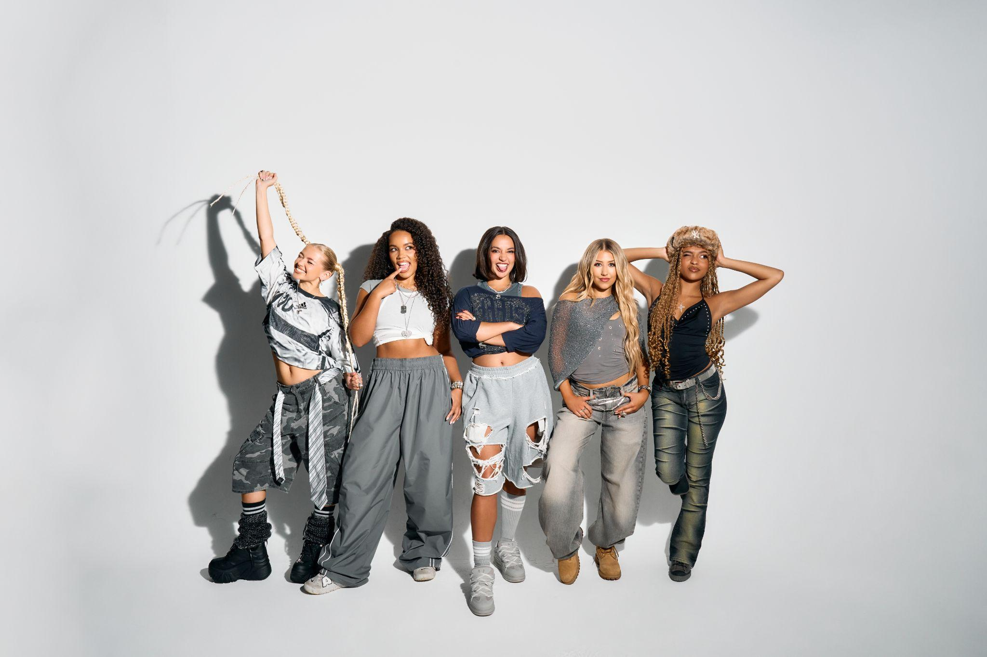
L-R: Zoe, Summer, Reanna, Emmy, Shali

XO release debut EP, Fashionably Late
Watch the video for new focus track, ‘Candy’
2026 UK headline tour also announced to follow sold-out dates
“A titanic debut…breaking through pop boundaries, XO are doing it their way” - CLASH
“Bolshy Y2K production…pop girlies, assemble” - Sunday Times Style
“Messy but charming: a tribute to keeping a ride-or-die circle that makes you want to be part of the gang” - The Fader
“Electrifying…XO’s unapologetic take on girl power, and it lands with impact” - Wonderland

Stream Fashionably Late: XO.lnk.to/fashionablylate

XO have today released their debut EP, Fashionably Late, via Polydor Label Group. The project arrives alongside high-energy focus track and video, ‘Candy’, as previewed on the band’s instantly-sold-out UK headline dates last month. XO have now announced a brand new UK headline tour, including a London show at O2 Academy Islington on May 29th: artist pre-sale opens at 9AM on November 19th, with tickets available for general release on November 21st.

Fashionably Late introduces XO, aka Emmy, Reanna, Shali, Summer and Zoe - the fearsome five-piece with their sights set on being Britain’s next, best girlband. Their mission-statement first EP drops alongside ‘Candy’, a joyful collision of 00s Timbaland beats, hooky, back-of-the-bus chants and in its playful accompanying video, a taste of the choreo XO are destined to become known for.

Creating Fashionably Late has been, as they say in pop, A Journey. Its six songs and ‘Wannabe’-inspired art channel the arc of a night out, from getting ready (‘Rush Hour’) and fly-on-the-wall interludes like ‘Give a Girl Her Shoe!’ to letting your hair down (see viral fan favourite, ‘Ponytail’), only to catch feelings (euphoric first single ‘Lovesick’). The EP also puts a flag in the ground for XO’s unapologetic ethos, and what they’re keen to represent: ‘Real Friends’ is anthemic call for sisterhood and solidarity co-written with pop royalty Charli xcx (an alternative acoustic version dropped last month, showcasing the band’s powerhouse harmonies). EP closer ‘Silly Boy’, meanwhile, came to Zoe and Shali in an Uber, and was penned in response to the catcalling they witnessed on the streets. On just their first EP, Fashionably Late is the mark of a band already evolving - emotionally, artistically - and inviting their audience along for the ride.

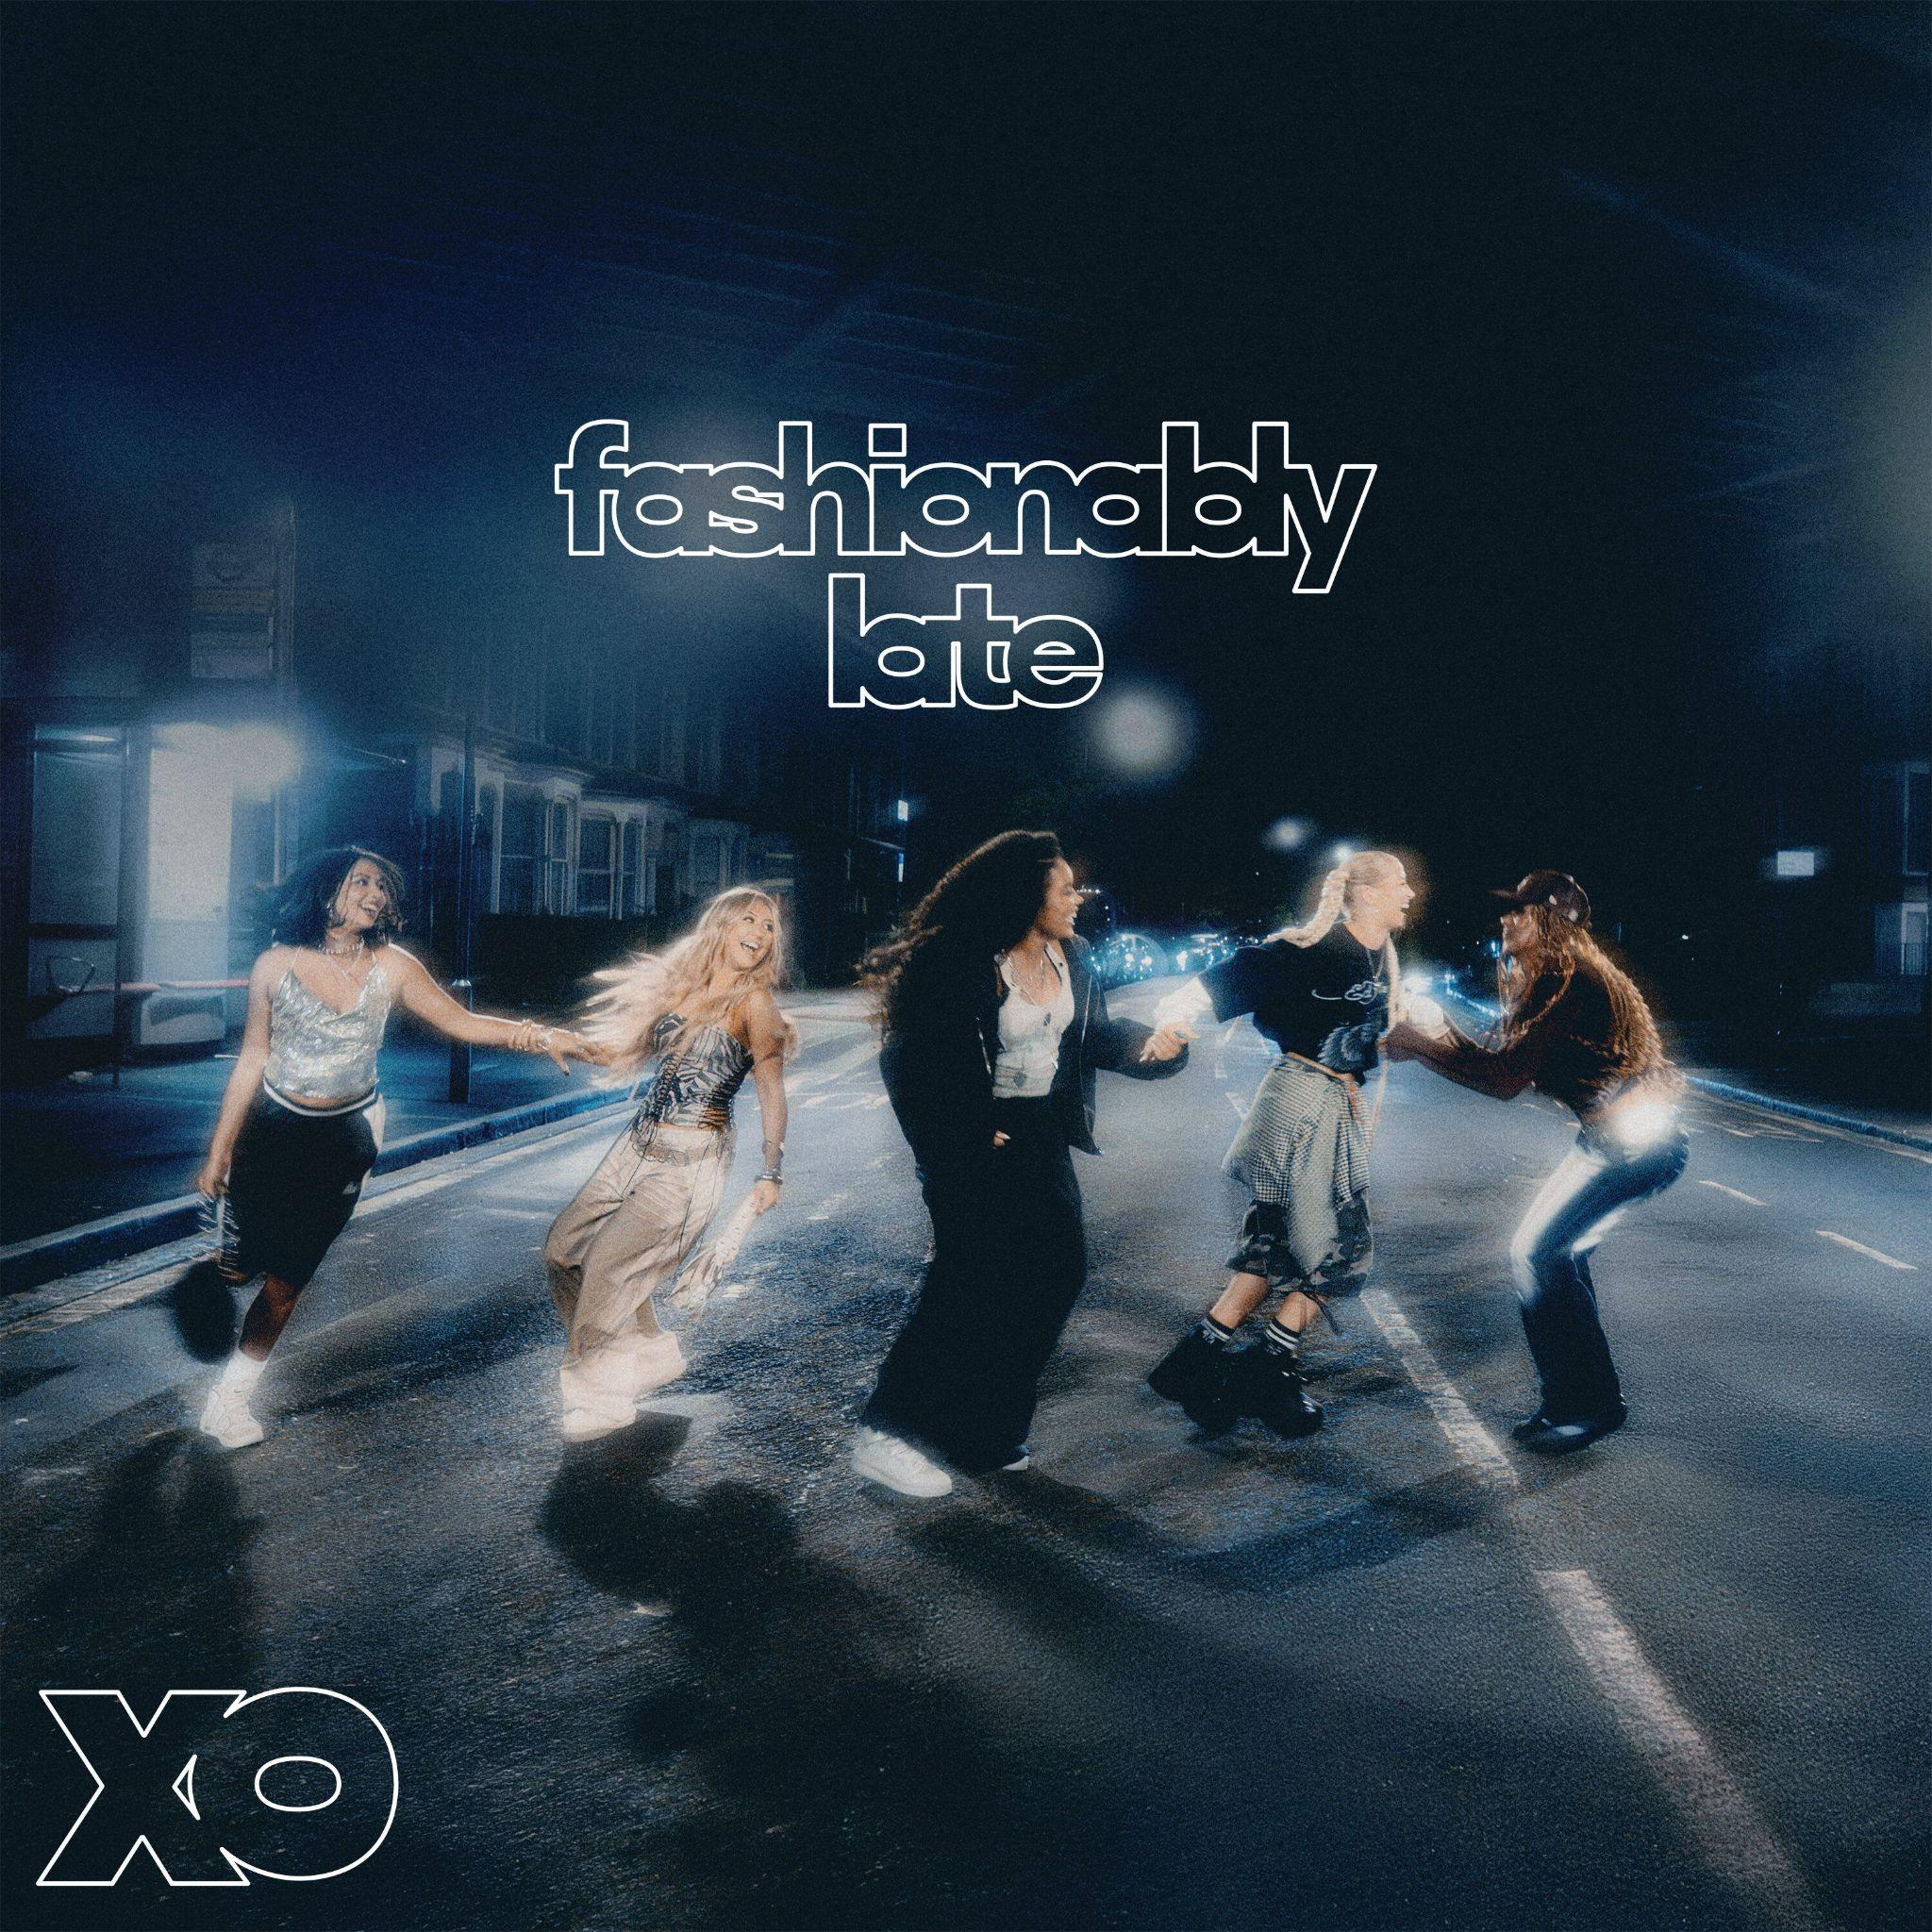
Fashionably Late - tracklist

- ‘Lovesick’
- ‘Real Friends’
- ‘Give a Girl Her Shoe!’
- ‘Rush Hour’
- ‘Candy’
- ‘Ponytail’
- ‘Dead Chat!’
- ‘Silly Boy’

UK HEADLINE TOUR

25th May Glasgow King Tuts
26th May Manchester Academy 3
28th May Birmingham O2 Institute 2
29th May London O2 Academy Islington
31st May Bristol The Fleece

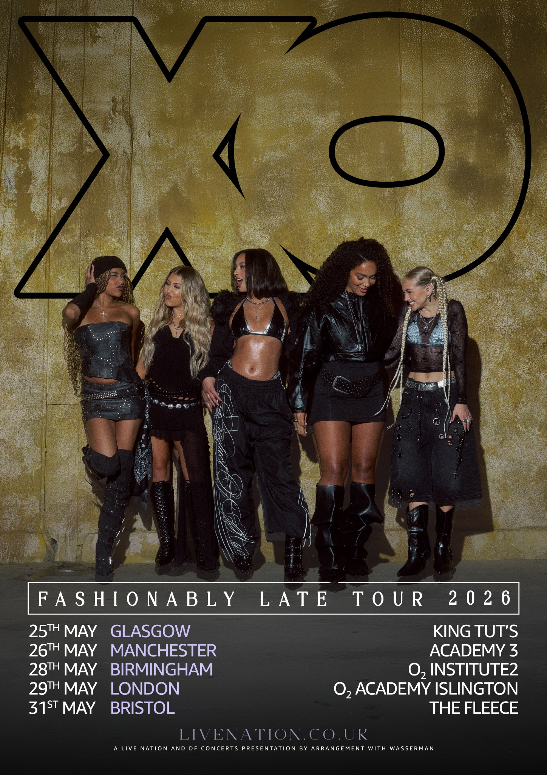

FOLLOW XO!
Instagram || Tiktok || Official Site || Youtube

For more on info contact warren@chuffmedia.com

