**THE ITCH SHARE DOUBLE SINGLE**

**‘THE INFLUENCER’ / ‘CO-CONSPIRATOR’**

**+ SIGN TO FICTION RECORDS / I OH YOU**

**CORSICA STUDIOS HEADLINE 12th JUNE**

[**WATCH HERE**](https://theitch.lnk.to/InfluencerPR/youtube) **//** [**LISTEN HERE**](https://theitch.lnk.to/InfluencerPR)

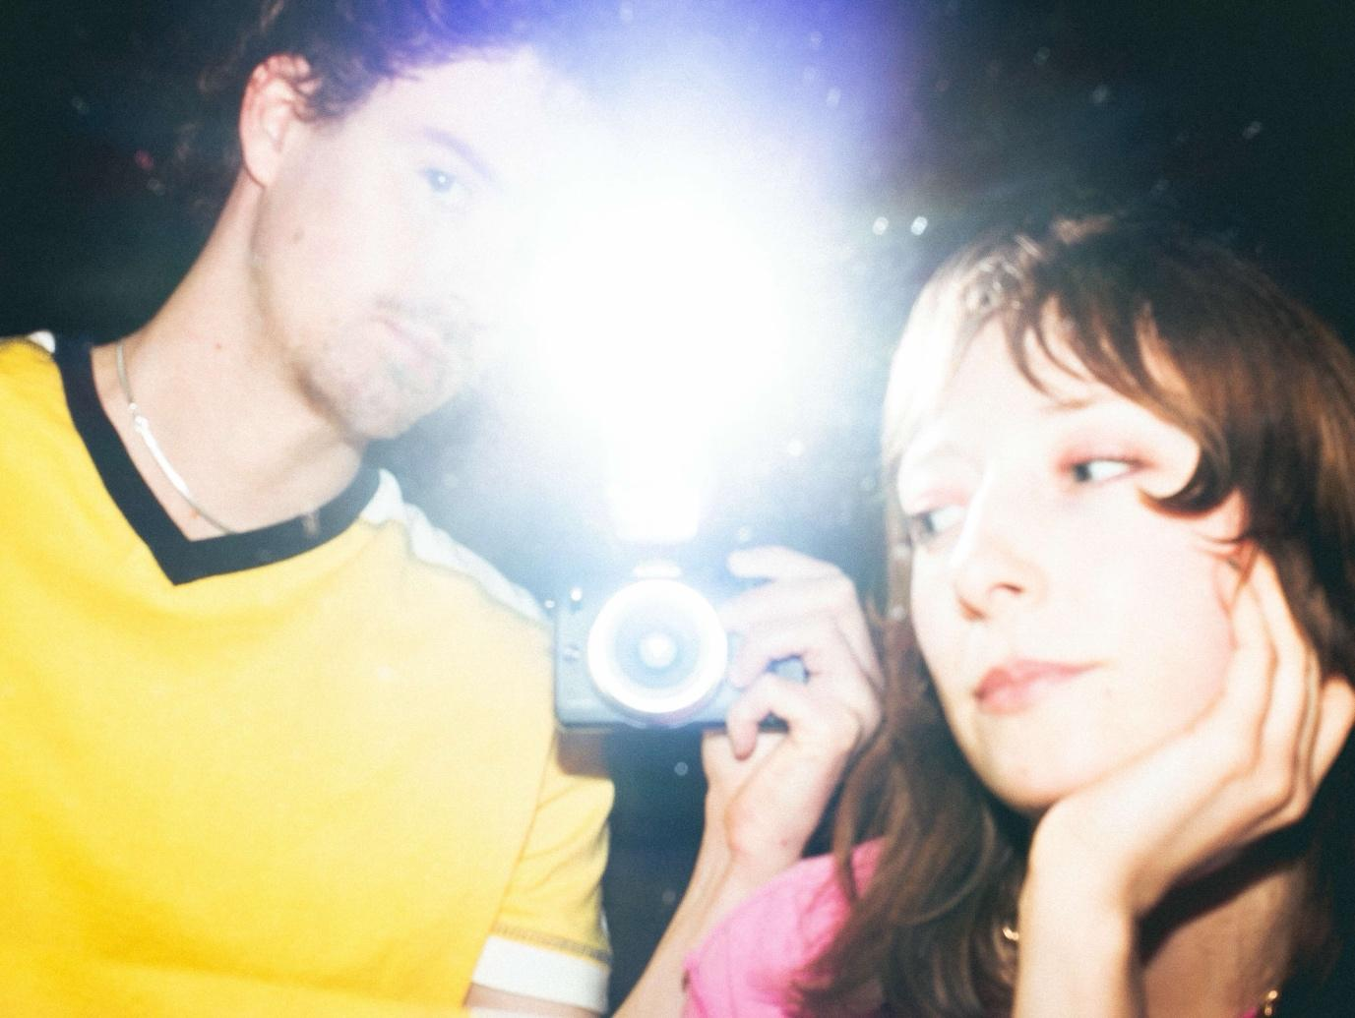

[*credit: The Itch [hi-res here]*](https://www.dropbox.com/scl/fo/cbganuc0qpm9ktn5bayu3/APTTWsfbQ9eURAQOfWasEqA?rlkey=4tw5l4hm4k52qa86zwjk2imqc&st=7xm09s5u&dl=0)

The Itch (Simon Tyrie & Georgia Hardy) share their first new music of 2025 with the double A-side of ‘The Influencer’ and ‘Co-Conspirator’, marking their inaugural release with Fiction Records/I OH YOU.

The two companion tracks twist and reform identical audio stems to create warped sibling compositions. Using the same drums and bass and mangling vocals into new melodic hooks, Co-Conspirator mutates The Influencer’s DNA into a shadow version remixed for club culture, sharing the same key, BPM, lyrical themes and audio.



In keeping with the theme of reimagining shared base materials, the accompanying videos for both ‘The Influencer’ and ‘Co-Conspirator’ see the same room shot in different states. The former gives dancer Joshua Hubbard free rein of a vacant venue, while the visualiser for ‘Co-Conspirator’ collates footage from a club night which The Itch hosted in the same venue the previous week.

[**Watch Video for ‘The Influencer’ / ’Co-Conspirator’ Here**](https://theitch.lnk.to/InfluencerPR/youtube)

This double A-side, the duo’s second release, arrives a year to the month after The Itch first announced themselves with the metamorphic debut single ‘Ursula’. An ever-evolving, 7 minute long homage to cult author Ursula K. Le Guin, ‘Ursula’ saw heavy support at press and radio alike alongside a triumphant debut headline show which sold out in a day, before the duo disappeared from view as quickly as they had emerged.

During this time, Simon & Georgia were competing in mixed doubles tennis tournaments (first regionally, then continentally) when Fiction Records [The Cure, Kae Tempest] and I OH YOU [Confidence Man, Rolling Blackouts Coastal Fever] tracked the duo down to sign them on a collaborative deal.

Having first appeared on the live circuit at the tail-end of 2023, The Itch’s pairing of undulating dancefloor fillers and disenchanted pop songwriting quickly saw their name passed form one gig goer to another despite a notable absence from social media; as word-of-mouth spread about an act tessellating New Romantic and rave influences on the capital’s sticky-floored circuit.

Live bookings from notable publications ensued, alongside a run of support slots which threatened to hijack the limelight and a tide of offers from major festivals including End of The Road, Wide Awake and Latitude - all before the release of 2024’s debut, ‘Ursula’.

Steering the project are Georgia Hardy and Simon Tyrie. After meeting as teenagers at an open mic night, the two swapped music recommendations online, exposing each other to new genres and a collaborative relationship blossomed. They learnt to DJ and put on club nights in their hometown before moving to London where they began writing, recording and producing music themselves in their makeshift home studio, leading them to develop a style that’s uniquely their own.

The Itch will perform their second headline show – and first in over a year – at Corsica Studios on 12th June.

**Catch The Itch live:**

Sat 3rd May - Wanderlust Festival, Southampton

Tues 13th May - The Garage, London (w/ Preoccupations)

Friday 6th June - The Castle, Luton

Thurs 12th June - Corsica Studios, London

[Follow The Itch on Instagram here](https://www.instagram.com/theitch_music/)

[https://theitchyouscratch.com](https://theitchyouscratch.com/)

**For more info contact Warren** [**warren@chuffmedia.com**](mailto:warren@chuffmedia.com)