WILLOW
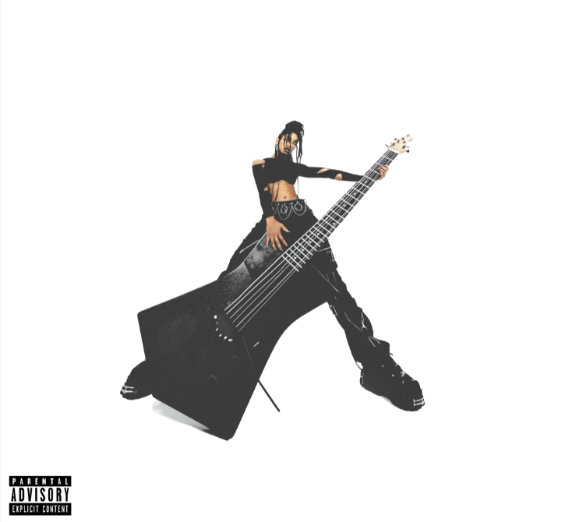

‘T R A N S P A R E N T S O U L’
FEATURING TRAVIS BARKER
LISTEN HERE / WATCH HERE

TAKEN FROM FORTHCOMING ALBUM
OUT THIS SUMMER
VIA MSFTSMUSIC / ROC NATION / POLYDOR

Today, WILLOW releases her new single ‘t r a n s p a r e n t s o u l feat. Travis Barker’, out now via MSFTSMusic / Roc Nation Records, via Polydor in the UK. The song is the first taste of her forthcoming full-length album, out this summer. The alt-rock track features heavy guitars, with a feature by pop-punk hero, Travis Barker of Blink-182 and marks a major sonic evolution for WILLOW.

“I am so grateful for this tune because it was created in such an introspective time (during the first couple months of quarantine),” she says. “It was the song that proved to me that I needed to let go of the insecurities I had about making a project of this genre”

The track was unveiled via Beats1’s Zane Lowe as a New Music Daily today. WILLOW has also released a companion performance video directed by multidisciplinary creative force Dana Trippe, who is known for her work with Haim, Demi Lovato and more. WATCH HERE.

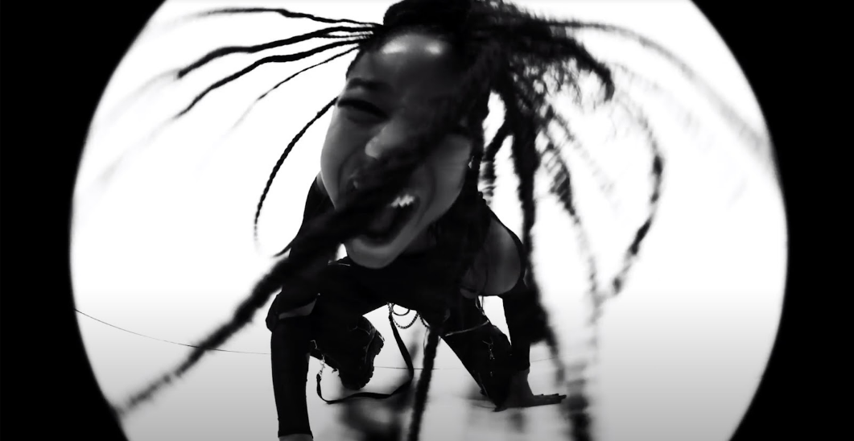

At 20 years old, WILLOW has spent most of her life working in the music industry and often making R&B tinged music that supported her vocal training. With more time than ever to experiment in her writing process this past year, she began making demos and writing songs that not only utilized her abilities as a guitar player but that were deeply inspired by her heroes and the music she grew up listening to. From 3-7, she accompanied her mother’s nu-metal band Wicked Wisdom on tour. The band featured powerful rock vocals and crushing guitars and paved the way for WILLOW’s own musical tastes which included My Chemical Romance, Paramore, Fall Out Boy and more.

That early ‘00 pop-punk and emo influence isn’t just heard throughout the record, but features some of WILLOW’s heroes of the era such as Barker, Avril Lavigne and more. As with all of WILLOW’s music, her lyrics are introspective and ethereal - examining her interior life and her place in the world. And with this more authentic sonic palette, she screams out the questions and answers she finds in her philosophical pursuit.

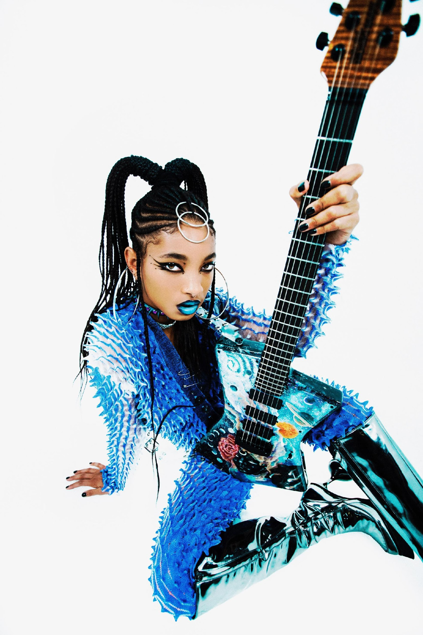
Photo Credit – Dana Trippe

FOLLOW WILLOW ON
SPOTIFY | INSTAGRAM | TWITTER | FACEBOOK | YOUTUBE | APPLE MUSIC | WEBSITE

For more information and press enquiries please contact

Jenny Entwistle
Jenny@chuffmedia.com

More about WILLOW and ‘t r a n s p a r e n t s o u l feat. Travis Barker’:
At only 20 years old, WILLOW has spent half her life in the music industry. With her fifth album coming this summer (out this summer via MSFTSMusic/Roc Nation/Polydor), a decade of growth both in the industry and as a young woman come to a head. Her new single and LP is a love letter to that constant evolution.

She began working on the album in 2020, during the pandemic. With all the extra time on her hands at home, she began recording demos that she would later re-record when she felt like she could safely enter a studio. It was a new process for her, born out of caution, but it helped her capture the rawness of her new sound. On the forthcoming record, WILLOW channels the alt rock, pop-punk and emo heroes she adored as a teenager, like Avril Lavigne, My Chemical Romance and Paramore. “I thought this was a really dope outlet for a new energy I wanted to bring to my music,” she says.

Though she considers her writing process “very solitary” and “insular,” she has found a fruitful musical partnership in Tyler Cole, who she first worked with on 2019’s WILLOW. She describes the relationship she has with Cole as a great “synergy,” which has unlocked something deeper in her music as she progresses in her career.

One major influence for the record comes from a deeply personal place: her own mother Jada Pinkett Smith. These days, the two co-host the Facebook Watch talk show Red Table Talk with her grandmother Adrienne Banield-Norris. But prior to that, Pinkett had a rocker past that she fulfilled alongside her acting career. Pinkett formed the nu metal band Wicked Wisdom when her daughter was an infant. “I was always so inspired by the power of her voice,” WILLOW says. Wicked Wisdom was at their most active during her most formative years. The group has released two albums, opened for Britney Spears on her Onyx Hotel Tour in 2004 and a year later appeared at Ozzfest. While she admired her mom’s musical route, WILLOW was sceptical of her own ability to channel that rock side. “I never felt like I could sing that kind of music because I was always trained to sing R&B and pop.”

Letting go of that insecurity proved to be a breakthrough when she realized how influential R&B and pop vocalists are on her pop-punk heroes like Hayley Williams, Gerard Way and Patrick Stump. She used the soulful range of her own vocal chops to add a fresh flare to the mosh-ready records she wrote for this release and learned how to stop looking at that training as a disadvantage. “I realized that it’s not my voice that can’t sing this kind of music. I was afraid to sing this kind of music because I wasn’t sure what people would think.”

‘t r a n s p a r e n t s o u l feat. Travis Barker’ tees off the album rollout, showcasing her own spin on emo and punk. It feels both nostalgic and modern, with a catchy hook and snappy melody that makes the song move like lightning. The lyrics were inspired by a quote from a “beautiful swami” she knows personally: “It is said that a saintly person is so pure that he or she acts like a spotless mirror. When we come in the presence of such mirror-like soul, we can see both the beauty and ugliness of our inner life.” She sees the single as a testimony to her desire to be the highest version of herself, something that she connects well with the angsty, pining feeling of the genres she explores. The songwriter rarely makes videos, but she felt so inspired by ‘t r a n s p a r e n t s o u l feat. Travis Barker’ that she decided to pursue one for it. She hopes the visual opens up new meanings for the listeners.

WILLOW’s own guitar playing factors into the project as well, which is something she was also inspired to do because of her mom’s band. She’s been playing the instrument since she was around 14, and it was part of a conscious effort to prove herself as a musician and songwriter, one that could have total involvement in more than the lyrics. “I personally feel it’s just really important to play an instrument if you’re going to have a career in music,” she adds. “Songwriting is 15 million times easier when you can actually write the songs.”
WILLOW compares her fifth LP to her last one, aptly titled The Anxiety. To her, this album showcases an artist who has made it to the other side of that anxiety and is a testament to everything she’s learned. Through the process specifically, she learned how to let go and show herself more compassion. More importantly, it helped her channel the playful inner child she felt she had lost for some time. “It was very cathartic for me,” she explains. “I want to live more like that."

