LANY SHARES NEW TRACK “ROLL OVER, BABY”
NEW ALBUM GG BB XX OUT
SEPTEMBER 3rd
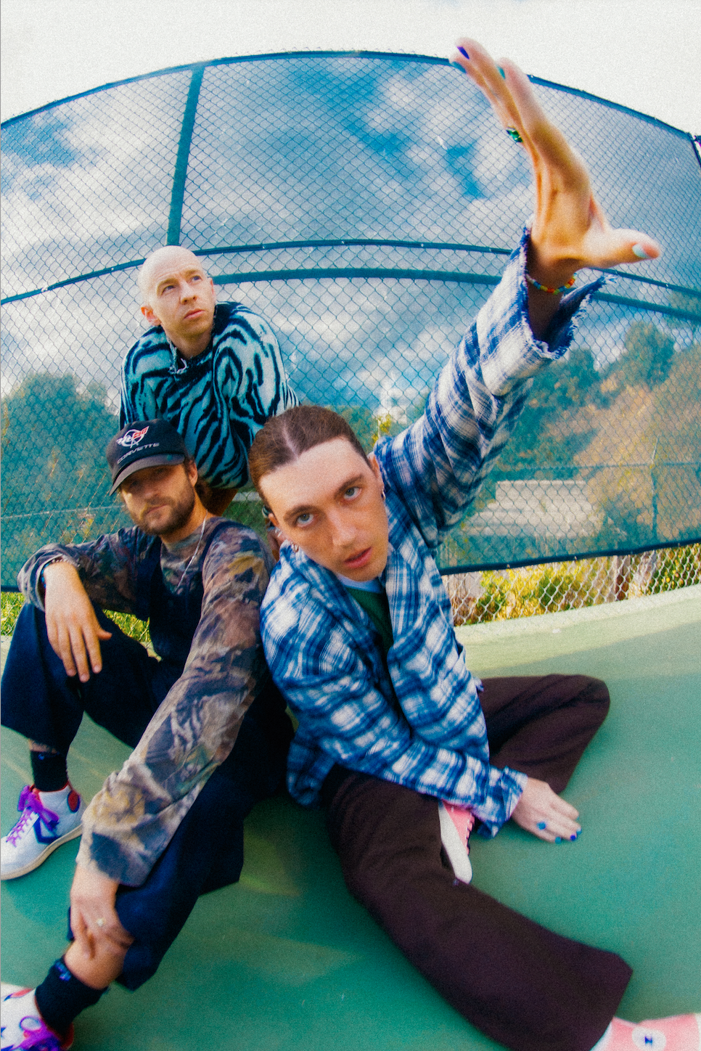
Photo Credit: Andy De Luca
Today, Los Angeles trio LANY unveils a new track, “roll over, baby,”—listen here. The new song is today’s New Music Daily feature track on Apple Music—listen to an exclusive interview between LANY front man Paul Klein and Zane Lowe here. It is taken from LANY’s forthcoming album, gg bb xx, out September 3rd via Polydor Records—pre-save/pre-order it here.
This fall, LANY will embark on a North American tour in support of gg bb xx—see full dates below. keshi will support on all North American dates. The tour will also follow a limited run in the U.K. this fall with more dates to be confirmed soon—get tickets here.
The new track is the fifth offering from gg bb xx, following “never mind, let’s break up,” “up to me,” “dna [demo]” and “dancing in the the kitchen”—which Uproxx says “showcases the group’s knack for penning relatable pop tunes, emphasizing the importance of enjoying life’s little moments over a joyous beat.” These new songs follow LANY’s first new music of 2021, “I Quit Drinking,” a duet with country superstar Kelsea Ballerini which debuted with a live performance at this year’s CMT Awards.
Following last year’s mama’s boy—which debuted at #7 on the Billboard 200 and #1 on the Alternative Albums sales chart with more than 300 million streams to date—gg bb xx finds LANY returning to their infectious pop sound, collaborating with an array of notable songwriters and producers including Andrew Goldstein (Maroon 5, Katy Perry, Lauv), John Ryan (Shawn Mendes, Charlie Puth, Harry Styles), David Hodges (Ed Sheeran, 5SOS, Blink 182), Tobias Jesso Jr. (Adele, Sia, HAIM), Dan Smyers of Dan + Shay and more.
LANY’s breakthrough came with their 2017 self-titled debut, which built an international fanbase and led to sold out arenas across the world. The heartbreak anthems on their 2018 follow-up Malibu Nights cracked the Billboard Album Chart and connected in a huge way across the globe, with their 2019 collaboration with Lauv, “Mean It,” garnering further attention. Fronted by songwriter, lyricist and producer Paul Klein, LANY have a social media following of 8.2 million people, have sold more than 415,000 tickets worldwide and played sold-out shows from L.A.’s Greek Theatre to London’s Brixton Academy. Their songs have been streamed over three billion times with more than 600 million video views to date.
LANY: GG BB XX TOUR, UK 2021
September 23 Birmingham, U.K. O2 Academy Birmingham
September 24 Manchester, U.K. Manchester Academy
September 25 Dublin, Ireland The Helix
September 27 Glasgow, U.K. O2 Academy Glasgow
September 29 London, U.K. Eventim Apollo

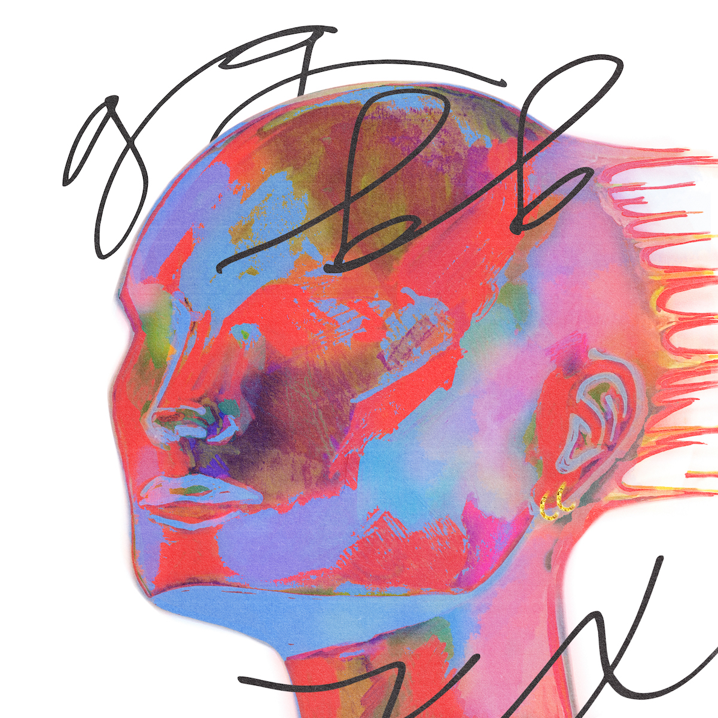
Download Hi-Res Artwork HERE

Follow LANY
INSTAGRAM // TWITTER // FACEBOOK // YOUTUBE

For more information and press enquiries please contact

Jenny Entwistle
Jenny@chuffmedia.com

