GOOD NEIGHBOURS
Return with new single ‘found u/me’
LISTEN/WATCH

Debut album Blue Sky Mentality - due for release on September 26th, 2025
PRE-ORDER


(Photo Credit: Rory Barnes)
Good Neighbours return today with anthemic new single ‘found u/me’ - the latest glimpse of their hotly-anticipated debut album Blue Sky Mentality, coming on September 26th via Polydor Records.
The duo’s latest offering is a euphoric rush of devotion and discovery – a shimmering love song that captures the moment everything changes. With radiant synths, sky-bound vocals and heart-on-sleeve intensity, Good Neighbours channel the dizzying realisation of finding your person – the one you’d give everything for. It’s a wide-eyed, life-affirming anthem, born in a single, breathtaking moment of clarity.
Speaking on it, the band add:“found u/me is about the life-changing epiphany when you meet someone that you want to spend forever with. It captures the feeling that stops you in your tracks - an overwhelming clarity that you’re ready to give everything for that one person."
‘found u/me’ arrives hot on the heels of jubilant first single ‘Suburbs’ - which premiered as BBC Radio 1’s Hottest Record last month - and the duo’s recent cover of The La’s iconic Track ‘There She Goes’, recorded exclusively for Amazon Music as part of their ‘brit summer’ campaign that captures the nostalgic spirit that is evoked by the wave of returning artists playing live shows this season. Good Neighbours bring their own signature blissful sound to the track - listen HERE and find the artwork HERE.
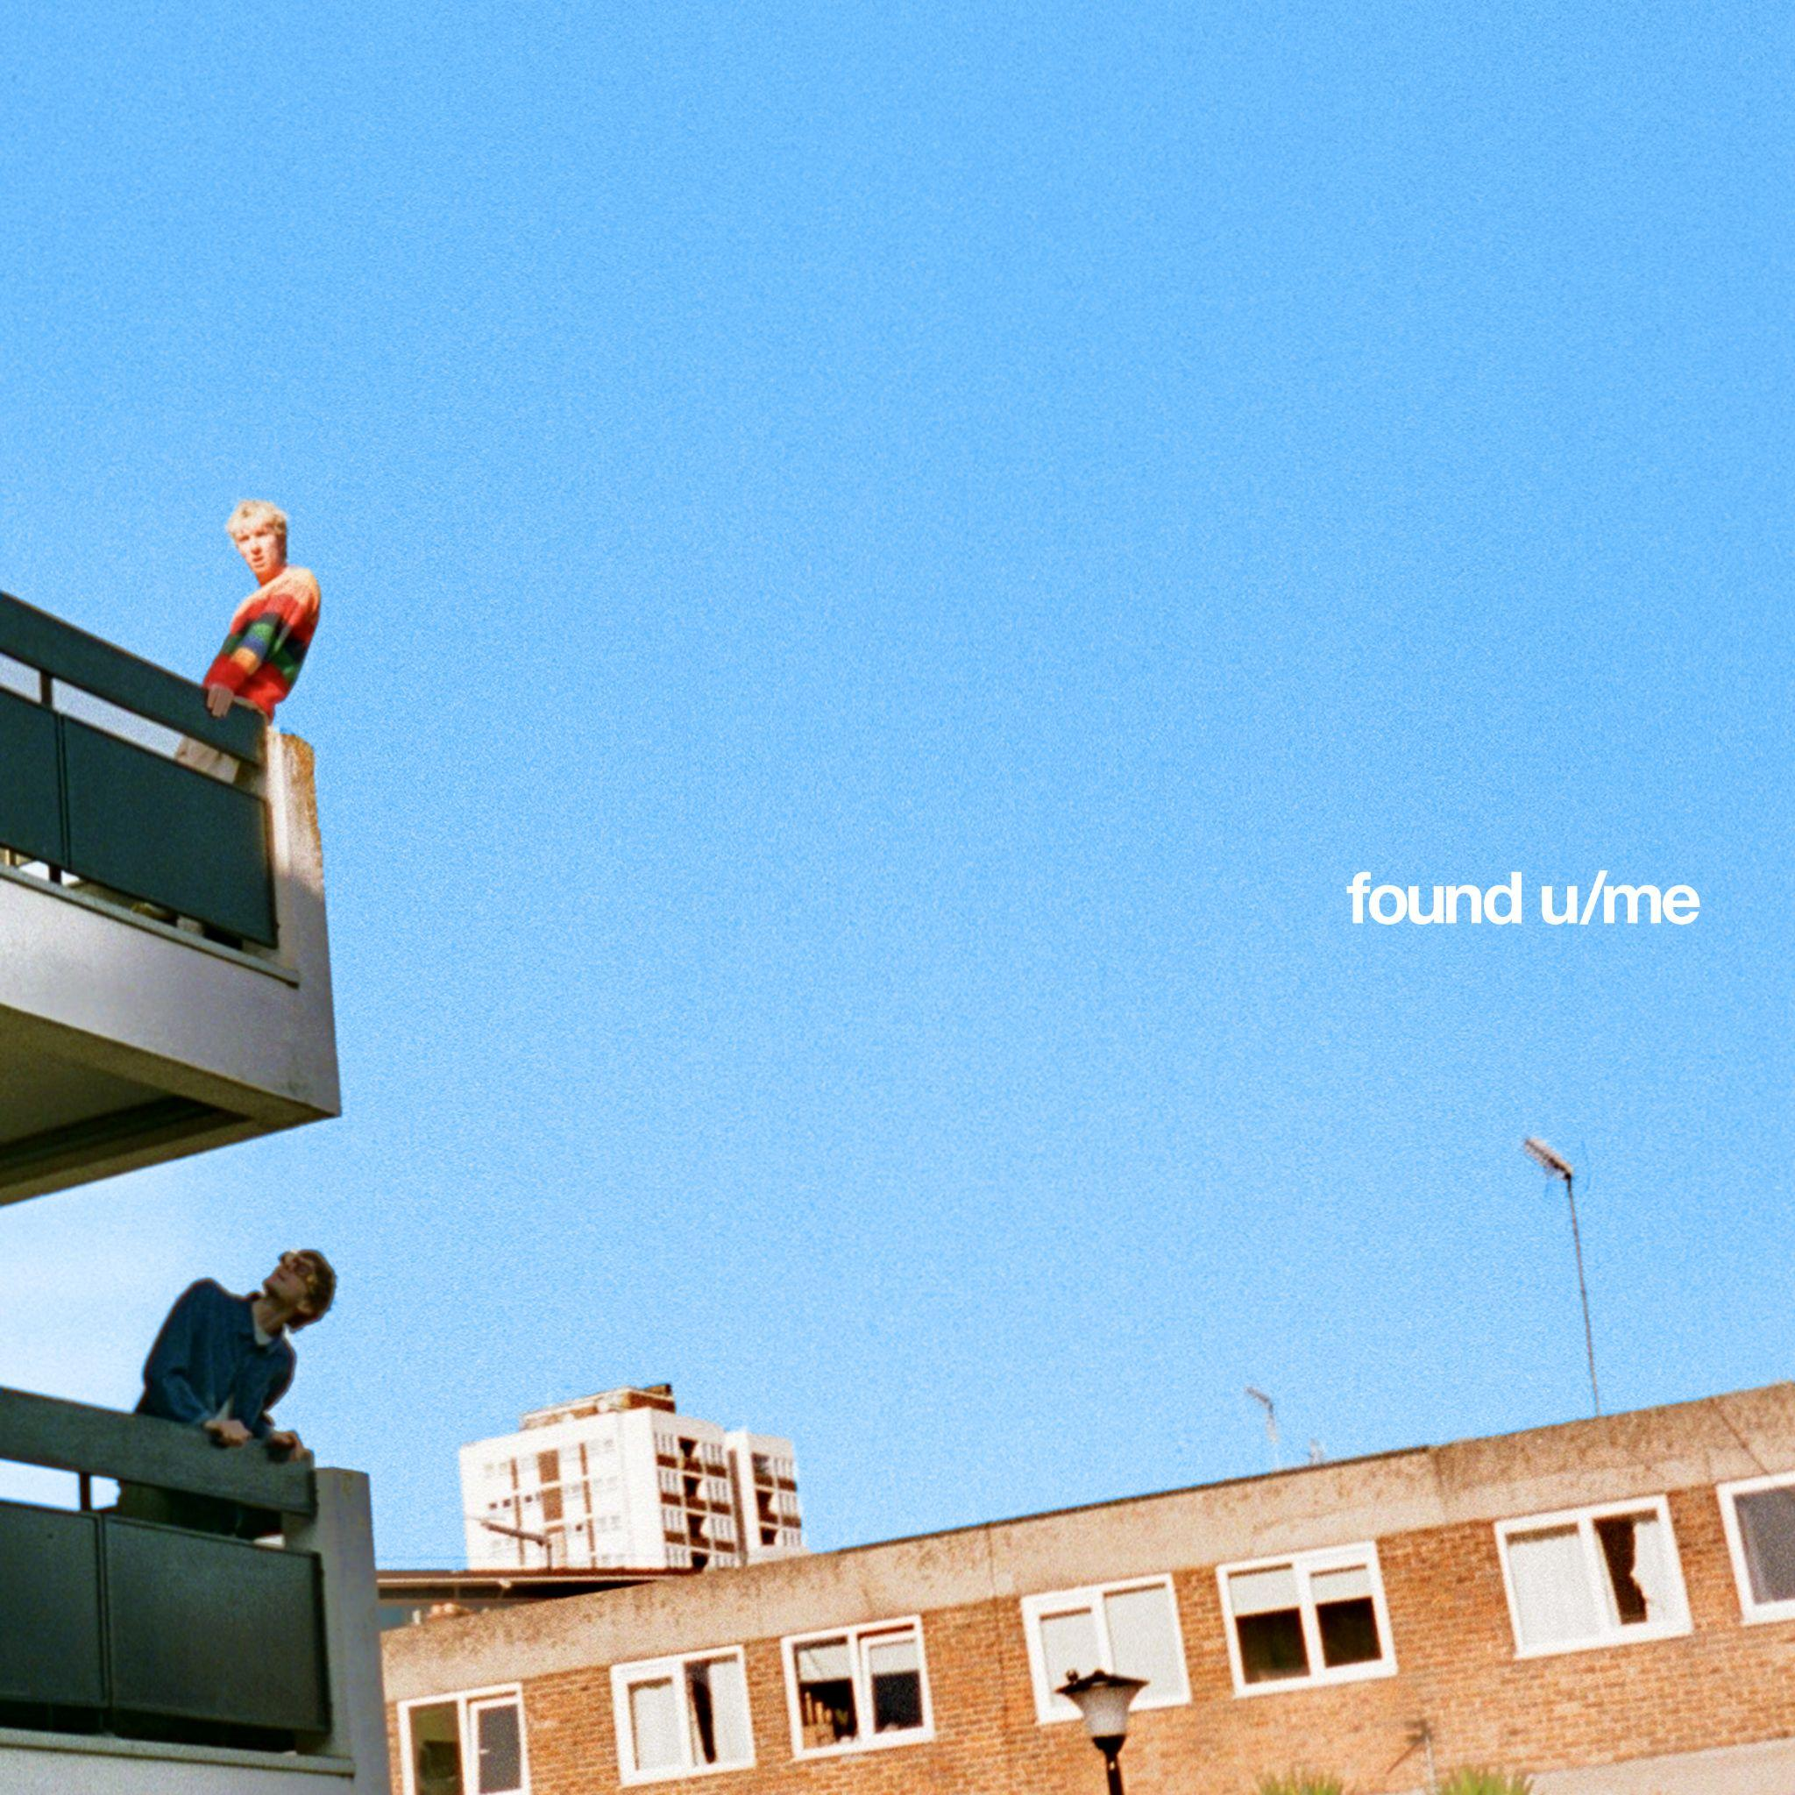

found u/me artwork
The announcement of Blue Sky Mentality arrived with a real sense of homecoming, as Scott and Oli marked the moment with a sweat-soaked, sold-out show at London’s Sebright Arms – the very venue where they played their first ever gig just 18 months ago, in November 2023.
Written across a whirlwind year of long-haul flights, tour buses, hotel rooms and emotional highs and lows, the album captures the tension between distance and belonging – the pull of community, the need for connection, and the journey back to yourself. It’s a record that wears its heart loudly and proudly: a 14-track burst of euphoric indie-pop that smuggles big feelings – grief, love, hope, resilience – into massive choruses and sun-streaked synths. From their viral debut ‘Home’ to fan favourites ‘Keep It Up’, ‘Ripple’ and ‘Starry Eyed’, Blue Sky Mentality is both a document of their meteoric rise and a rallying cry for openness, optimism and togetherness.
Speaking on the album, the band share:“Blue Sky Mentality has been our motto since day one. Our band began as a kind of light relief - a creative outlet to break from jobs that we couldn’t stand and some tough personal times. Over the last year, we ran with that feeling, writing our debut album on the road - in the back of tour buses, hotel rooms, and scattered corners of the world. That’s what Blue Sky Mentality means to us - finding light, friendship and a sense of escapism wherever you are.”

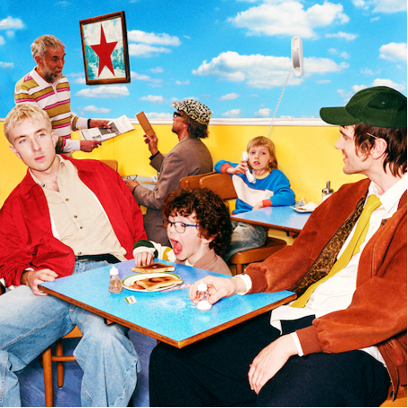
(LP Artwork)

Blue Sky Mentality tracklist:
1. Keep It Up
2. Skipping Stones
3. Ripple
4. found u/me*
5. Walk Walk Walk
6. Kids Can’t Sleep
7. Home
8. Small Town
9. Starry Eyed
10. People Need People
11. Left Hand Man
12. Suburbs
13. Wonderful Life
14. The Buzz
*Vinyl edition includes ‘Somebody’ instead of ‘found u/me’
UK Indie Store tour dates:
22/09 – Rough Trade, Bristol
23/09 – HMV, The Vault, Birmingham
25/09 – Banquet / Pryzm, Kingston
26/09 – Jacaranda, Baltic, Liverpool
27/09 – Crash Records, Wardrobe, Leeds
29/09 – Assai, Caves, Edinburgh
30/09 – Rough Trade, The Saltbox, Nottingham

Follow Good Neighbours:
TIKTOK | INSTAGRAM | TWITTER/X | FACEBOOK | YOUTUBE

For more information and press enquiries please contact

Jenny Entwistle
Jenny@chuffmedia.com

