MACHINE GUN KELLY RELEASES NEW SINGLE “emo girl” WITH WILLOW
Sixth Studio Album ‘mainstream sellout’ To Arrive March 25

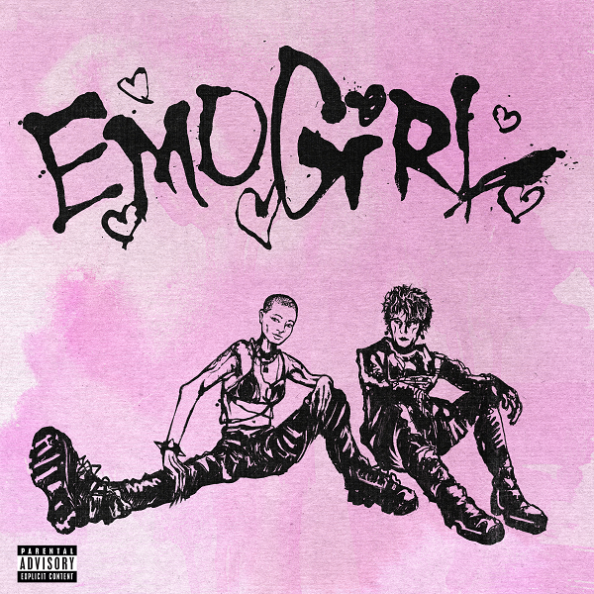

Rock dynamo Machine Gun Kelly (Bad Boy/Interscope Records) and WILLOW have teamed up to bring “emo girl,” the new single from MGK’s forthcoming album mainstream sellout. MGK previewed his rock-tinged single alongside WILLOW on his TikTok last weekend. The 15-second snippet quickly sparked conversation as the clip reeled in over 17 million total views and was the 3rd fastest growing TikTok in 24 hours from his account. At the top of week, MGK sat down with executive producer Travis Barker to comically unveil the new album title after the pair previously tattooed the former name born with horns six months ago. His sixth studio album mainstream sellout will arrive March 25. Pre-order the new album HERE.

Listen to “emo girl” HERE.

MGK will headline the 2022 NHL All-Star Game in Las Vegas this weekend and deliver a scintillating halftime performance for hockey and rock enthusiasts. Leading up to this year’s Super Bowl week, MGK will team up with Halsey for a Bud Light sponsored show at the Crypto.com Arena.

As for WILLOW, the 20-something multi-hyphenate continues to achieve more wins. Last year, she released her fourth studio album, lately I feel EVERYTHING and emerged as a pop-punk star. After being named Billboard’s Greatest Pop Stars 2021: Comeback Artist of the Year, WILLOW looks to take her talents on the road this month and join Billie Eilish for the U.S. leg of her Happier Than Ever World Tour.

Machine Gun Kelly’s “emo girl” feat WILLOW eSingle
Retail: http://MGK.lnk.to/emogirl

Machine Gun Kelly’s mainstream sellout eAlbum
Retail: http://mgk.lnk.to/mainstreamsellout

For more information and press enquiries please contact

Jenny Entwistle
Jenny@chuffmedia.com

