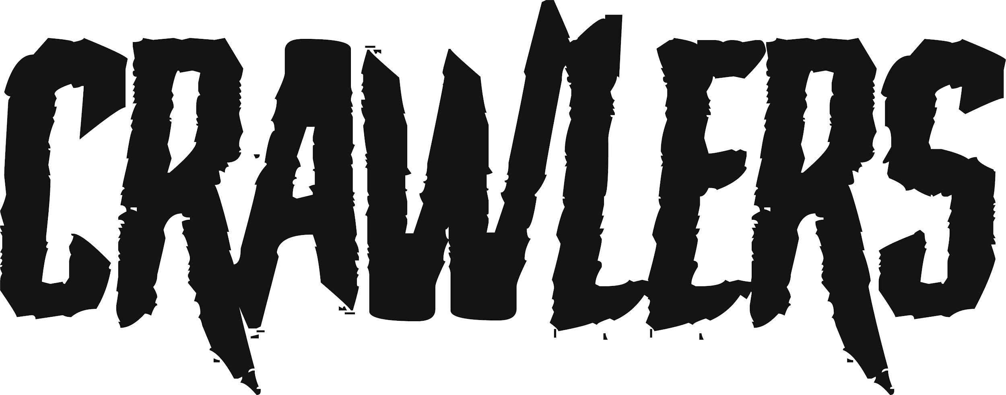
SHARE NEW SINGLE ‘WOULD YOU COME TO MY FUNERAL’
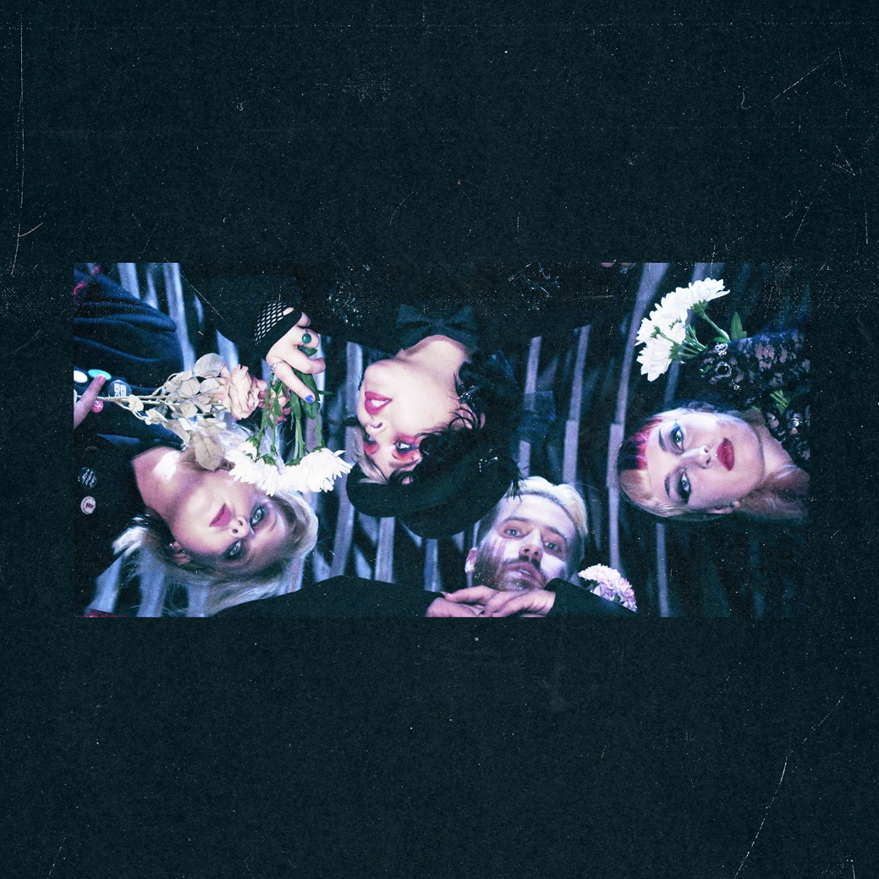

DOWNLOAD HI-RES ARTWORK HERE

CRAWLERS today (Sept 18th^{th}) share their new single ‘Would You Come To My Funeral’ via Polydor Records LISTEN HERE. The Liverpool four-piece make exhilarating rock anthems, music that recasts the electrifying grunge-y bursts of the 90s in modern lyrical themes that strike to the heart of what it means to be young in 2023. ’Would You Come To My Funeral’ is the latest sonic dispatch from this vital quartet and is released on the eve of their UK & Europe headline tour dates kicking off tomorrow in Glasgow, before heading to London’s iconic Heaven on Friday. It launches as today’s Hottest Record on BBC Radio 1.
Building up over a fuzzy riff, indelible melodies and stomping drums before cascading into an uplifting, epic chorus, ‘Would You Come To My Funeral’ explores fractured relationships and lovers left behind. “Have you ever looked at someone who meant everything in your life and now is a complete stranger and wondered - if you died, would they attend your funeral?” says Holly Minto of the song’s message.
‘Would You Come To My Funeral’ follows CRAWLERS last single ‘Messiah’ which launched as Radio 1’s ‘Hottest Record in the World’ in June.
CRAWLERS formed in 2018 and spent their first couple of years honing their live chops by playing intimate shows around their home turf of Merseyside. It’s an approach that paid off over the past year, when everything has stepped up a notch or five for the band with their intoxicating live set wowing crowds at Glastonbury and Download across the summer, a period in which they also supported YUNGBLUD at Eden Project, Cornwall.
Each new release has sealed CRAWLERS reputation as one of the UK’s most exciting young bands. Debut mixtape ‘Loud Without Noise’ cemented their global status and contributed to the band achieving a huge 80+ million streams to date.
The tour dates are:
Thurs 21st Glasgow QMU
Fri 22nd London Heaven
Sat 23rd Liverpool Invisible Wind Factory
Wed 27th Berlin Hole 44
Fri 29th Paris Le Point Ephemere
Sat 30th Amsterdam Paradiso Tolhuistuin

DOWNLOAD HI-RES PRESS IMAGES HERE
CRAWLERS are Holly Minto (she/they), Amy Woodall (she/her), Liv May (she/they) and Harry Breen (he/him).
Connect with CRAWLERS:
INSTAGRAM | TWITTER | FACEBOOK

For more information and press enquiries please contact

Jenny Entwistle
Jenny@chuffmedia.com

