Victor Ray Releases New Single ‘World At My Feet’
WATCH THE VIDEO HERE

Taken from ‘I WILL’ EP Out Today on
LISTEN HERE

“a muscular yet vulnerable voice aching with heartbreak” - The Observer
“his star shines brighter with every subsequent release” - Clash
“one of the most breathtaking young talents of today.” - BET

‘World At My Feet’ is the new single and video from Victor Ray and arrives with his new EP ‘I WILL’, out today on Decca Records/Capitol. The EP features all three of Victor’s most recent singles; ‘Hearts Break and People Change’, ‘Still The Same’ and the stellar ‘Sticks & Stones’ ft. Kojey Radical and Strandz. The final single is perhaps Victor’s most infectious yet, brimming with ambition and telling his story from busking on the streets of Newcastle to being one of the most hotly tipped young artists all around the world. Speaking about ‘World At My Feet’ he says
“World At My Feet is a song that represents everything it took just for me to get a seat at this table. This song is the story of my 10000 hours and a promise of what comes next.”

Victor Ray has every right to be reflecting on his staggering achievements over the last year, as he has found himself tipped as one to watch by MTV Push 2025, Amazon Music, The Independent, Clash, Notion and The Line of Best Fit, as well as being selected as Wonderland’s cover star in Autumn of last year.
Currently embarking on his first US and Australian tours, Victor’s ascent to superstardom is in full flight across the globe. His potent combination of vulnerable, autobiographical story-telling delivered with staggering, world-class vocals is proving irresistible the world over.
The tracklist for the ‘I WILL’ EP is:
- Still The Same
- Sticks & Stones ft. Kojey Radical and Strandz
- Hearts Break and People Change
- World At My Feet

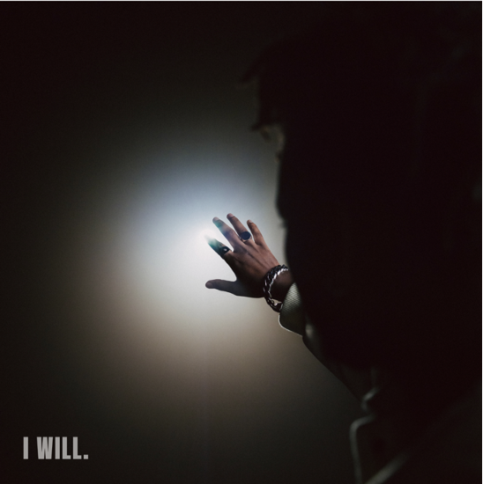
‘I WILL.’ EP artwork

Keep up to date with Victor Ray:
TIKTOK // INSTAGRAM // SPOTIFY // YOUTUBE

For more info contact Warren warren@chuffmedia.com

