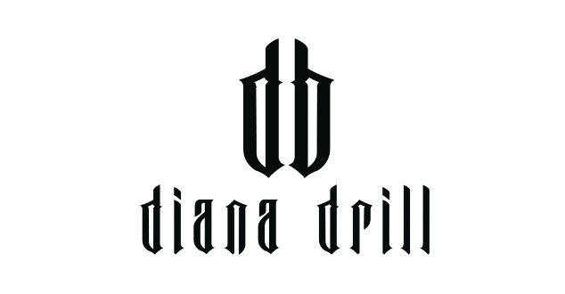
MYSTERIOUS ARTIST DIANA DRILL
IS BACK WITH NEW SINGLE ‘WORKING ON ME’

LISTEN/WATCH HERE: https://dd.lnk.to/WorkingOnMe

“Delivering a refreshing twist to the UK drill scene with her authentic touch.” – LINK UP TV

“One of the most exciting artists of the scene” – GRM DAILY

“Diana Drill proves why she is one to watch!” – Mixtape Madness

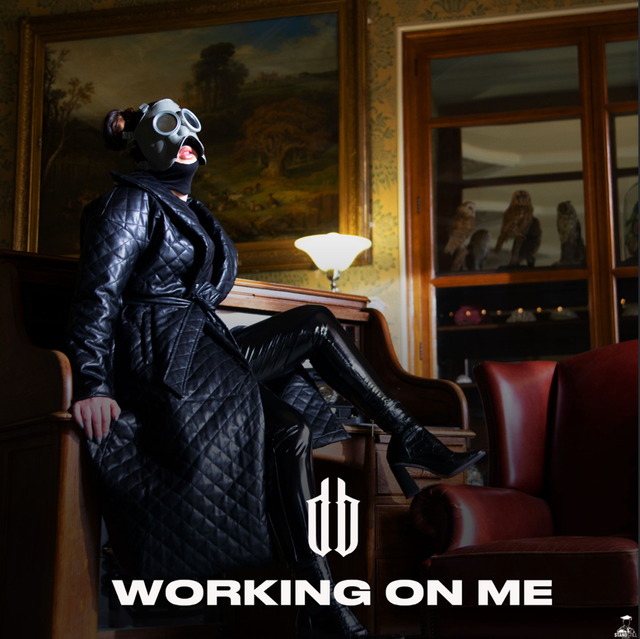

Mysterious Nottingham native Diana Drill returns with new single ‘Working On Me.’ Following the success of her debut self-titled release late last year & her recent track ‘Winning’ Diana is here to further cement her position as one to watch. Launching with a video directed by Simon Aukes & co-directed by Mazza Motion, Diana further showcases her versatility on this new release as she focuses on herself with ‘no stress, just progress.’ On the track Diana says “‘This single will show another side to my music, I'm gassed to drop this one, I know people will relate!” Diana effortlessly transitions between rapping and melodic hooks in her songs, and visually stands out wearing a trademark custom gas mask.

‘Working On Me’ is the third release from Diana since Summer 2020, with her self-titled debut immediately attracting the attention of tastemakers across the UK, leading her to a placement on BBC Radio 1’s Playlist as Introducing Track of the Week. Since then she has only picked up more fans from the scene and beyond with a ‘Fire in the Crib’ for Charlie sSoth & strong support at press from the likes of GRM Daily, Link Up Tv & Mixtape Madness who labelled her as ‘one to watch.’

Diana comes from the gritty city of Nottingham; her surroundings have shaped her sound and she is all about the music. This is the reason she chooses to keep her identity under wraps and let her bars do the talking. ‘I want the music to speak for itself’ she says about the fact she always wear her signature mask ‘You don’t need to know how pretty or ugly I am. If you don’t like me for my music then do you really like me?’

Growing up singing in her bedroom she always knew she had a talent, but it was a lot more recently that she discovered she had a flair with lyrics and rapping. Taking influence from UK artist such as Mist, Nines, Giggs & Ghetts, Diana adds her own flavour to her diverse sound that makes her stand out, crediting US female rappers like Saweetie & Cardi B for showing her that she can do both. “I started putting pen to paper in moments when I would have a lot of anger in me and I would send them to my brother, he was the one that replied to me saying – Nah, you’ve got to do something with this!”

That is where her whirlwind journey began and she’s only rising. In only a year since she started her musical journey she’s already amazed & humbled by the people she’s had a chance to work with. Stay tuned to hear the name Diana Drill a lot more next year. As she says in her opening line, ‘you might not know my name right now, but you will.’

FOLLOW DIANA DRILL
INSTAGRAM | TWITTER

For all media enquiries contact warren@chuffmedia.com on 07762 130510

