Sam Fender Shares New Track Ahead of Seventeen Going Under Live Deluxe Edition Release

Wild Grey Ocean Is Streaming Now

Pre-Order The Live Deluxe Edition And Live From Finsbury Park HERE

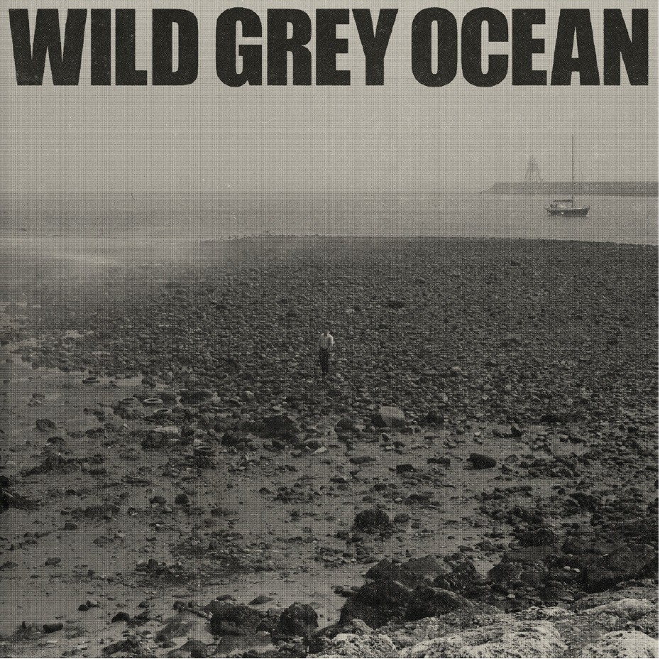

Sam Fender is pleased to share a new track. It is the first of two new songs included on the forthcoming deluxe edition release of Seventeen Going Under on 9th December through Polydor Records.

Wild Grey Ocean is streaming now, and was recorded during the original album sessions, held back for future release. Similarly to much of the material on the record, it’s a track that reflects moments and memories of Sam’s teenage years; Personal ruminations punctured by his distinctive guitar motif.

“Seventeen Going Under – Live Deluxe Edition” and “Live From Finsbury Park” are both released on 9th December.

Seventeen Going Under was originally released on 8th October 2021. It debuted at number 1 in the UK on a wave of critical acclaim, and set up a tremendous twelve months for one of Britain’s best songwriters, winning Sam a second BRIT Award for Best Rock/Alternative Act, two NME Awards, a prestigious Ivor Novello Award for songwriting, and Sam’s first Mercury Prize nomination.

In June 2023, Sam headlines two nights at the 55,000+ capacity St. James’ Park in Newcastle. Both shows sold out instantly. New dates in Belfast and Dublin are also on sale now for next Summer.

“Live From Finsbury Park” captures Sam’s scintillating sell-out performance in front of 45,000 fans earlier this Summer in London. As Sam’s biggest headline show to date, and straight off the back of his show-stealing performance at Glastonbury Festival, the Finsbury Park show paid testament to an incredible twelve months for an artist whose rise has been meteoric.

The album will be released as a standalone double coloured vinyl. It will also feature on a “Live Deluxe Edition” of Seventeen Going Under on double CD, including the B-sides and two new tracks.

Fans can pre-order the Finsbury Park vinyl or Live Deluxe Edition of Seventeen Going Under on CD HERE

Watch a live video of Sam performing Getting Started from Finsbury Park, London.

Sam Fender Live:
9th June – St James’ Park, Newcastle SOLD OUT
10th June – St James’ Park, Newcastle SOLD OUT
23rd June – Ormeau Park, Belfast
25th June – Malahide Castle, Dublin

Seventeen Going Under Live Deluxe (CD 1):
Seventeen Going Under
Getting Started
Aye
Get You Down
Long Way Off
Spit of You
Last to Make It Home
The Leveller
Mantra
Paradigms
The Dying Light
Better of Me
Pretending That You’re Dead
Angel In Lothian
Good Company (Live)
Poltergeists
Howdon Aldi Death Queue
The Kitchen (Live)
Alright
Wild Grey Ocean
Little Bull Of Blithe

Live From Finsbury Park (CD 2):
Will We Talk?
Getting Started
Dead Boys
Mantra
Better Of Me
The Borders
Spice
Howdon Aldi Death Queue
Get You Down
Spit Of You
Alright
Play God
The Dying Light
Saturday
Seventeen Going Under
Hypersonic Missiles

For more information & enquiries please contact jenny@chuffmedia.com

