THE BIG MOON ARE BACK AND YOU DON’T KNOW JUST HOW MUCH YOU’VE MISSED THEM

THE FIRST SINGLE, WIDE EYES, SPEAKS TO TOGETHERNESS, COMPANIONSHIP, TRUST AND LOVE. YOU SHOULD LISTEN TO IT NOW AND WATCH THE LIFE-AFFIRMING VIDEO HERE

HERE IS EVERYTHING WILL BE RELEASED 14 OCTOBER 2022. IT’S THE SOUND OF A CLOSE-KNIT BAND OF FRIENDS TAKING ANOTHER GIANT LEAP FORWARD.

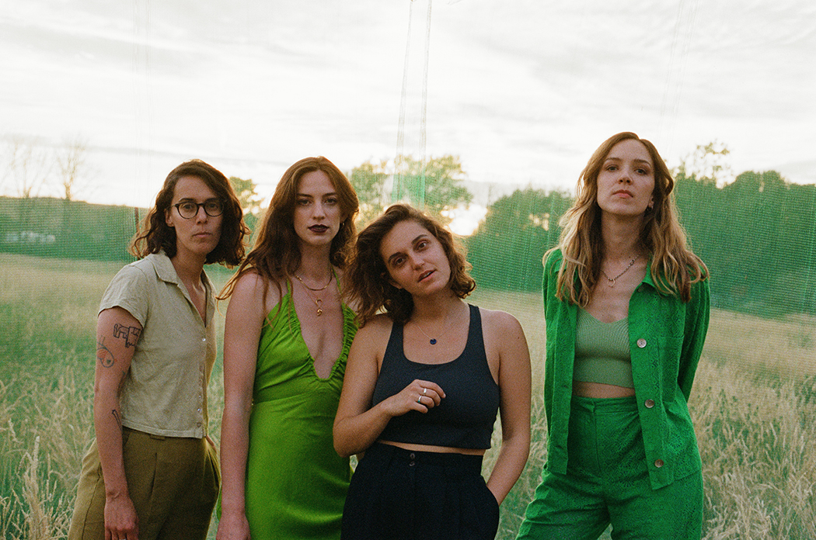
Credit: El Hardwick

The Big Moon are back. The band release their third album, Here Is Everything, on 14th October 2022 via Fiction Records.

​​Listen to the album’s first single, Wide Eyes, and watch the video HERE

The last time you heard The Big Moon was welcoming the release of their dazzling second album, Walking Like We Do, back in January 2020, when life was very different. That was a coming of age record, with bold songs for Saturday nights and sad songs for Sunday mornings. So much has changed and continues to change. And in this world of constant change, we yearn for something familiar. Thankfully, we can continue to rely on the unique, jubilant, unassailable bond that sews this brilliant London band together. Another such constant is their collective ear for melody and knack for writing smart, sharp, and infectious alt pop knockouts.

Jules Jackson on Wide Eyes: “I was desperate to write a really big, happy song. My soul was overflowing with the joy of something but I was too physically and mentally exhausted to actually string words together and define it and make music with it. In late 2021, I met Jessica Winter who came into my life like an angel and helped me turn those jumbled feelings into a song and I think it’s just a mad snapshot of a time when life just felt huge and holy and raw and incredible. I was nursing a five month old baby, I was barely sleeping, I was losing my hair, I was pumping and sweating and crying and lonely and only just about coping, but amongst all that, I felt a burning love and a new kind of happiness. I guess the world felt innocent again. For a while anyway.

“For me, this song feels so personal but when Soph, Celia and Fern stepped in, it turned into something bigger, and it feels like friendship and promise - we have loved every minute of being back together and doing what we do.

“With this song I get to spend three and a half minutes in that place, and that time, and I’m so glad I have it and I’m so glad I get to share it with people.”

Like so many records landing in store and on streaming services right now, Here Is Everything was conceived during the weight and worry of lockdown in a pandemic. Worlds were turned upside down and inside out. Lives became seismically different, whilst every day a carbon copy of the last. So, whilst Covid pulled the duvet tightly up over our heads, it was also the unlikely backdrop to welcoming new life. Vocalist Juliette Jackson might have started lockdown teaching fans how to play guitar on Zoom to help pay the rent (including, to her eternal bemusement, one Courtney Love), but she ended it as mother to a super little human being.

Here is Everything documents the arrival of that baby in real time, and the simultaneous arrival of a new mother, full of excitement and fear. Meanwhile, the rest of the band doubled-down in the studio, taking Jules’ embryonic song frameworks and stepping forward as one, revelling in an innate, giddy togetherness and with a clutch of genuinely fantastic tunes.

The record is introduced today with Wide Eyes, a pure, uplifting song of collective jubilance. It sounds like a band in top form having the time of their lives against all the odds. It sounds instantly like The Big Moon whilst sounding unlike any of the music that’s gone before it.

Here Is Everything was mostly self-produced, with the expert guidance and expertise of CECIL (Self Esteem, Jehnny Beth, PJ Harvey) and the Grammy Award winning producer Ben Allen (Gnarls Barkley, Deer Hunter, and the producer of Walking Like We Do).

Pre-order the album HERE

This month, The Big Moon play Finsbury Park (in support of George Ezra), Truck Festival and Y Not Festival, before embarking on a headline tour of the UK in advance of the new album’s release. The 8-date tour concludes at The Forum in London on 28th September 2022.

The Big Moon Live:
17th July – Finsbury Park, London (w/ George Ezra)
22nd July – Ventnor Fringe, Isle of Wight
23rd July – Truck Festival, Oxfordshire
24th July – Leopallooza, Cornwall
29th July – Kendal Calling, Cumbria
30th July – Underneath The Stars, Yorkshire
31st July – Y Not Festival, Derbyshire
19th September – The Leadmill, Sheffield
20th September – Concorde 2, Brighton
21st September – O2 Academy, Birmingham
23rd September – Oran Mor, Glasgow
24th September – Newcastle University
25th September – Academy 2, Manchester
27th September – Tramshed, Cardiff
28th September – O2 Forum Kentish Town, London

Find remaining tickets at www.thebigmoon.co.uk

The album’s artwork was shot by Pooneh Ghana

For more on info contact warren@chuffmedia.com

