**THE LAFONTAINES RELEASE BRAND NEW SINGLE *WHERE THEY KNOW MY NAME***

**LISTEN** [**HERE**](https://lnk.to/WhereTheyKnowMyName)

**PRE-ORDER THE NEW ALBUM *BUSINESS AS USUAL*** [**HERE**](https://townsendmusic.store/products/artist/The+LaFontaines)

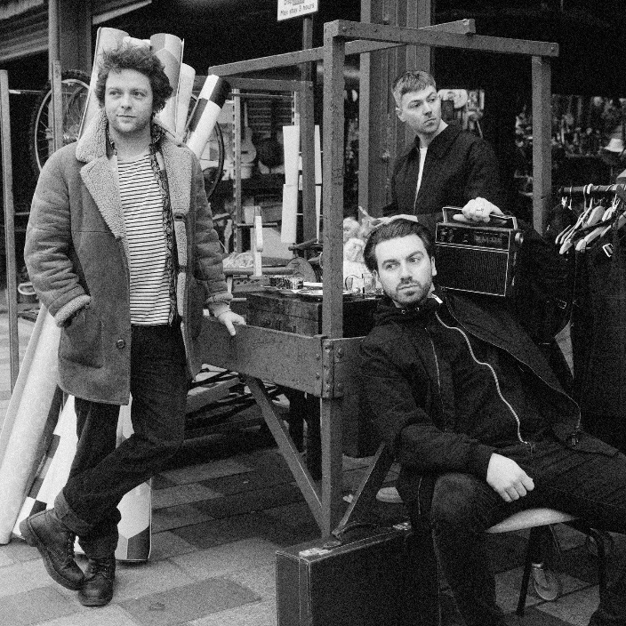

Credit: Euan Robertson

Press assets [here](https://www.dropbox.com/scl/fo/9a3fqyhcamobq6d8yak64/h?rlkey=bygmbob2pg166e30zh4cgeyfq&dl=0)

**The LaFontaines** today release ***Where They Know My Name***, the second single from their upcoming album ***Business As Usual.*** Pre-order the album [here](https://townsendmusic.store/products/artist/The+LaFontaines) and listen [here](https://lnk.to/WhereTheyKnowMyName).

Speaking about the track,Kerr Okansays: *“****Where They Know My Name*** *is my love song to Glasgow. The type of tune that can only come when you’ve left the familiarity, good or bad, of your hometown. Childhood memories, dreams, and the struggle for opportunities all wrapped in one big Glasgow Kiss. It’s about the place I always dreamed of leaving but never imagined I would.”*

**The LaFontaines** previously released the albums title track, [*Business As Usual*](https://open.spotify.com/album/5Q6OigtVlM8tFCr3ebBrOC). As the catalyst for the album, it sums up the band in 3:23 seconds. Unique, bold, and Scottish.

On the album, frontman Kerr Okan adds: *“To be a band at this point, 15 years deep, on the verge of releasing our 4th studio album says it all really. To still be going hard at it shows the love we have for the music. To have a fanbase that continues to grow proves we’re not f%@kin’ mental, and to have a live show that is genuinely one of the best in Britain, is the reason we keep selling out shows with no industry backing. This record is far from a farewell; it’s a resolute declaration that it’s ‘Business As Usual”*

The bands personality, charm and charisma coupled with their unrivalled unique offering has earned them a dedicated, loyal fanbase who identify with the band through more than just the music. Connecting with their live audiences on a level that most acts never achieve, their live shows are their superpower.

Across their career, **The LaFontaines** have performed across the globe with festival highlights including TRNSMT in Scotland, VERY TV Festival in Bangkok, the Radio 1 Dance Tent at Reading & Leeds Festival in England and the NH7 Weekender in India. They have toured everywhere from New York to Paris with the likes of Linkin Park’s Mike Shinoda, Anderson .Paak, Don Broco, Deaf Havana and Example to name a few.

Their third studio album [*Junior*](https://open.spotify.com/album/5J2hNBFAVRz88KRL7gnU3Z) was released via SO Recordings in June 2019 to critical acclaim. The album charted at number 33 in the UK Albums Chart, giving the band their first top 40 record.

**The LaFontaines** are Kerr Okan (vocals), Jamie Keenan (drums, vocals) and Darren McCaughey (guitars, production).

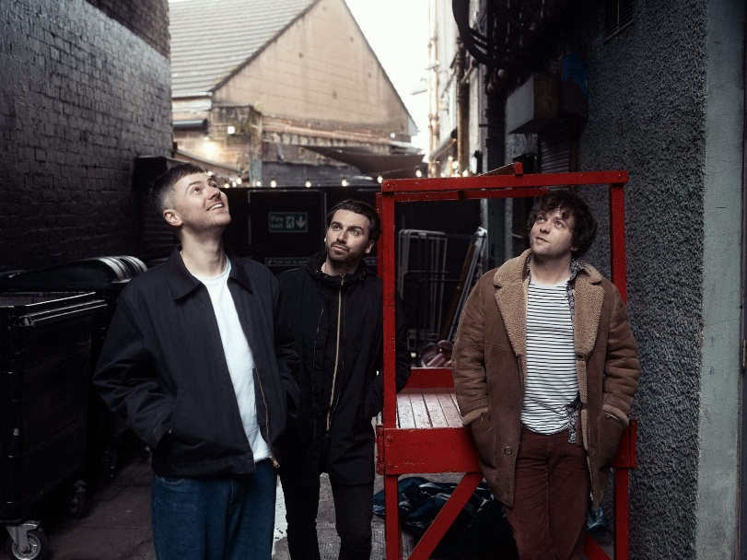

Credit: Euan Robertson

**Follow The LaFontaines:**

[Instagram](https://www.instagram.com/thelafontaines/?hl=en)

[TikTok](https://www.tiktok.com/@thelafontaines)

[Facebook](https://www.facebook.com/thelafontainesmusic)

[X](https://twitter.com/TheLaFontaines?ref_src=twsrc%5Egoogle%7Ctwcamp%5Eserp%7Ctwgr%5Eauthor)

[Spotify](https://open.spotify.com/artist/1oR94M02IeFan1KOhPCpqd)

[YouTube](https://www.youtube.com/channel/UCunWx9RPlmuGWAXwexSEmXg)

[Website](https://www.thelafontaines.co.uk/)

**For all media enquiries please contact** [**warren@chuffmedia.com**](mailto:warren@chuffmedia.com)