ALT-POP ICON LORDE RELEASES BRAND NEW SINGLE
‘WHAT WAS THAT’ — OUT 24TH APRIL 2025
‘What Was That’ Signals the Dawn of a Striking New Era for Lorde
WATCH THE VIDEO HERE
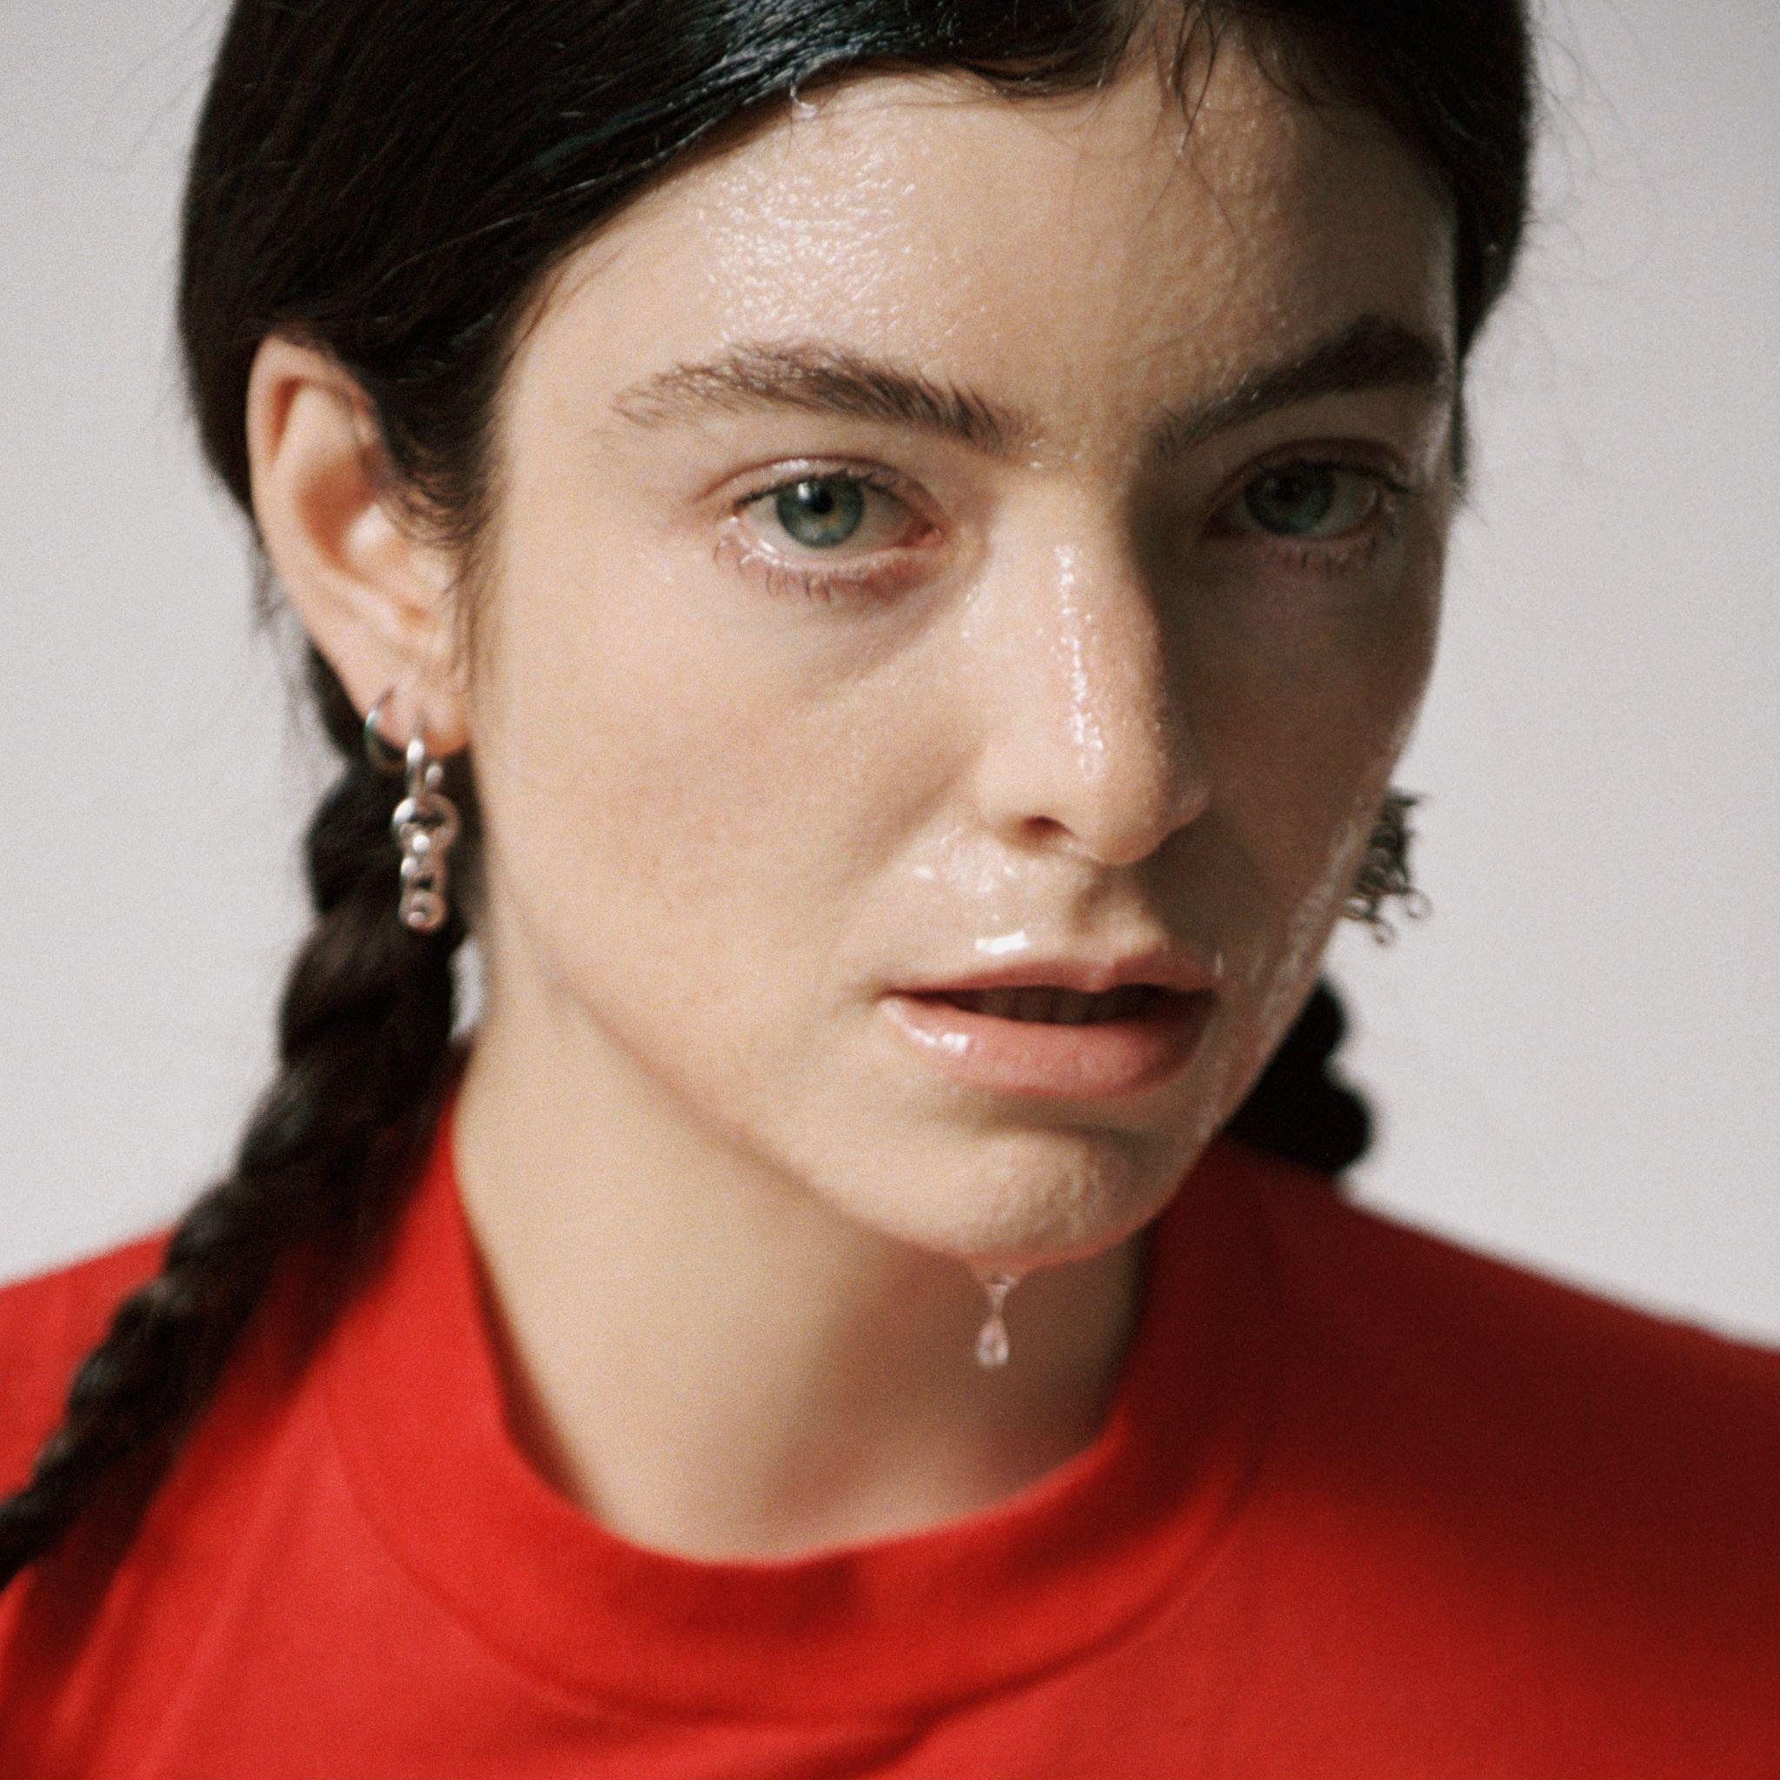
Lorde returns with What Was That, her first major release in almost four years and co-produced by Lorde, Jim-E Stack and Dan Nigro. Listen HERE
The accompanying music video was shot on location in New York, including Washington Square Park, where Lorde surprised fans with a pop-up performance earlier this week.
##
lorde.co.nz | X | Instagram | Tik Tok

For more info contact Warren warren@chuffmedia.com

