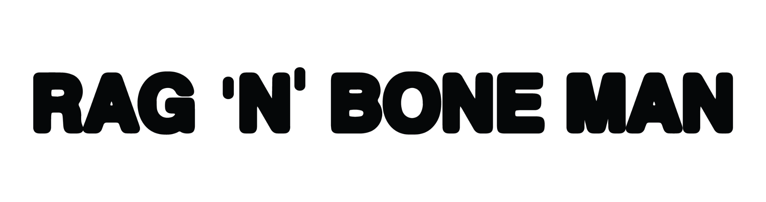
RAG'N'BONE MAN UNVEILS NEW SINGLE
'WHAT DO YOU BELIEVE IN?'
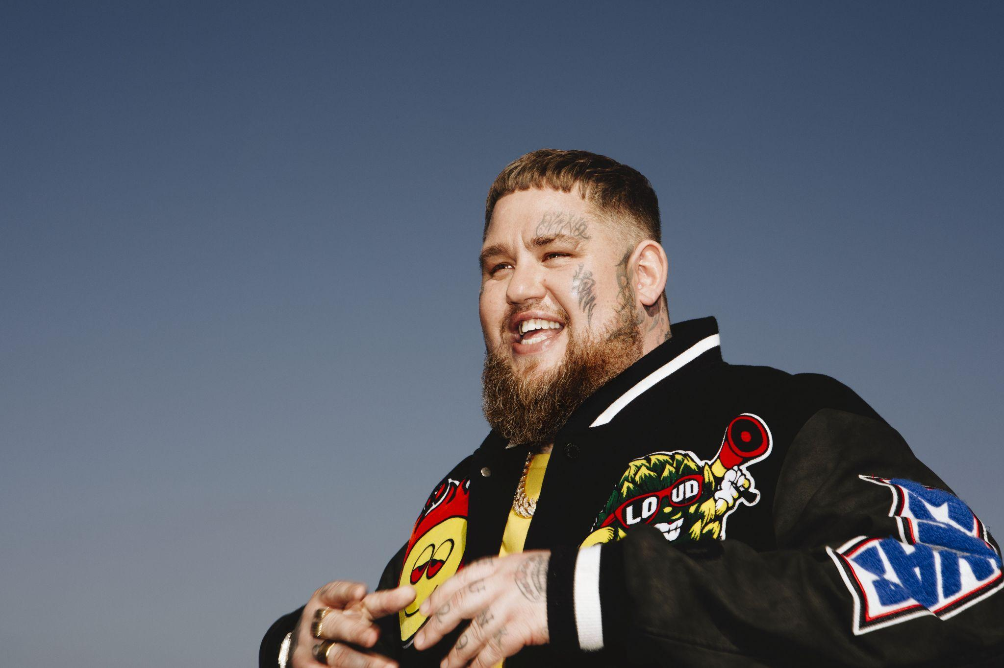
Photo credit: Fiona Garden

(London, UK - 23rd May 2024) – Today, following a Radio 1 Hottest Record launch, Rag’n’Bone Man, the acclaimed British vocalist known for his soul-stirring blues vocals, today releases his brand new single, 'What Do You Believe In?'. The eagerly awaited track marks a significant milestone in his career. Listen Here.

A truth-telling voice that has framed an era, Rag’n’Bone Man’s success speaks for itself: his debut album ‘Human’ went platinum four times over in the UK and multi-platinum in a further twenty seven countries - becoming the fastest selling male debut album that decade. While his latest release ‘Life By Misadventure’ debuted at #1 and spent seven weeks in the Top 10, making it the fastest-selling album by a solo artist in 2021. With over nine-billion worldwide streams (and counting) over his entire catalogue, Rag’n’Bone Man is a voice that’s recognised across the globe.

New track ‘What Do You Believe In?’ encapsulates Rag’n’Bone Man's journey towards embracing joy and finding solace in family life. Inspired by personal experiences, the song delves into themes of loss, fatherhood, and the search for meaning in the face of adversity. On the track, Rag’n’Bone Man explores the universal questions surrounding life and death, emphasising the importance of family as a source of strength and comfort.

Speaking about the inspiration behind the song, Rag’n’Bone Man shares, “I wrote this after losing someone close. Now, having to explain something like that to your child is a bit weird. I’ve never been involved with religion, but the question you get asked is: where do people go? And that’s what the song is about. It doesn’t really matter what people believe in, you can believe that they’ve gone to a better place.”

'What Do You Believe In?' showcases Rag’n’Bone Man's evolution as an artist, blending soulful melodies with the vibrant sounds of 00s hip-hop - a genre that has been tremendously influential in his musical journey. With its poignant lyrics and uplifting energy, the song sets the tone for what Rag’n’Bone has in the pipeline for 2024, promising listeners a profound and enriching musical experience.

Rory Charles Graham, better known by his stage name Rag’n’Bone Man, captured global attention with his debut album 'Human' in 2016. Since then, he has amassed numerous awards and accolades solidifying his status as a vocal powerhouse. Now, with this upcoming phase - 'What Do You Believe In?' see’s Rag’n’Bone Man returning to his roots while exploring new creative territories. Listen Here.

This summer, Rag’n’Bone Man will embark on a run of shows with performances at BBC Radio One’s Big Weekend, Hits Radio Live, Montreux’s Jazz Festival and Latitude Festival, as well as supporting icon’s P!NK and Shania Twain on their UK/European tours - see full show listing/get tickets here.



Follow Rag’n’Bone Man
Youtube | X | Instagram | Facebook

ragnboneman.com

For more information and press enquiries please contact
Jenny Entwistle
Jenny@chuffmedia.com

